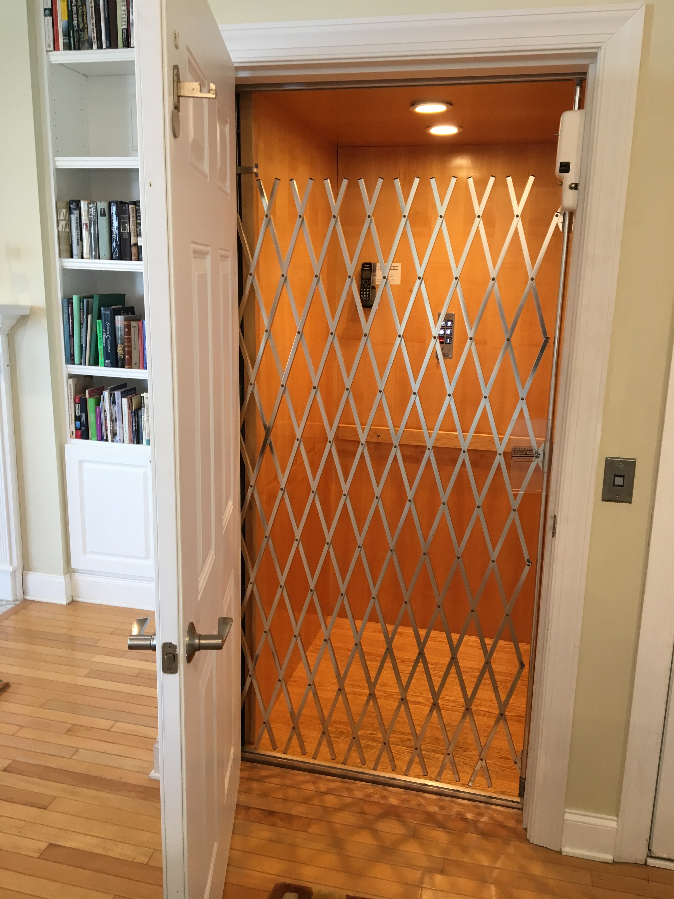
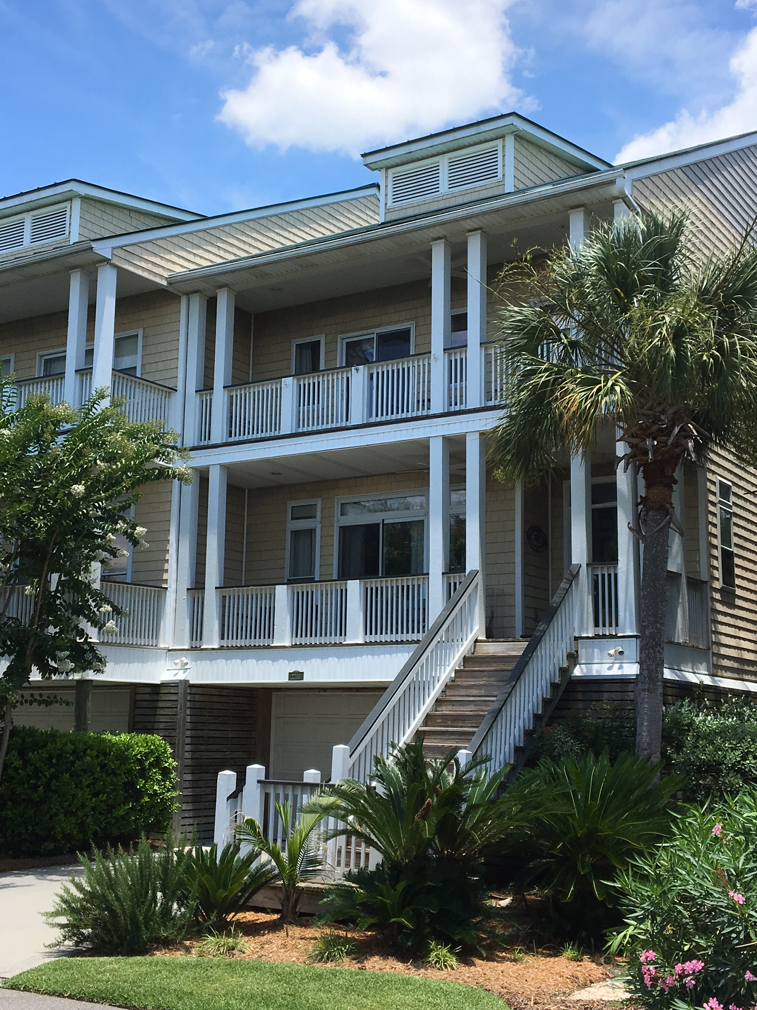
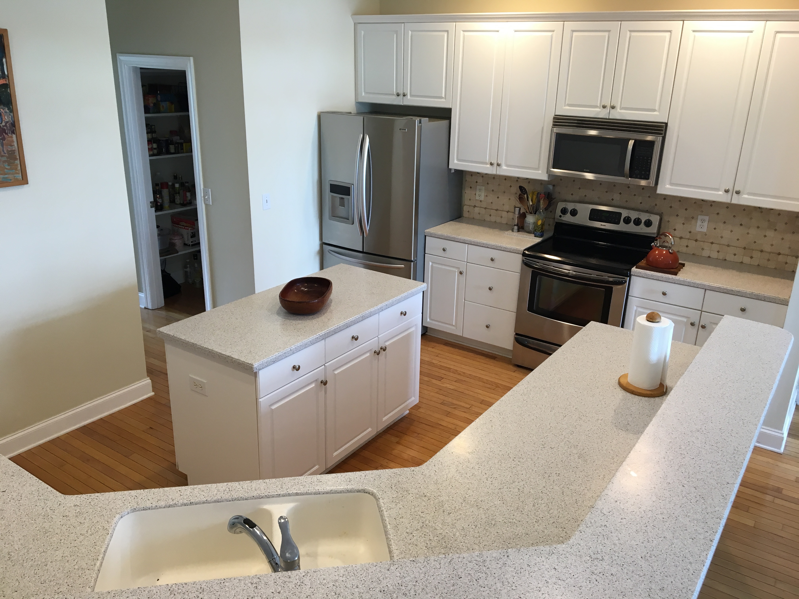
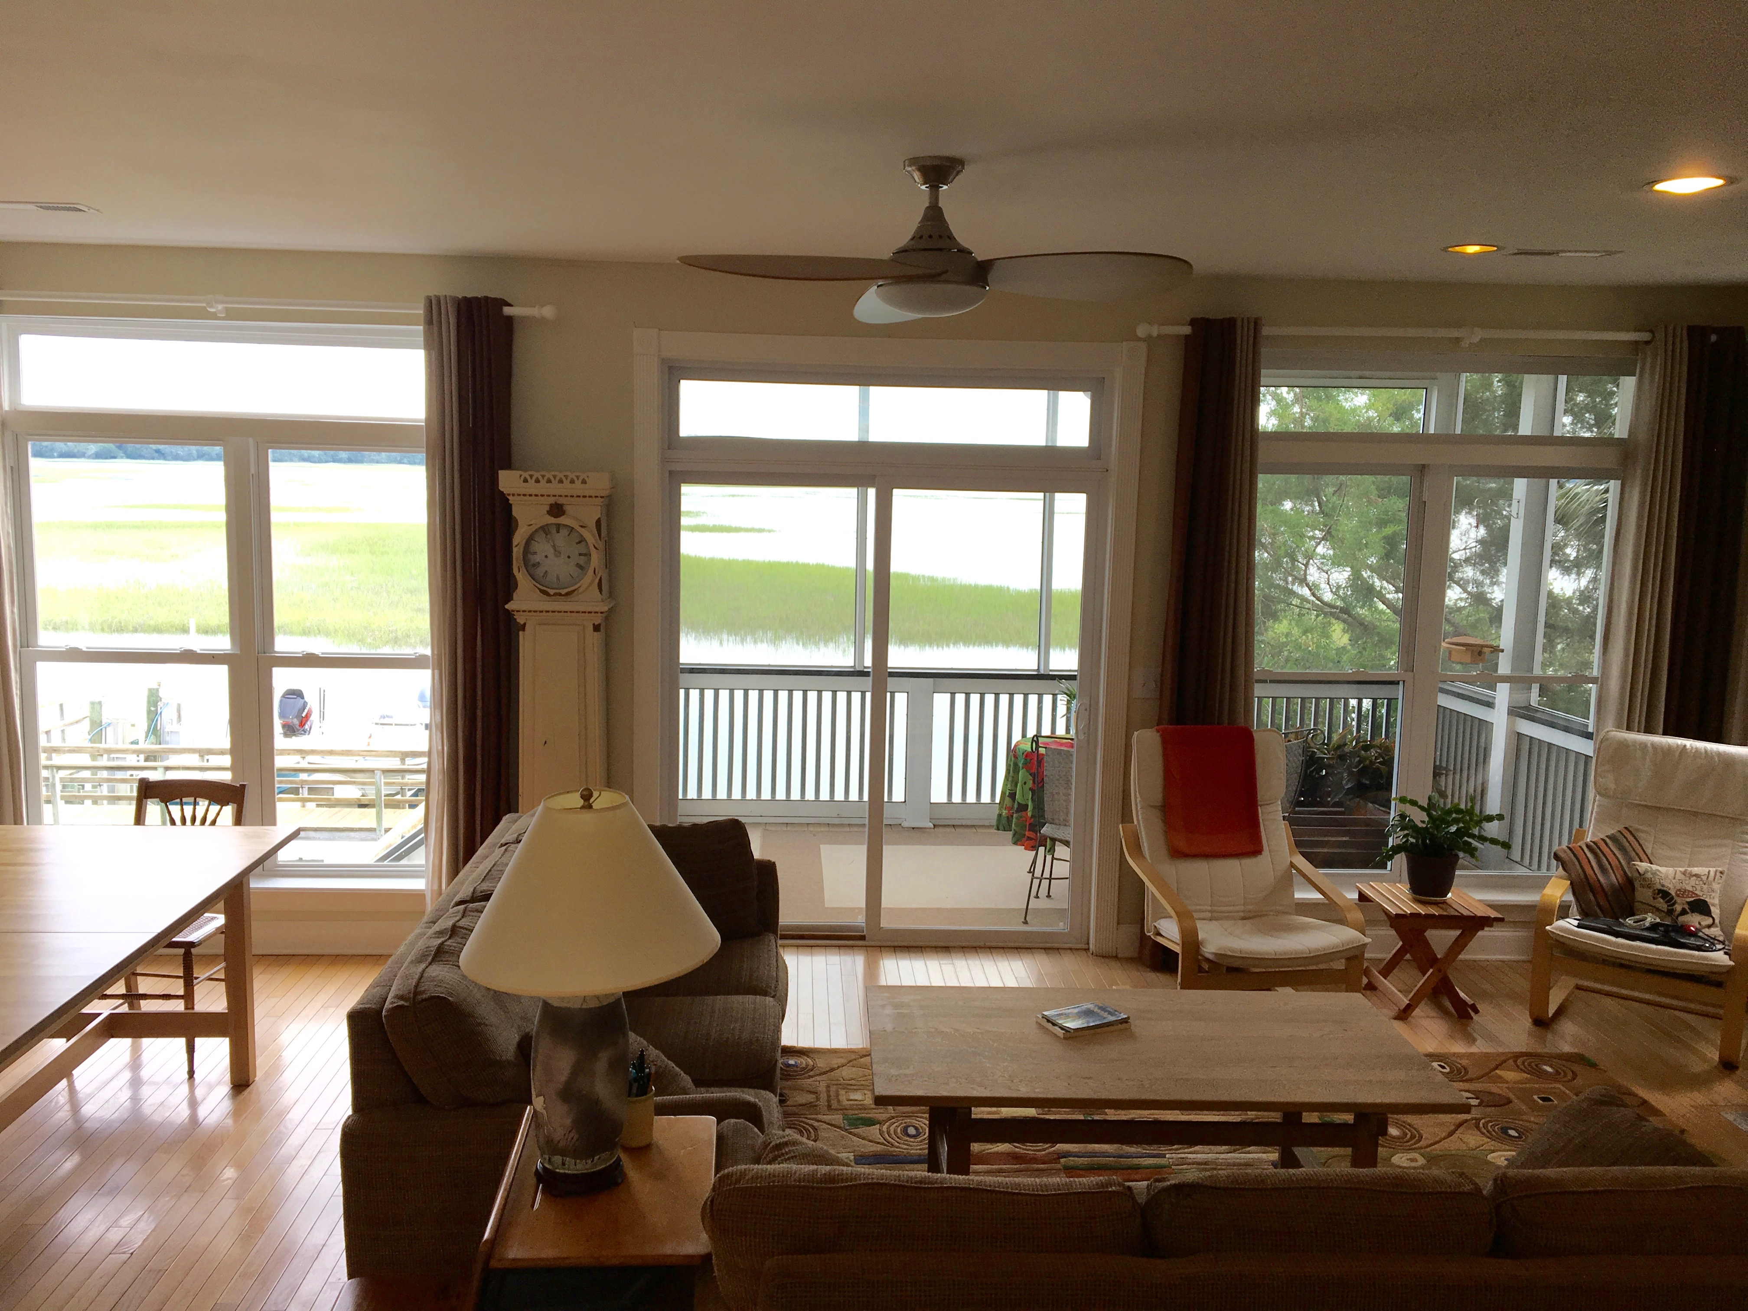
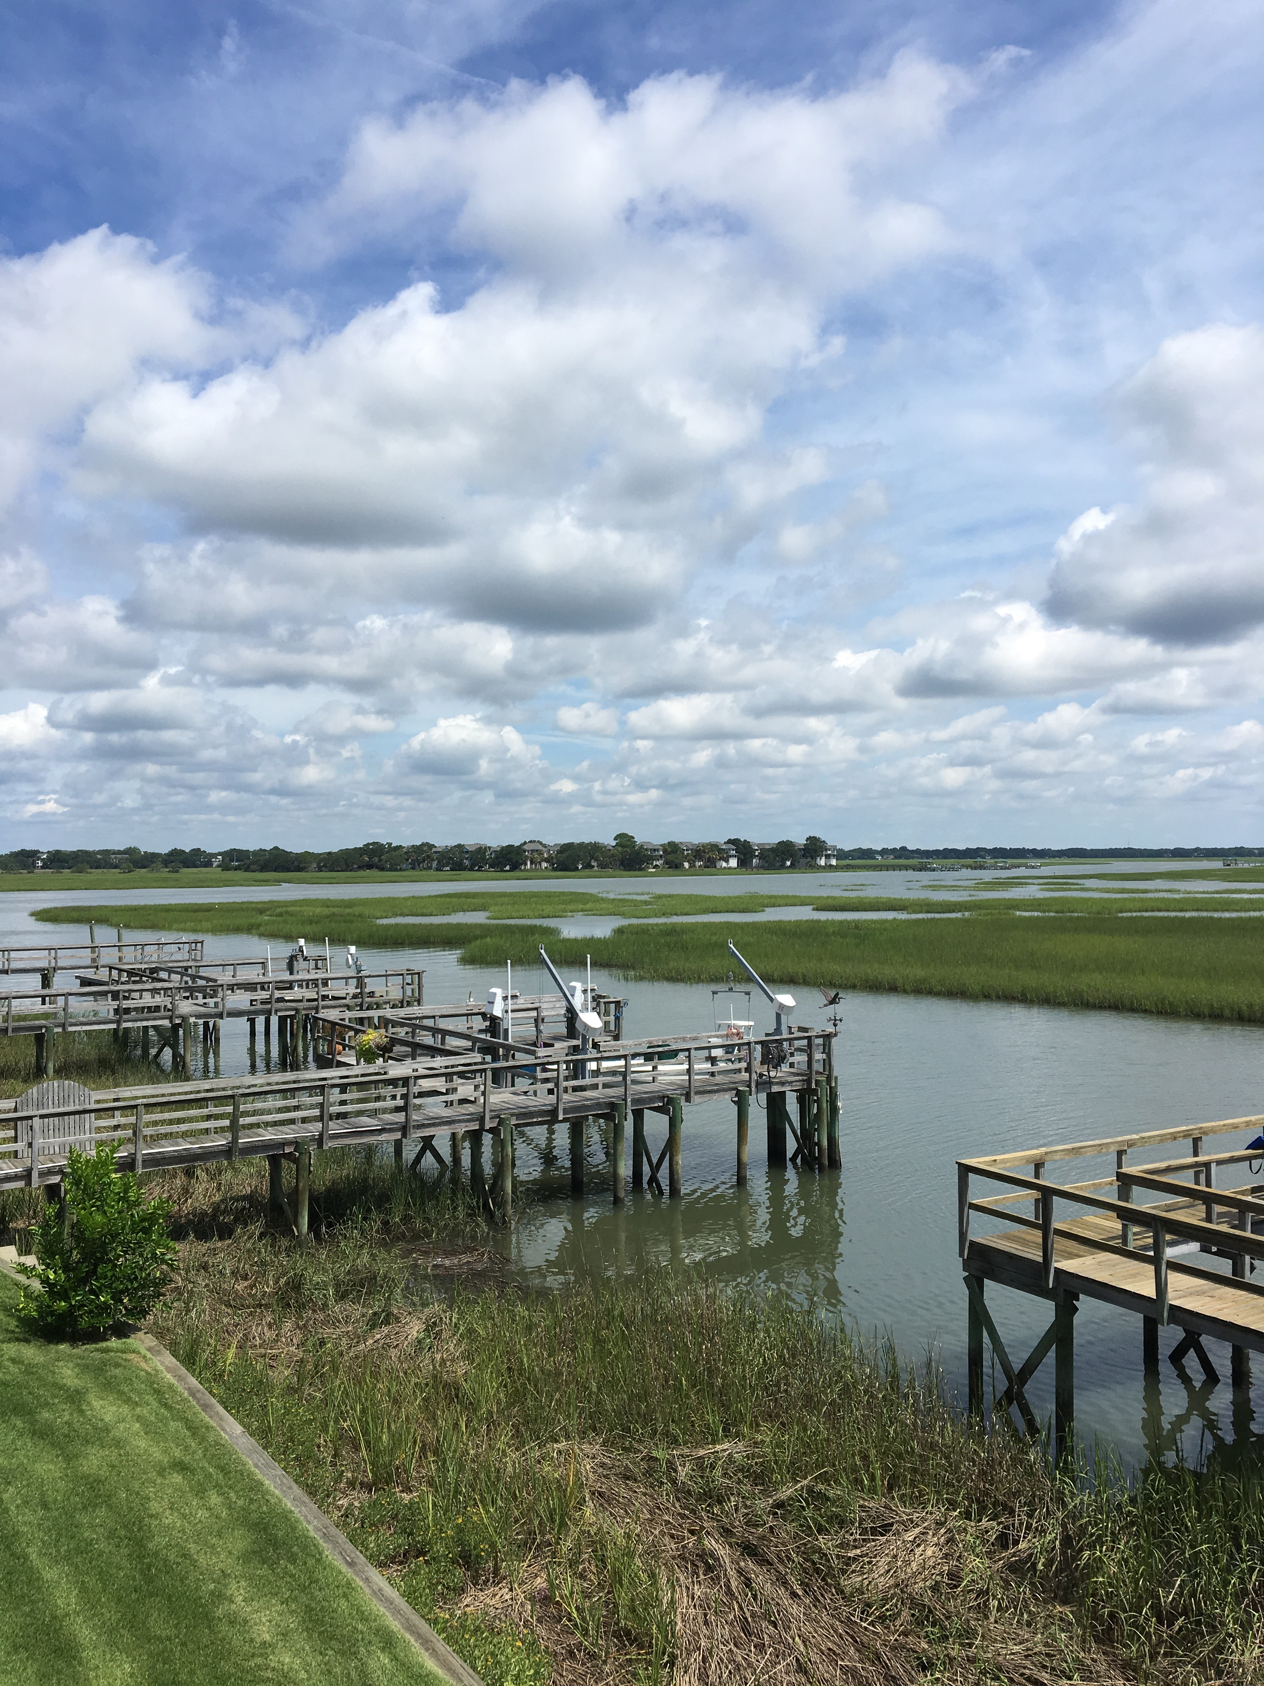

Agent Preview November 9th from 11-2
Light Refreshments will be served
Alan Kleinfeld, Realtor – Ellen O'Neil Realty
alan@arrivemanagement.com
843.638.3063

2210 Folly Rd

Offered at $674,900

Do you want to feel as if your life is a vacation, with gentle breezes and million-dollar views? This waterfront townhouse has it all! Beautiful scenes from all FOUR balconies, including the screened porch right off the open, airy living room. At your backdoor, a private dock with brand new boat lift. The dining room/library features large windows with captivating water views. The family room is large and features a back wall full of windows with magnificent water scenes, hardwood floors, built-in shelves, and media center. At the heart is a new, vented gas fireplace. The open floorplan kitchen is perfect for any cook and includes a large island. The Master Suite has its own private balcony, for watching sunrises or spotting dolphin in the deep water creek.
New boat lift, new elevator and low flood insurance.

MLS #17018126

Water Front Point
  - 3 Bedroom, 2.5 Bath

