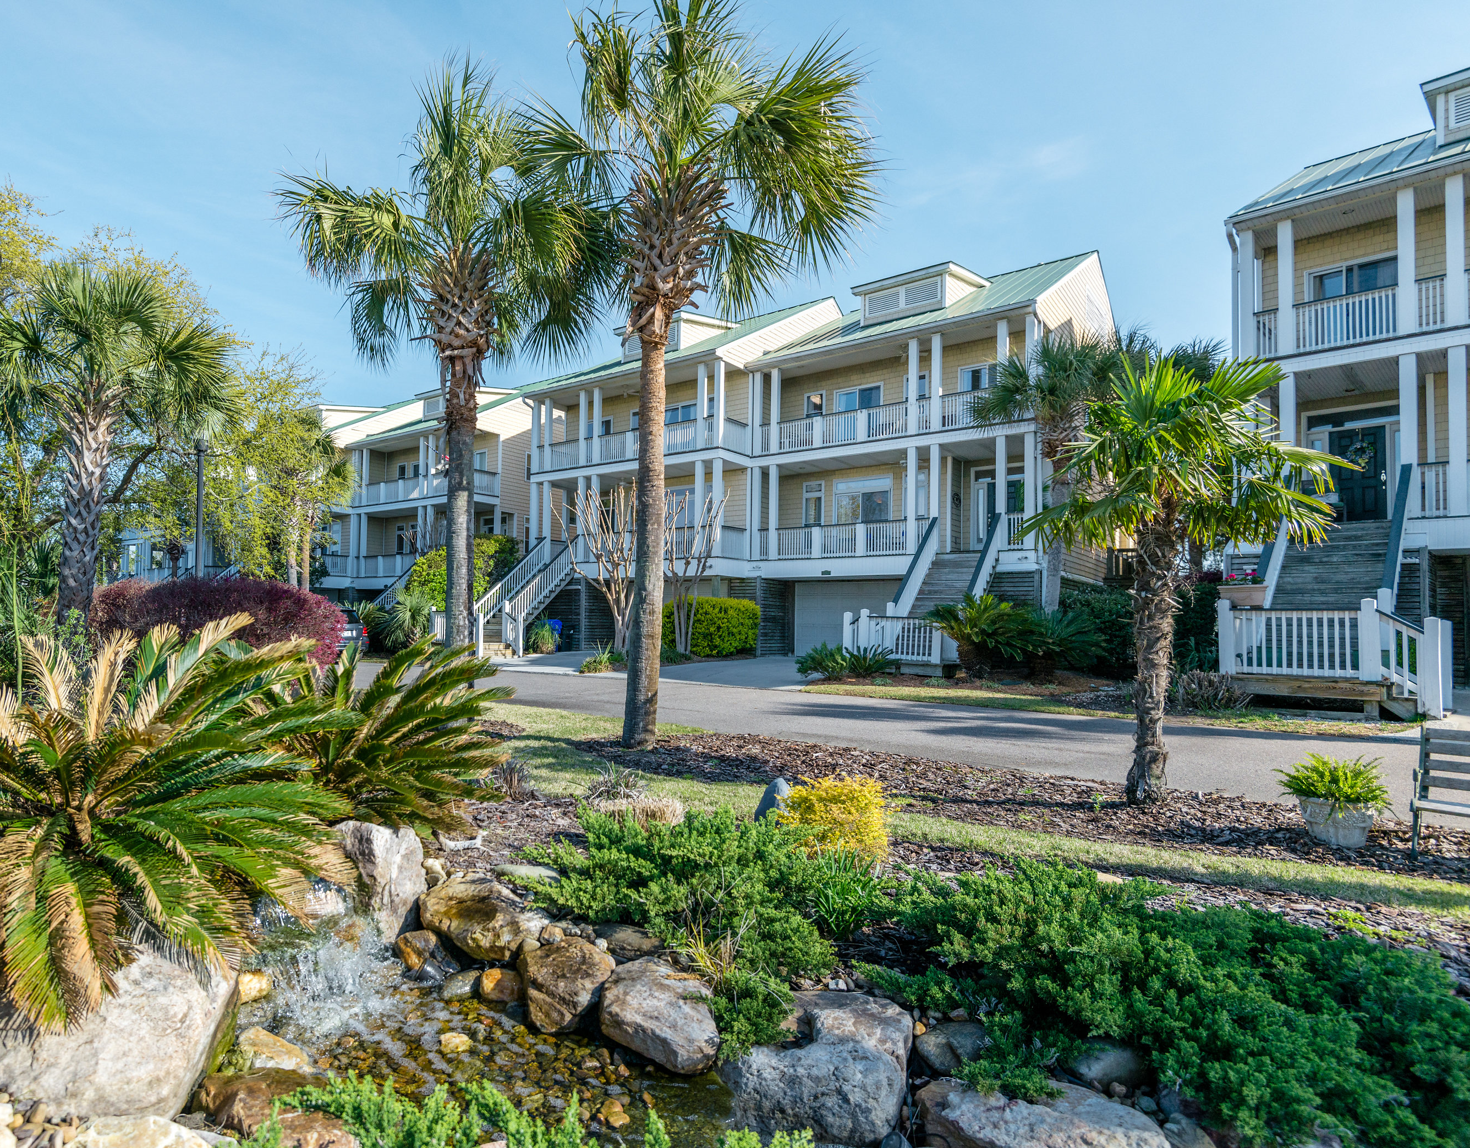
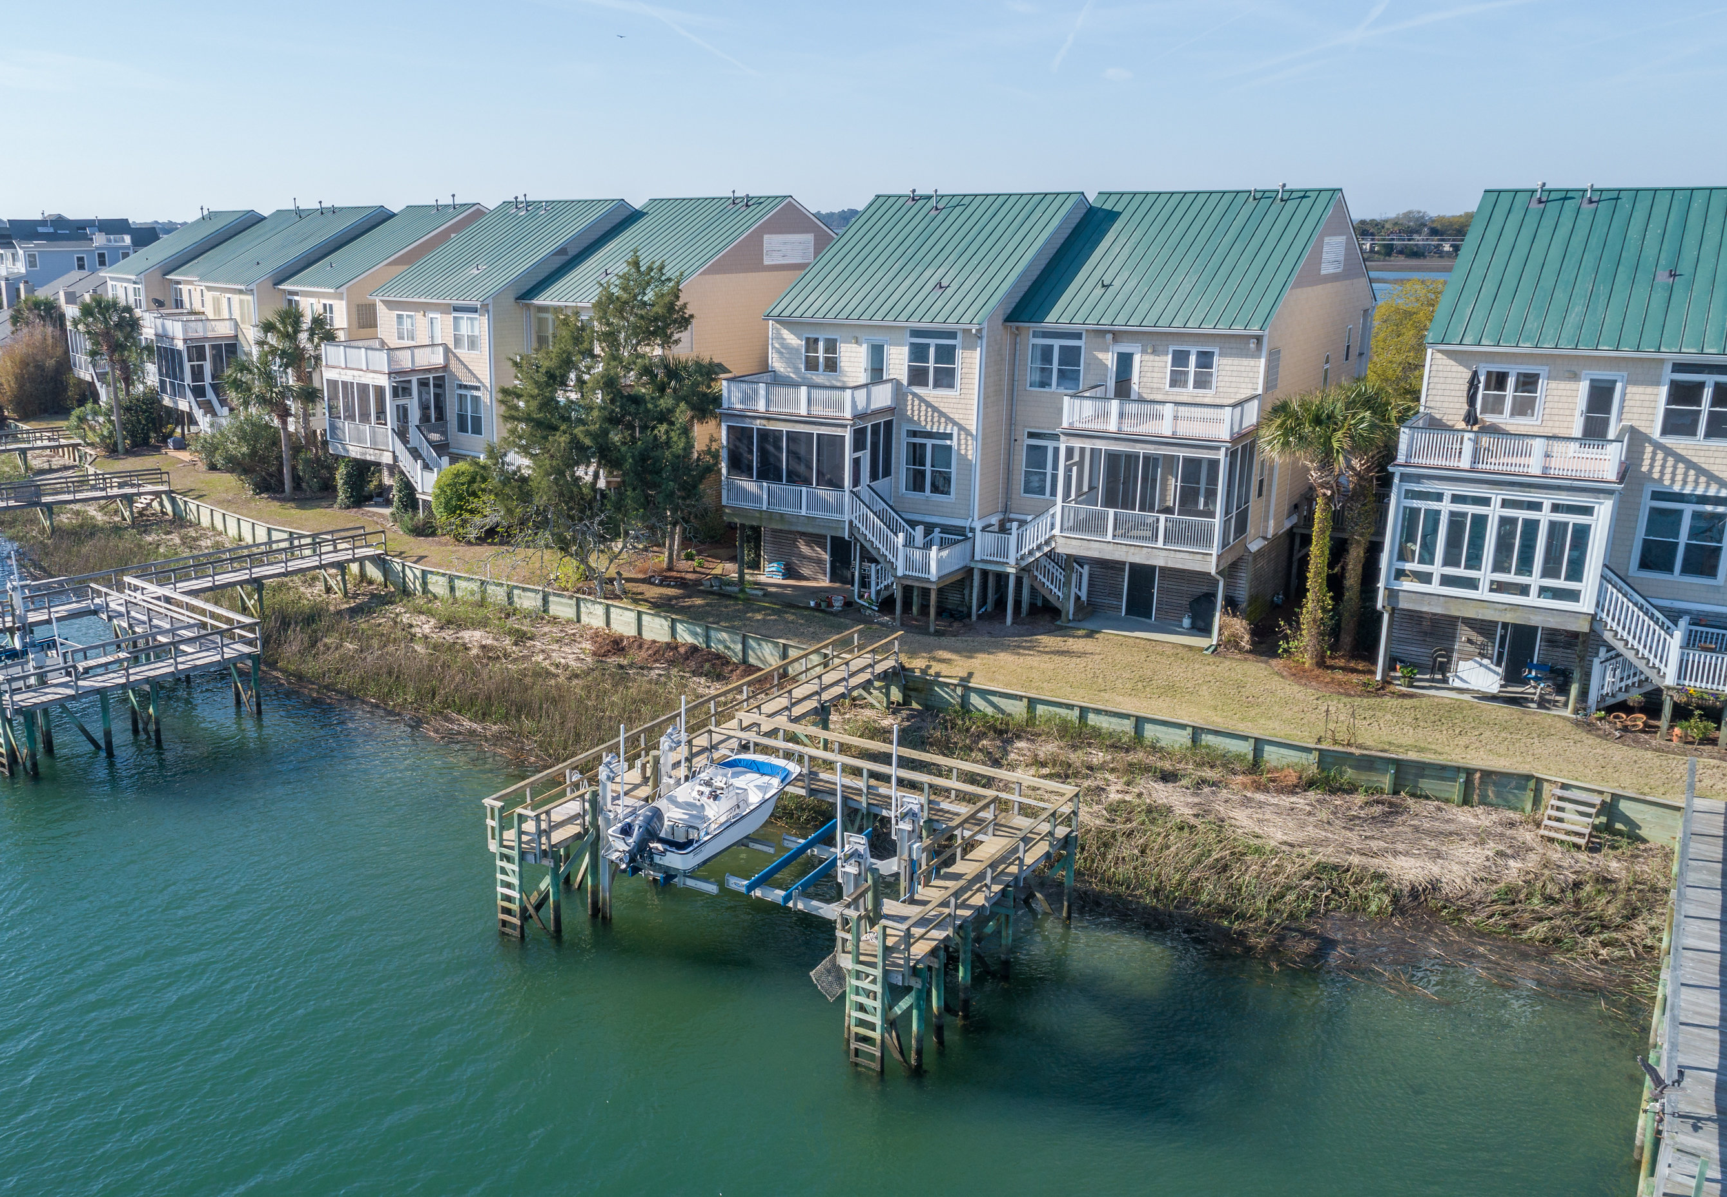

Rarely available! The greatest Folly location with the best views! This waterfront townhouse has it all. Beautiful scenes from all four balconies, including the screened porch off the living room. At your backdoor, a private dock with new boat lift. The dining room/library features large windows and captivating views. The large family room showcases a wall full of windows with magnificent water scenes, hardwood floors, built-in shelves, media center, and in the middle, a new, vented gas fireplace. The open floorplan kitchen is perfect for any cook and includes a large island. Out back, enjoy your covered patio, right off the huge garage. All of the bedrooms upstairs highlight gorgeous views and access to balconies. The Master Suite has its own private balcony, for watching sunrises or spotting dolphin in the deep water creek.

New boat lift, new elevator and low flood insurance.

MLS #17018126

Water Front Point

2210 Folly Rd

Back On Market!

Offered at $669,900
alan@arrivemanagement.com
843.638.3063
Alan Kleinfeld, Realtor – Ellen O’Neil Realty
  - 3 Bedroom, 2.5 Bath

