Agents Only Open House
This Week
Wednesday ** January 14 ** 1:00pm-3:00pm

2217 Beckenham Drive
$875,000
MLS#1415895 *** $75,000+ PRICE REDUCTION!
Leave Your Business Card for Multiple Drawings

Elevator * Luxury Executive-Style Family Home
3-car Garage * High-end Finishes * Flex Spaces * Workshop
Master Suite on Main Living Level * Ground floor Side Door Access
Well-Maintained * Move-in Ready * Shows Like a Model
Exterior repainted 2013 * AHS Home Warranty
4,903+ finished square feet

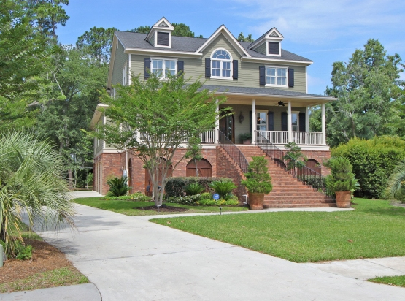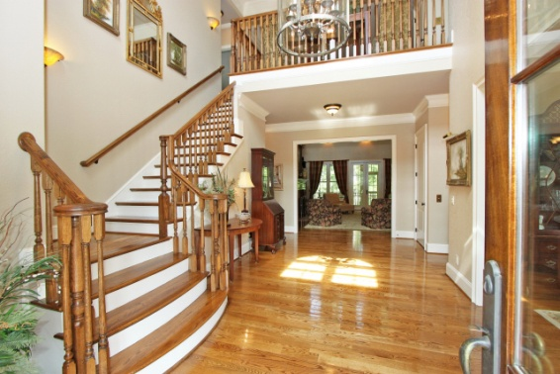

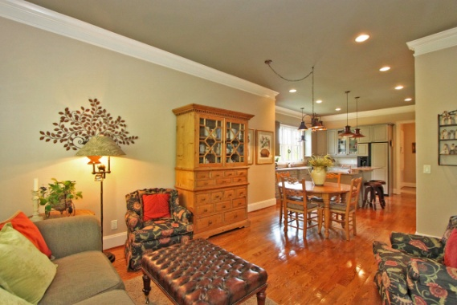

Directions ~ Mount Pleasant. Park West. Masonborough (2nd Entrance)
At Stop Sign turn left on Beckenham by newly completed Masonborough Park @ Crabbing Dock.
Home on left. Call Kay Minson as Needed * 843-697-2970 * Carolina One Real Estate

