Agent Open House
Mount Pleasant
This Week!
Tuesday ** February 10 ** 11:00am-1:00pm
Multiple Drawings ** Light Lunch Available

2217 Beckenham Drive
$865,000
Premier Masonborough Subsection
Park West
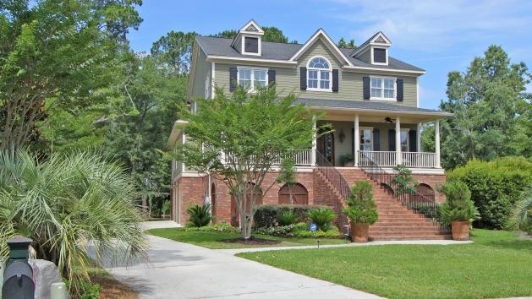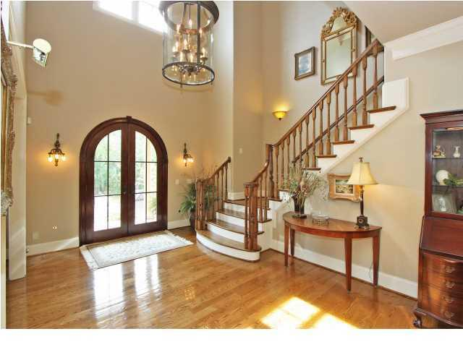

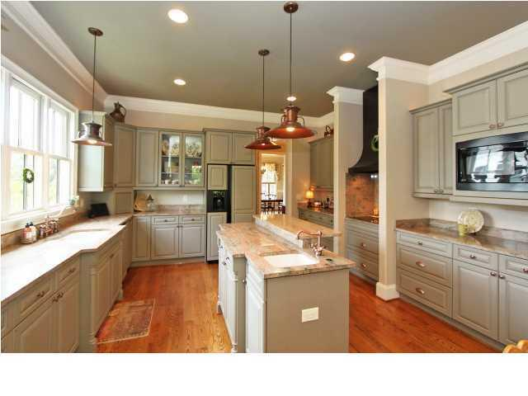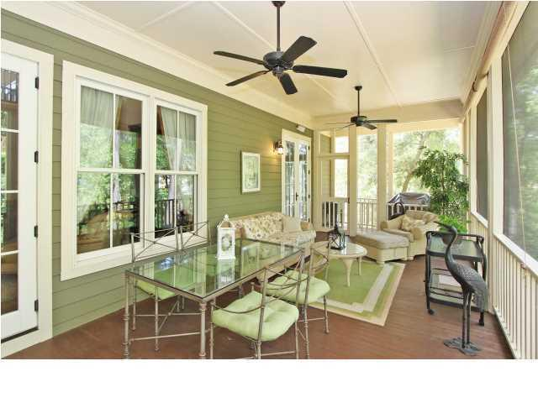
Luxury Comfort Executive Home * Master Suite on Main Level
Elevator * 3-car Garage * Multiple Flex Spaces * Workshop * AHS Warranty
Ground floor Side Door Access * Well-Maintained * Exterior Repainted 2013 *
4,903 + finished square feet * Can Close Quickly!
Masonborough (2nd Entrance). At Stop Sign turn left on Beckenham by new Masonborough Park & Crabbing Dock. Home on left. Kay Minson. 843-697-2970. Carolina One Real Estate.

