Broker Only Open House
This Week
Thursday ** August 21 ** 11am-2pm

2217 Beckenham Drive
$892,000
MLS#1415895 *** $50,000+ PRICE REDUCTION!

Leave Your Business Card for Multiple Drawings Light Lunch Available

Tour this Luxury Executive-Style Family Home w/ Elevator
Uncommon High-end Finishes & Flex Spaces
Well-Maintained * Move-in Ready * Shows Like a Model

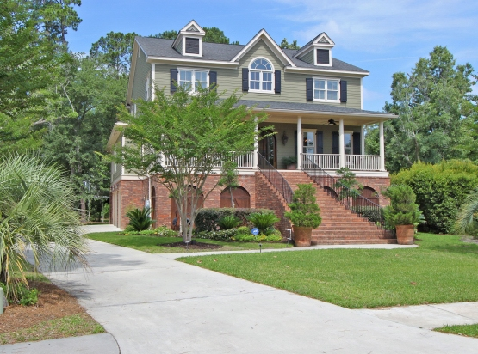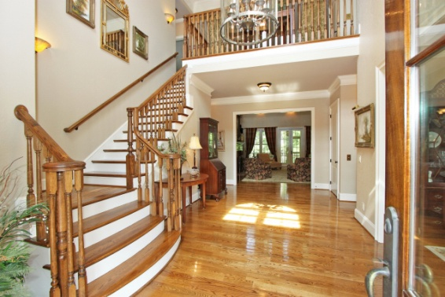

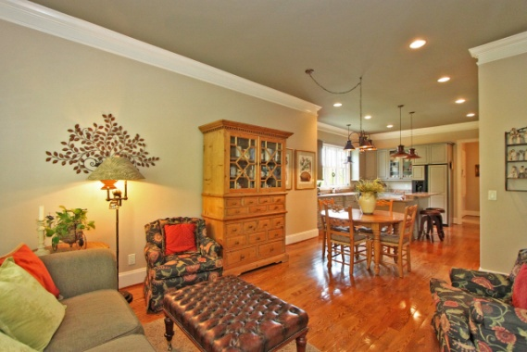
Directions ~ Mount Pleasant. Park West. Masonborough (2nd Entrance)
At Stop Sign turn left on Beckenham by newly completed Masonborough Park @ Crabbing Dock.
Home on left. Call Kay Minson as Needed * 843-697-2970 * Carolina One Real Estate

