Agent* Open House
Wednesday, October 15 ~ 11:00am - 1:00pm

2217 Beckenham Drive
Masonborough at Park West
Elevator ~ Private Master Suites ~ 3-car Garage ~ Flex Spaces Galore
Award-Winning Schools ~ See MLS#1415895 for Interactive Floor Plan & Video
Gorgeous ~ Move-in Ready ~ Well-Maintained

$892,000

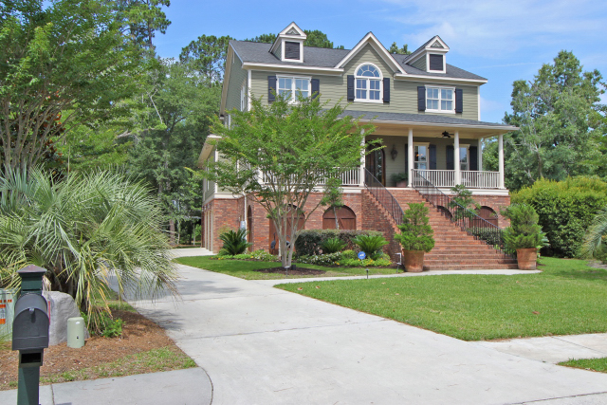
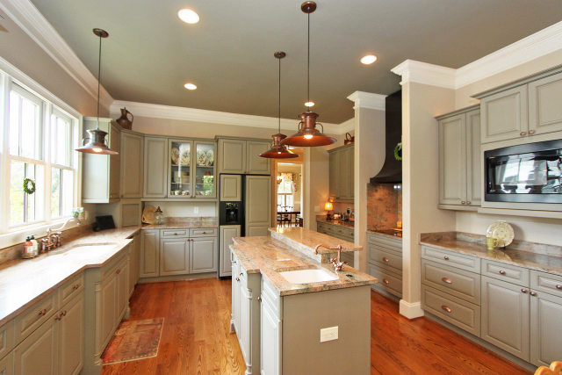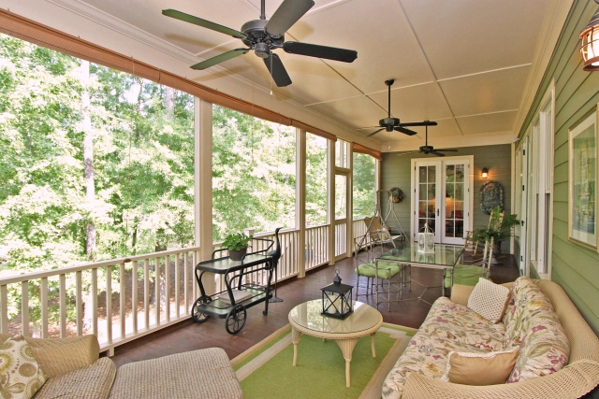

*Tour & Leave Your Card
10 drawings will be held for
$25 gift card to Stella Nova Salon & Spa!

Kay Minson, Realtor ~ Carolina One Real Estate ~ 2713 Hwy. 17 North ~ Mt. Pleasant, SC 29466
Call or Text: 843-697-2970 for Directions ~ kminson@carolinaone.com

