JOIN US!
AGENT OPEN HOUSE
THURSDAY * MARCH 20 *
11:00AM-1:00PM
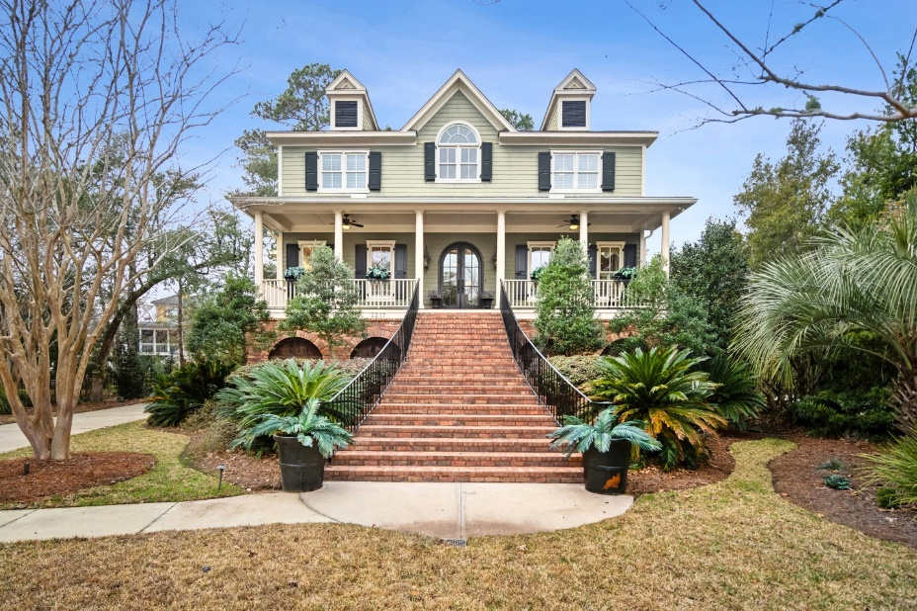
2217 BECKENHAM DRIVE
MOUNT PLEASANT, SOUTH CAROLINA
4,953 SQFT+ $1,724,900

LUXURY COMFORT PRIVACY STORAGE 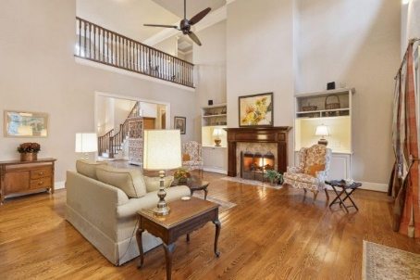 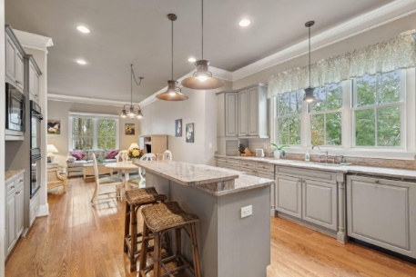 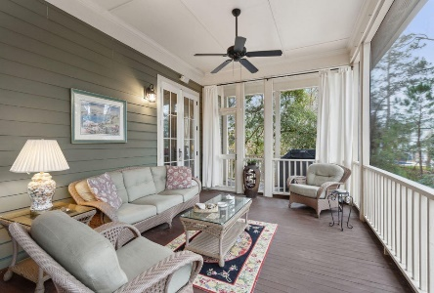

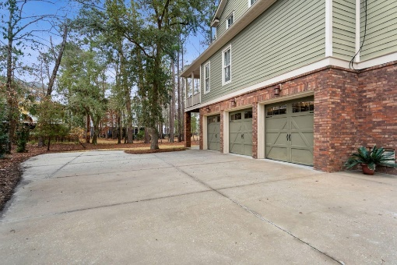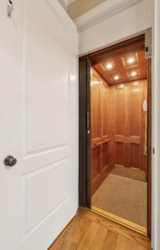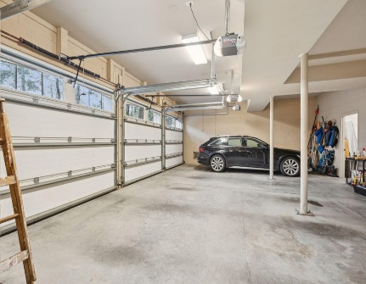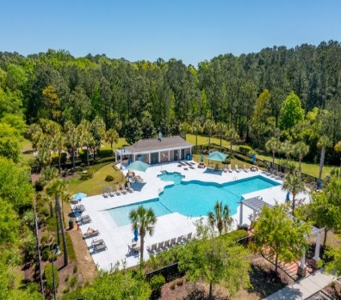
Call or Text Kay Minson. Listing Agent. Carolina One Real Estate. 843.697.2970

