JOIN US!
BROKER OPEN HOUSES
Masonborough at Park West
This THURSDAY April 3rd
11:00AM - 1:00PM
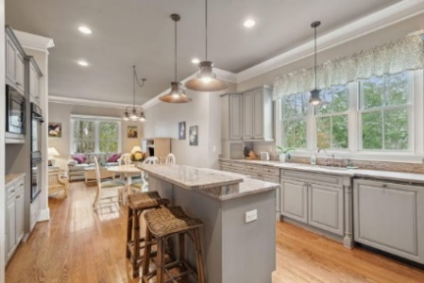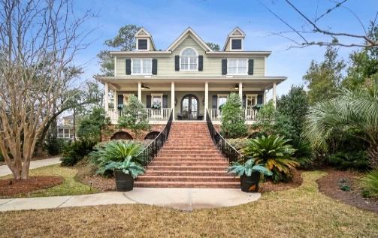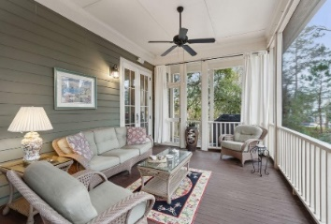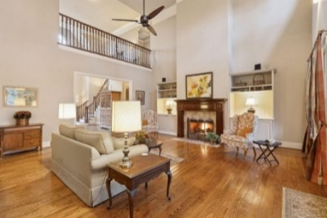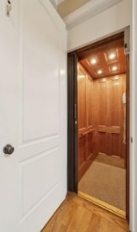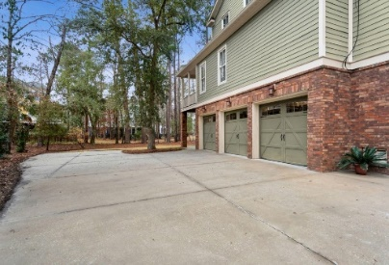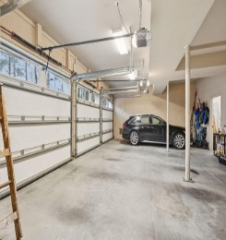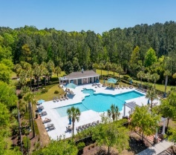
2217 BECKENHAM DRIVE
4,953 SQFT+ Listed for $1,695,000
LUXURY COMFORT PRIVACY STORAGE
Tour & receive your choice of one Springtime favor
Cash “surprise” Easter egg, Eid al-Fitr envelope, or Passover treat (supply limited)
Call or Text Kay Minson, Listing Agent. Carolina One Real Estate. 843.697.2970

2292 BECKENHAM DRIVE*
Exclusive Broker Open House
Waterfront on the Wando Listed for $3,000,000
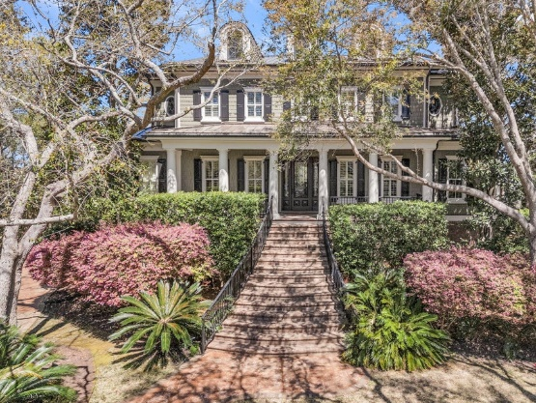
*Access Details: Contact Bobette Fisher, Listing Agent. Carolina One Real Estate. 843.224.6375

