Celebrate Cinco de Mayo with Us!
AGENT OPEN HOUSE
MONDAY * MAY 5 * 1:00PM-3:00PM
FIVE Separate Drawings will be held to Win a $25 Gift Card to SOL Southwest Kitchen!
Tour and Leave your Business Card. One win per Licensed Agent.
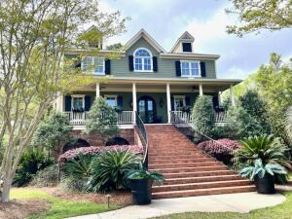
2217 BECKENHAM DRIVE * MASONBOROUGH @ PARK WEST
4,953 SQFT+ $1,595,000 MLS #25004670

LUXURY LOCATION PRIVACY STORAGE
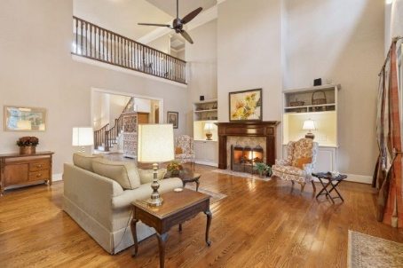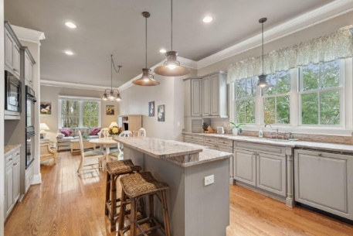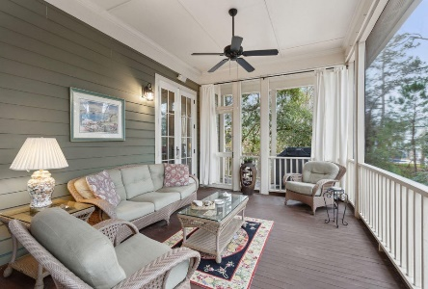
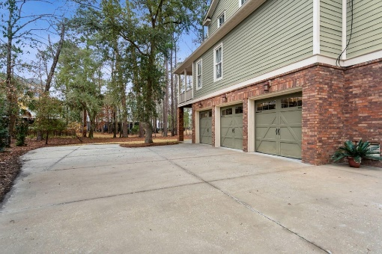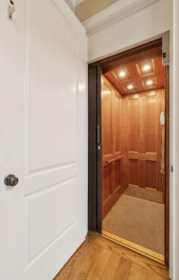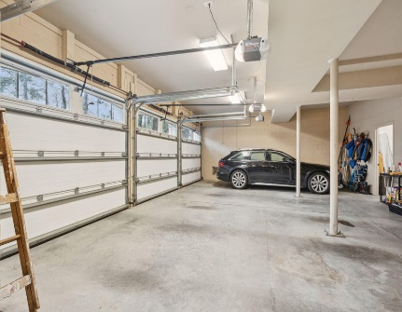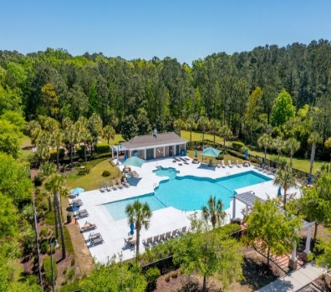

Call or Text Kay Minson. Listing Agent. Carolina One Real Estate. 843.697.2970.

