JUST LISTED - Mt Pleasant New Construction

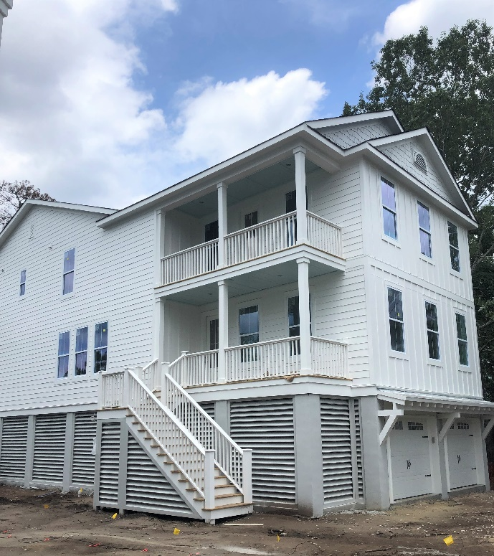
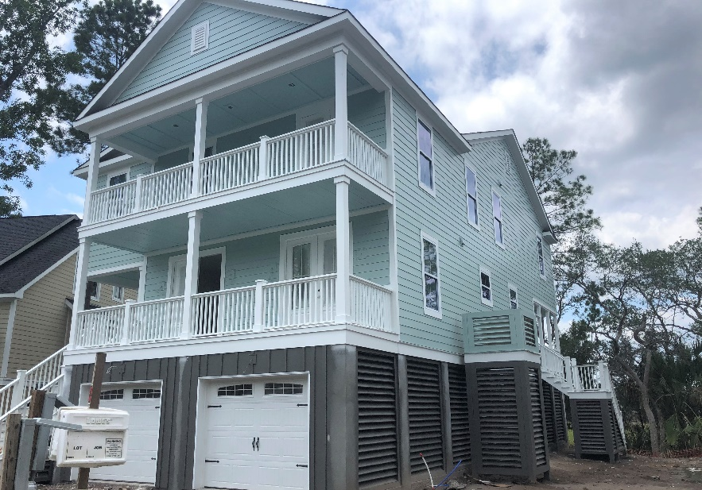

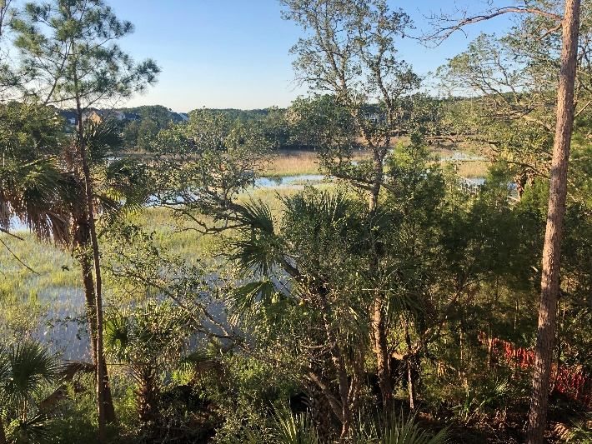
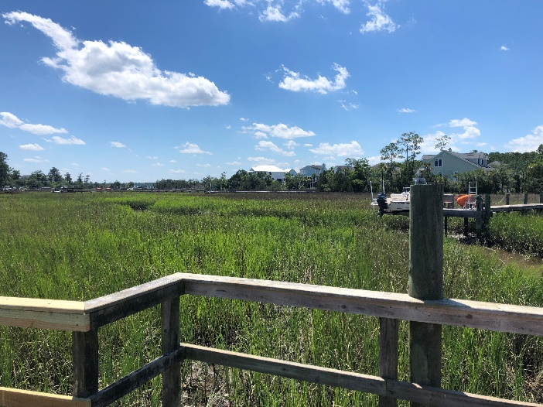

2267 and 2269 Palmetto Marsh Cir
Mt Pleasant, SC 29466
These new construction homes are the epitome of southern living, offering an open floor plan, indoor/outdoor living and a personal design touch. Key features include:
- 5 Bedrooms, 4 Bathrooms / 4 Bedrooms, 4.5 Bathrooms
- 3,437 / 3,294 SF with elevated foundation, shared dock
- Elevator ready
- Andersen Silverline impact resistant windows
- Gourmet kitchen with island, gas cooktop, soft close hinges, Bosch appliances and more
- Each home has a downstairs bedroom, perfect for multi-generational living
- Heavy trim package includes mission style trim and shiplap
- Hardwood floors downstairs, loft, master bedroom
- Tile baths and shower surrounds and frameless shower doors
- The Pointe has a deep-water dock on the Wando River
- Rivertowne Country Club boasts Charleston’s only Arnold Palmer Signature golf course and a robust amenity center
- Estimated completion August/September 2019
- See full listing for more information

Carrie Newbern
Wilcat Realty
843-557-9001
carrienewbern@gmail.com
2269 Palmetto Marsh
$898,900
MLS # 19018175
2267 Palmetto Marsh
$914,500
MLS # 19018173

