Multi-Home Open House in Rivertowne!
Sunday, 10/6, 1-4pm

*Drawing *Appetizers *Pelicans Snoballs
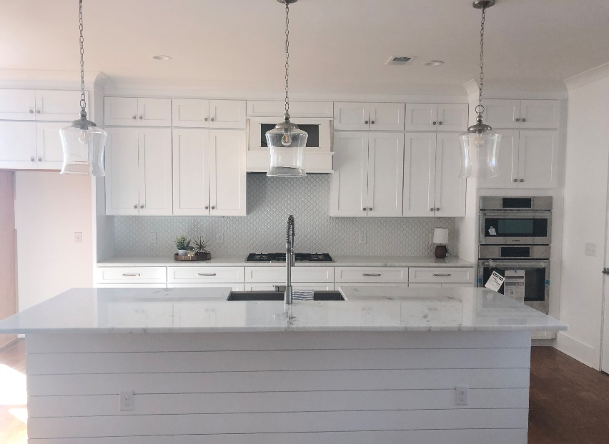
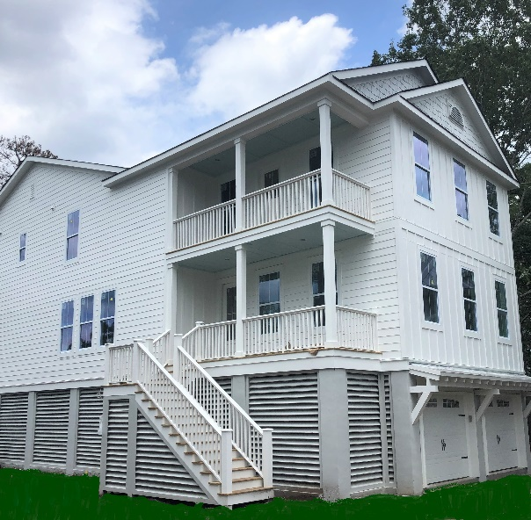

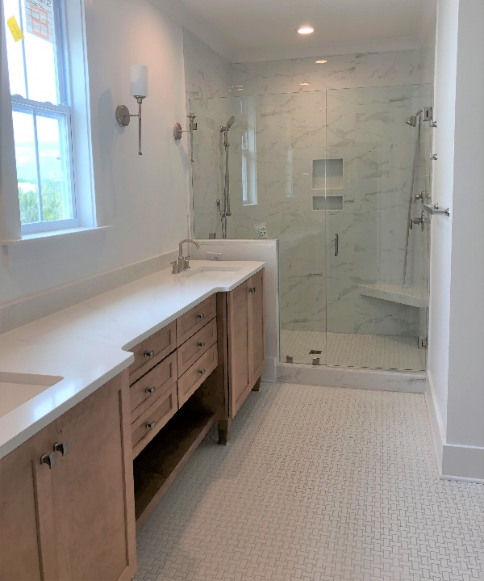
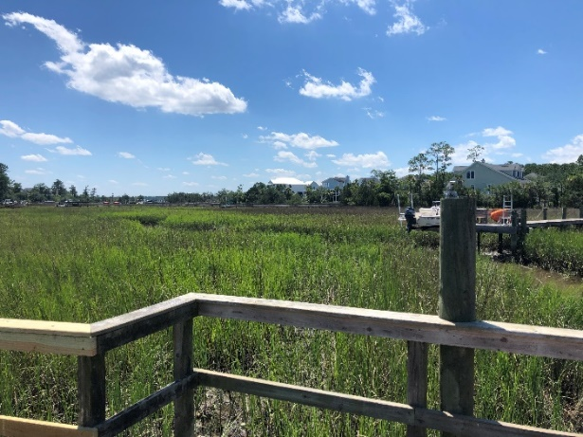

2269 Palmetto Marsh
$898,900
MLS # 19018175
2269 Palmetto Marsh Cir
Mt Pleasant, SC 29466
This new construction home is the epitome of southern living, offering an open floor plan, indoor/outdoor living and a personal design touch. Key features include:
- 4 Bedrooms, 4.5 Bathrooms
- 3,294 SF with elevated foundation, shared dock
- Elevator ready
- Andersen Silverline impact resistant windows
- Gourmet kitchen with island, gas cooktop, soft close hinges, Bosch appliances, shiplap and more
- Dual master bedrooms, one downstairs, perfect for multi-generational living
- Heavy trim package includes mission style trim and shiplap
- Site-finished wood floors downstairs, loft, master bedroom
- Tile baths and shower surrounds and frameless shower doors
- The Pointe has a deep-water dock with boat slips on the Wando River
- Rivertowne Country Club boasts Charleston’s only Arnold Palmer Signature golf course and a robust amenity center

Carrie Newbern
Wilcat Realty
843-557-9001
carrienewbern@gmail.com

