226 Clouter Creek Drive
Wando, SC 29492
MLS# 16000628
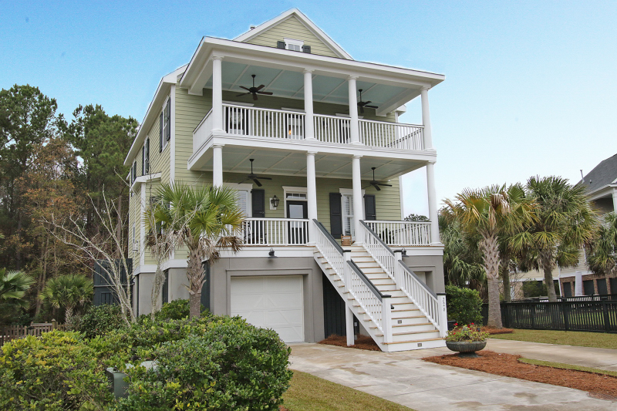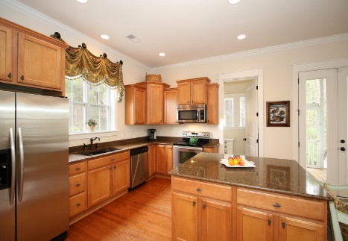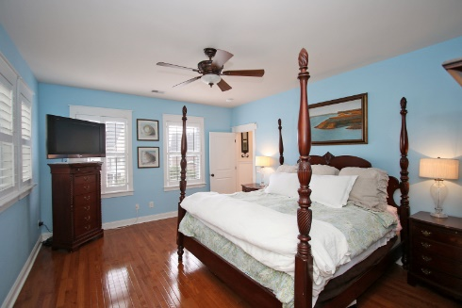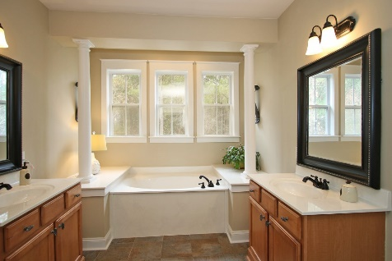
Beautiful 3 Bedroom, 2.5 Bath Charleston Single Home. Charm exudes throughout the home with gleaming hardwood floors, and tons of natural light. Enter off the full front porch into the light and airy living area complete with a fireplace. A flex space is located to the right which would be perfect for a formal Dining Room or Office. The Kitchen is open to the Family Room and features granite counter tops, stainless steel appliances, and a large island for additional counter and cabinet space. Enjoy dining with large groups in large Eat-In Dining Area or a cup of coffee on the Screened-In Porch directly off the Kitchen. Upstairs, you will find the Master Suite with a luxurious Master Bath with soaking tub where you can relax, his and hers sinks, large walk-in shower and walk-in closet. Head to the Master’s private porch for a night cap and star gazing. Two additional bedrooms are upstairs, connected by a full bath, and entry to the second story porch.

