

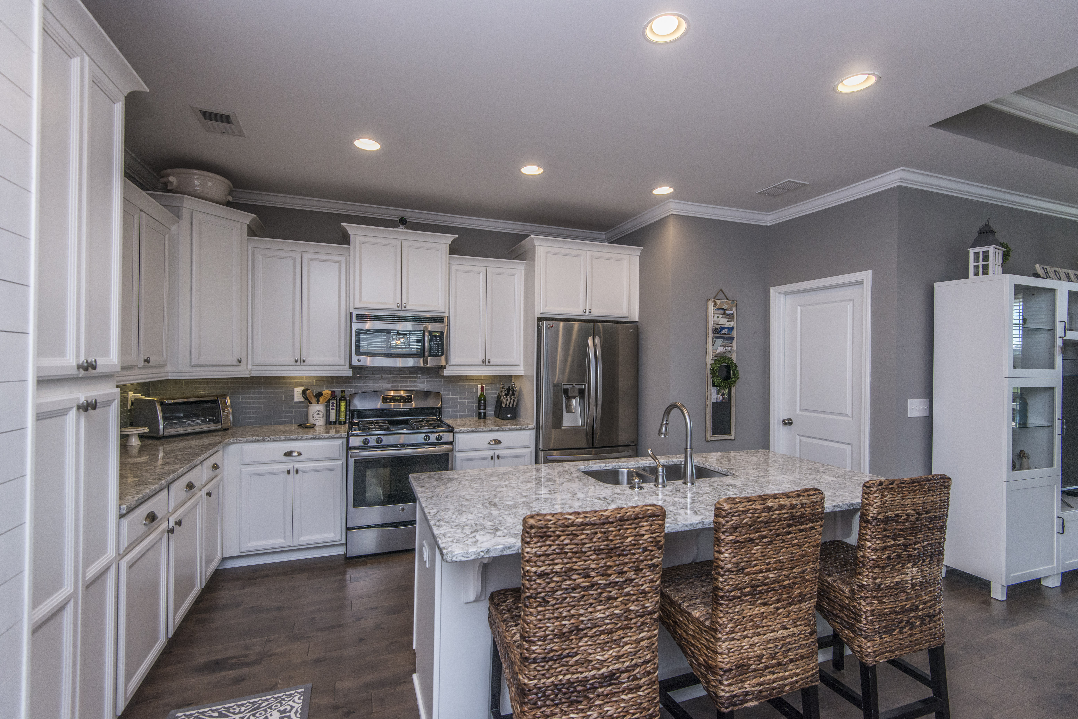
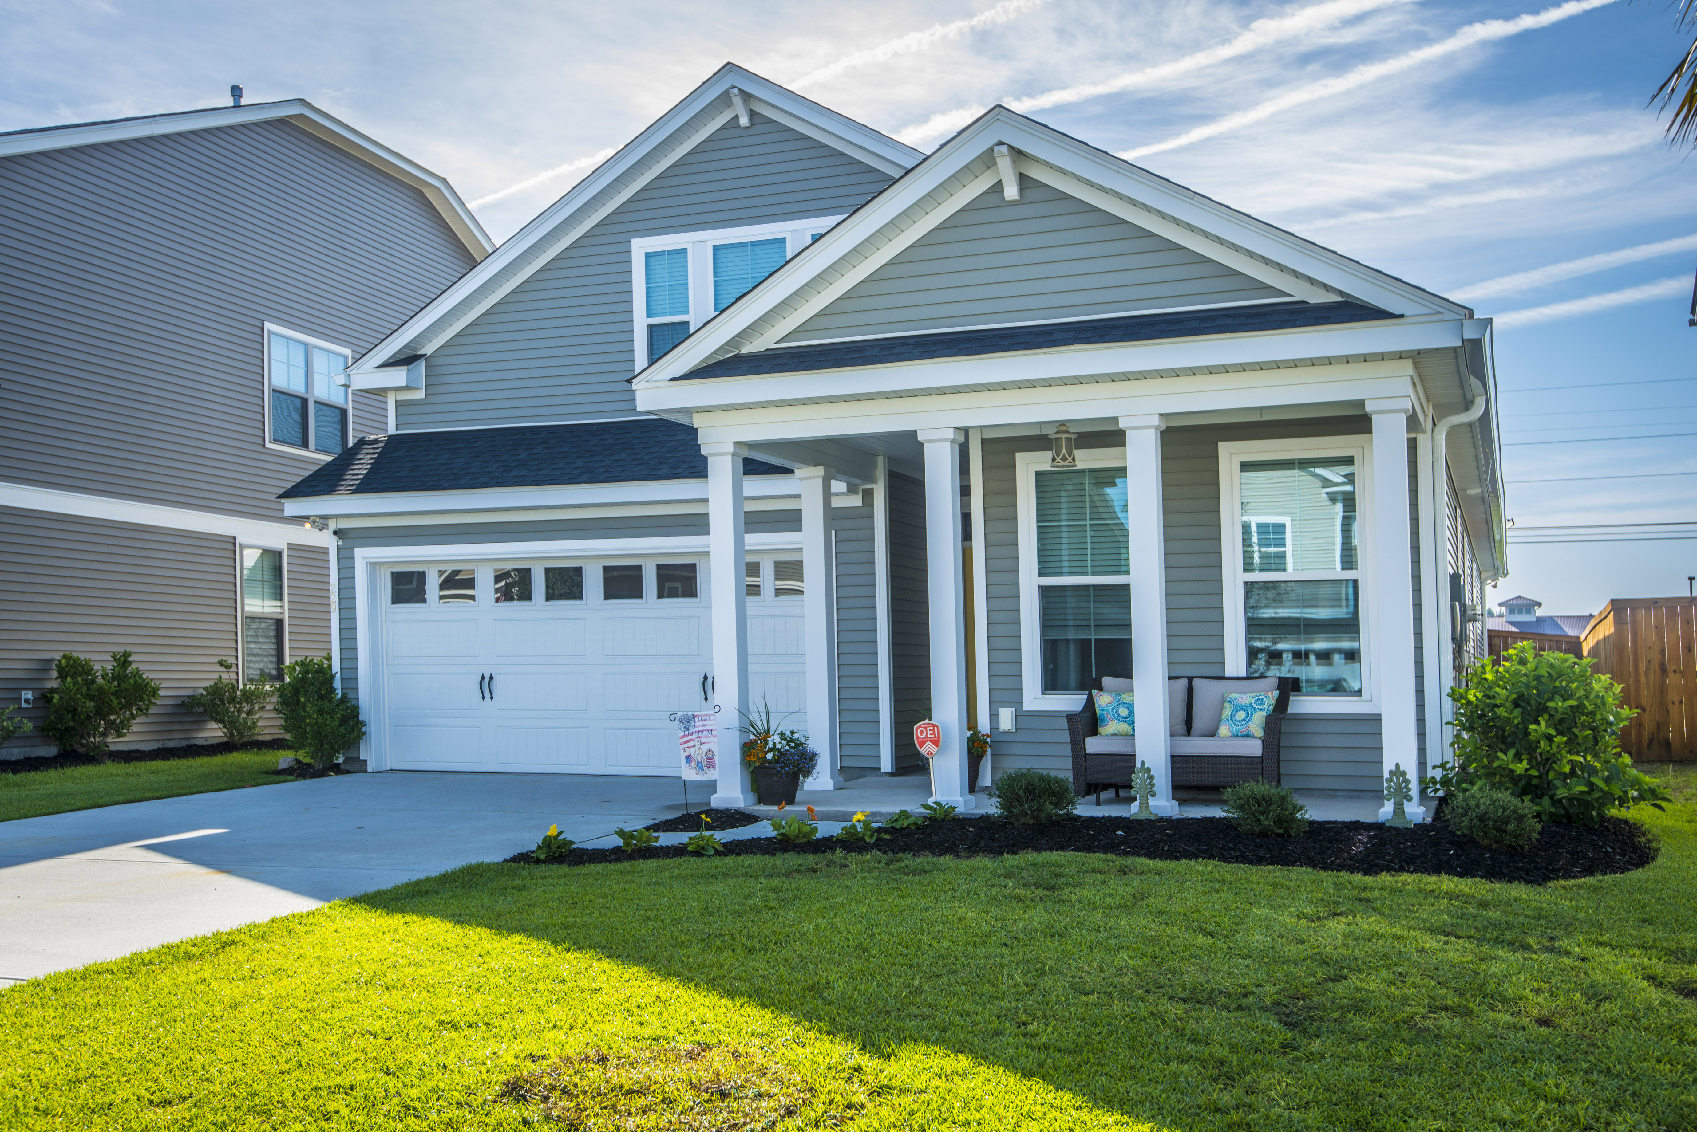
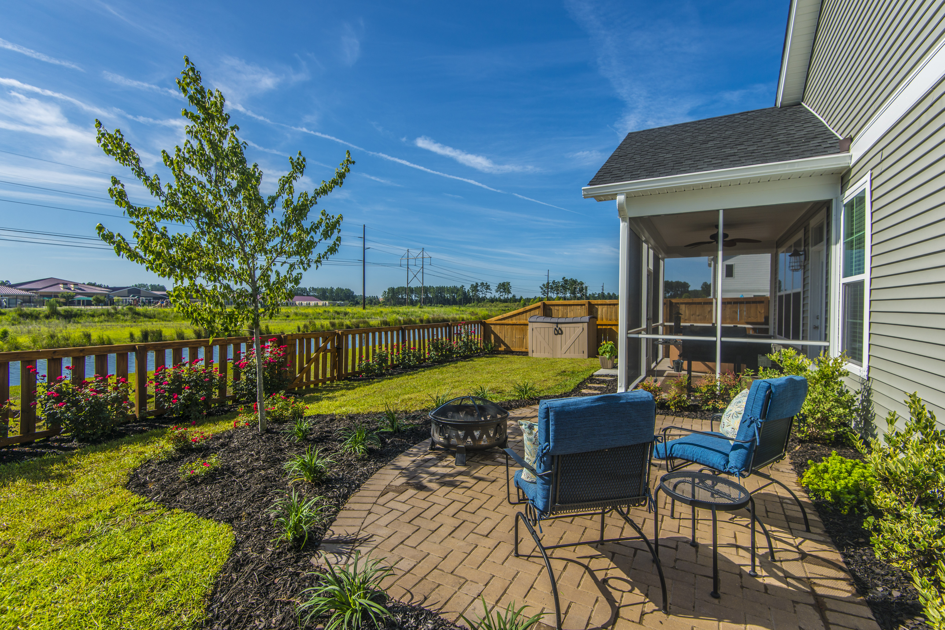
Geri Lipps 843.810.8398
glipps@carolinaone.com
THURSDAY 6/28 10AM-NOON
$50 GIFT CARD
229 Palmetto Walk Cane Bay
Beautiful
One Story
Living with a Fabulous FROG

AGENT OPEN HOUSE
- 2050 Square Feet
- 4BR/3BA
- Kitchen w/SS and Quartz Island
- Engineered Hardwoods In Main Living Areas
- Wood Blinds
- Pond View with Fenced Yard Screen Porch and Patio

