2363 Parsonage Woods Lane
In Park West
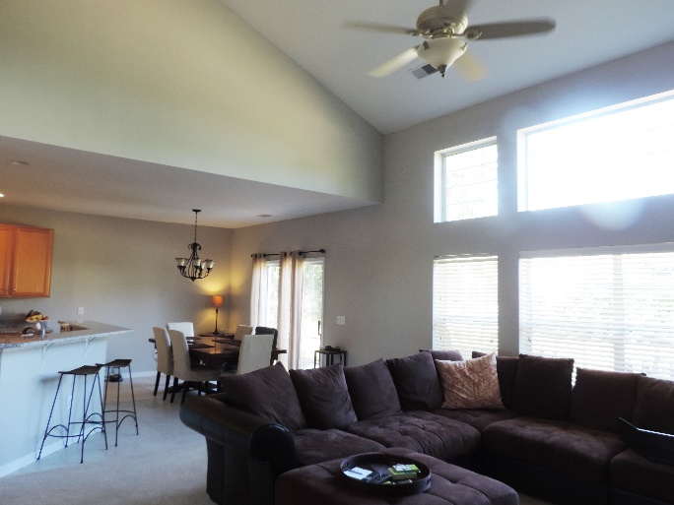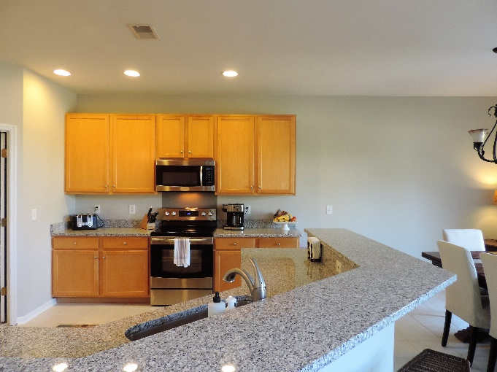
Newly painted, tiled, and updated 4BR 2.5BA, 2,630 sq ft home in Arlington in Park West. Not on the market yet, but will be having an Open House this Sunday, March 13 from 1pm -3pm.
Formal Dining Room, Open Flow between Living Room, Breakfast Area and Kitchen. Kitchen has granite countertops and stainless steel appliances, tiled floor, and a pantry. Breakfast Area opens onto the patio. Living Room has wood burning fireplace and built-in shelves.
Master Suite has lovely bay windows and Master Bath and walk-in closet. Up the winding staircase, there are three more bedrooms. The fourth bedroom has built-in shelving and can be used as an office or flex space.
Contact Kimberly Ritter if interested (843) 693 - 8802

