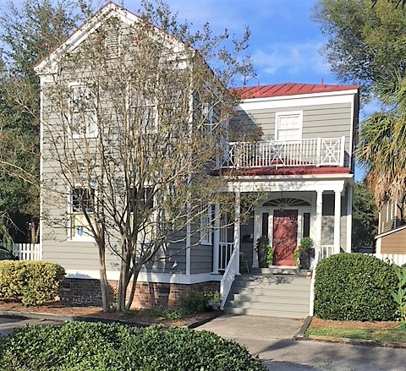
OPEN HOUSE**
Light Lunch Served
Thursday 12/13 12pm-2pm
23 Ascot Aly Charleston 29401
$769,000

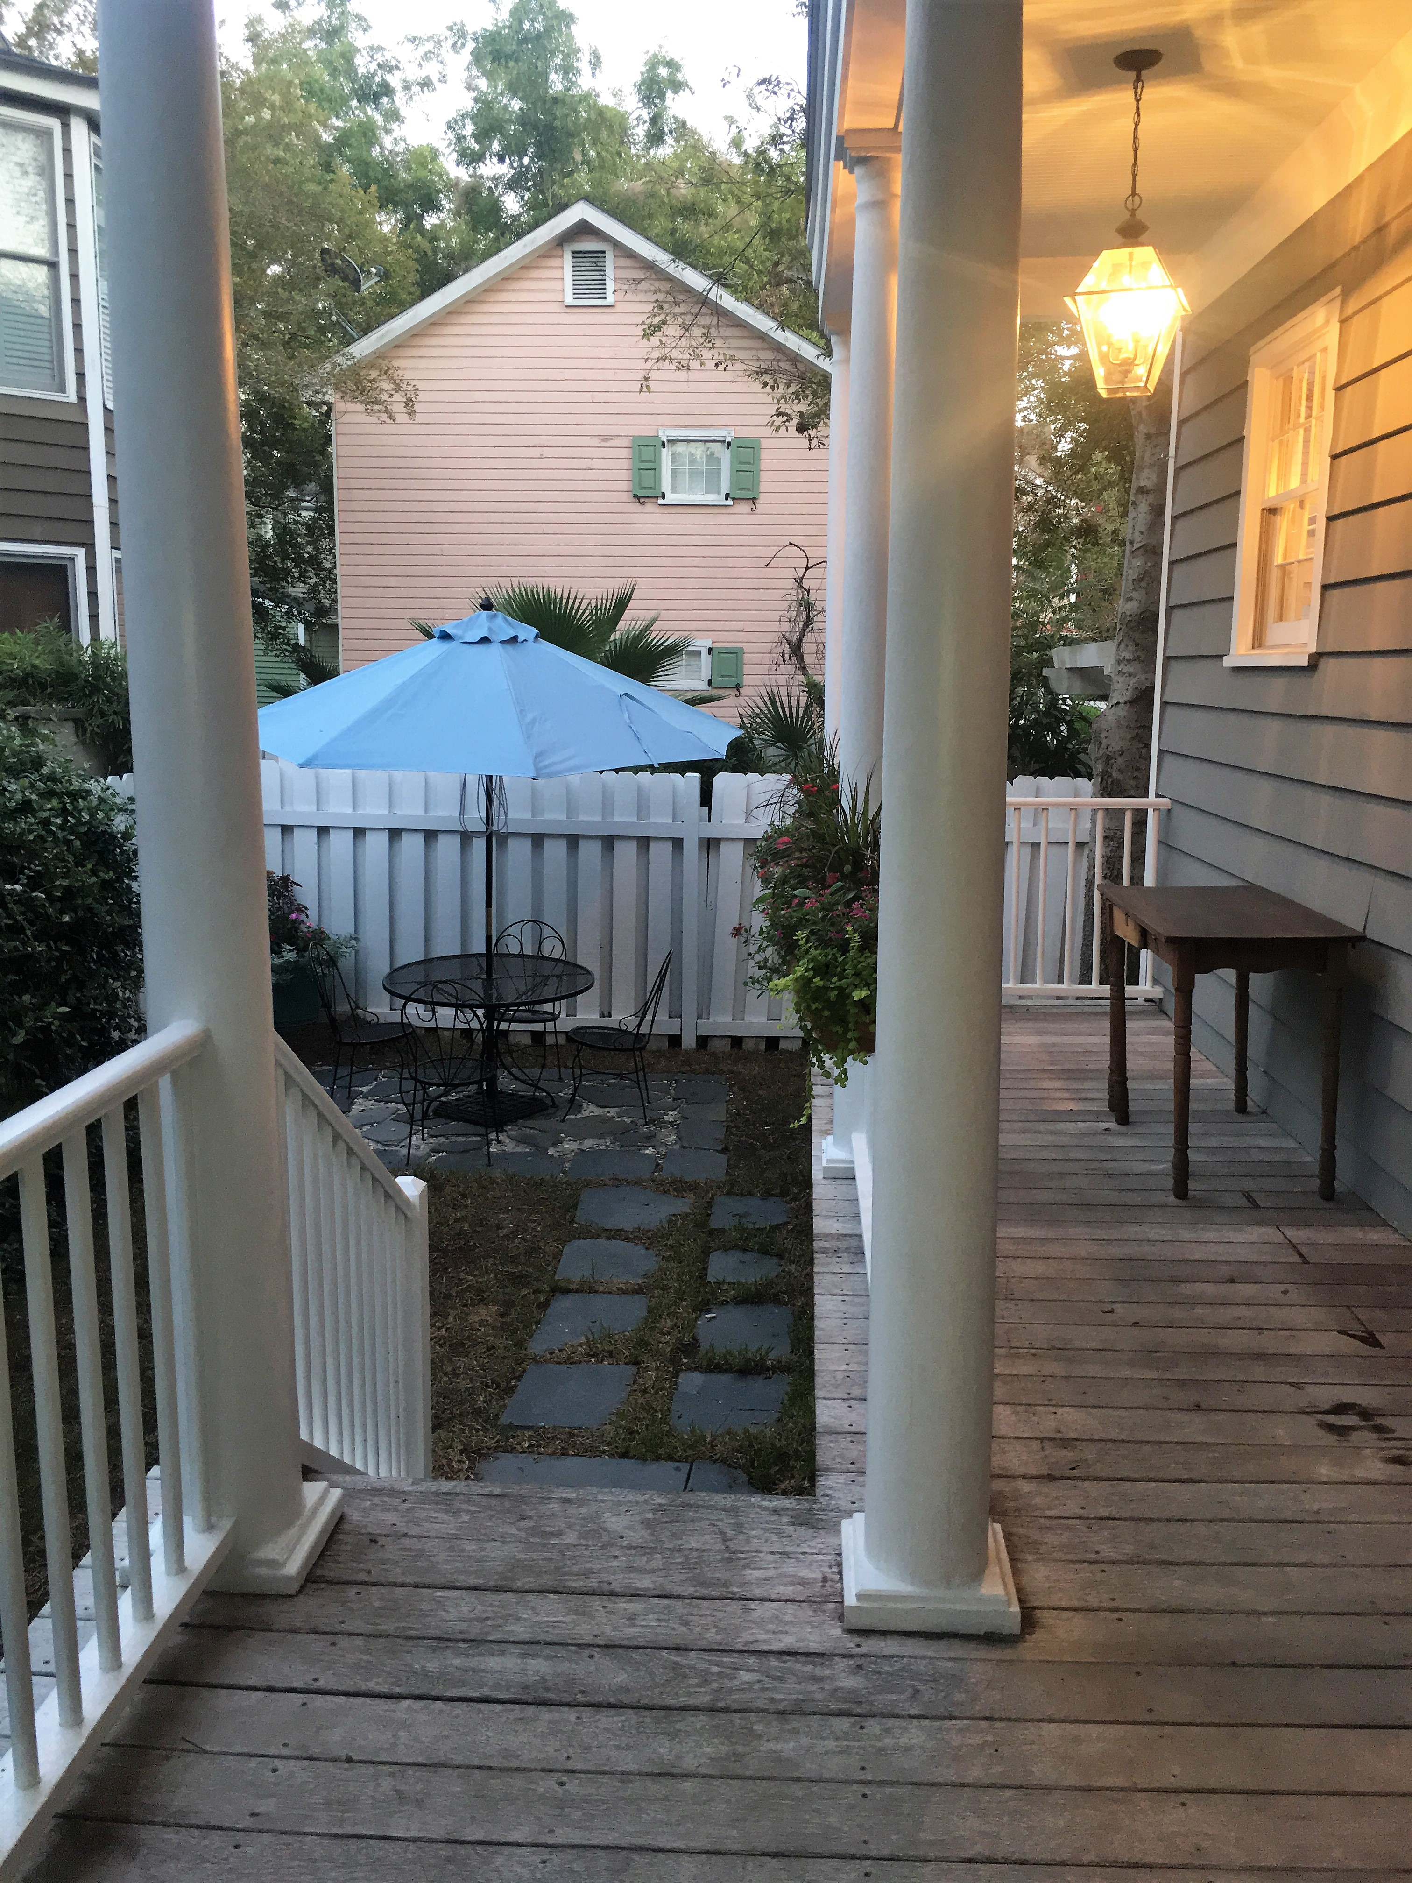
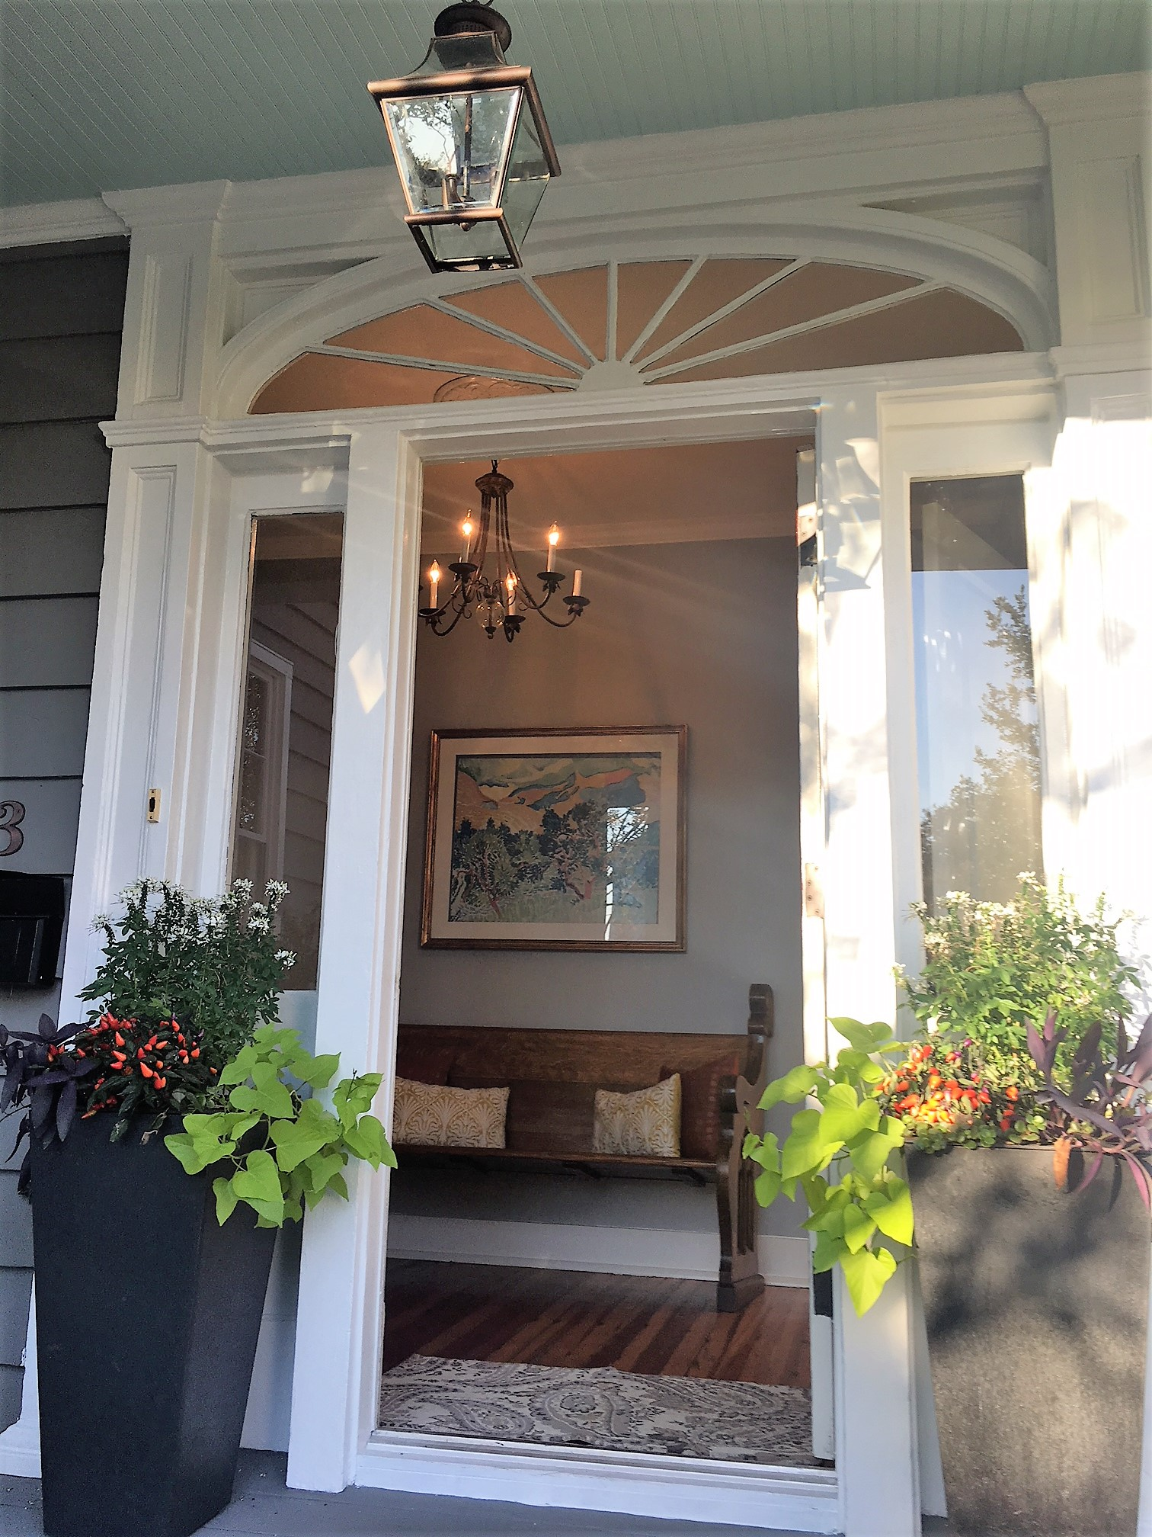

Beautiful Downtown Charleston Home

Walking distance to College of Charleston, MUSC, Cannon Park, Marion Square, Colonial Lake,
King Street and
Numerous Restaurants

1918 SF
3-4 Bedrooms
3 Full Baths

Built in 1892
Heart Pine Floors
10’ Ceilings
3 Porches
3 Fireplaces

Granite Countertops
Stainless Steel Appliances
Freshly Painted Exterior
Freshly Painted Interior

Quiet Courtyard for
Outdoor Entertaining

www.findyourcharleston.com

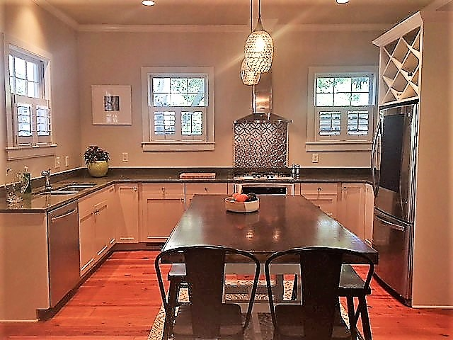

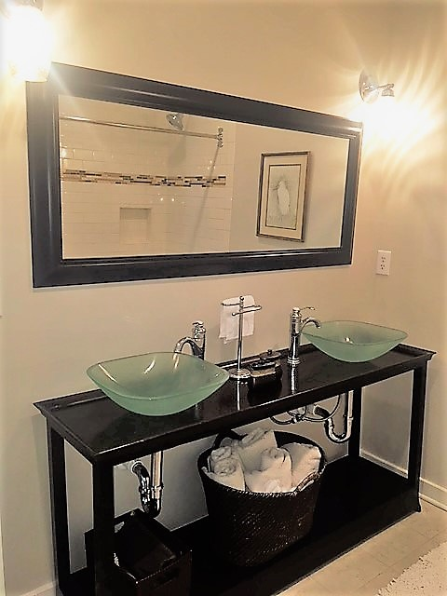

**SEE BOTH 15 JUDITH STREET-E FROM 10AM -12PM &
23 ASCOT ALY FOR A CHANCE TO WIN A $50.00 GAS CARD!

Stephanie Howard, Realtor
843-224-5912
Stephanie@Stephanie-Howard.com

1850 Sam Rittenberg Blvd.
Charleston, SC 29407

