
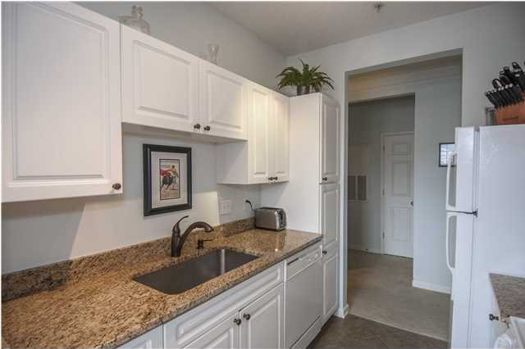
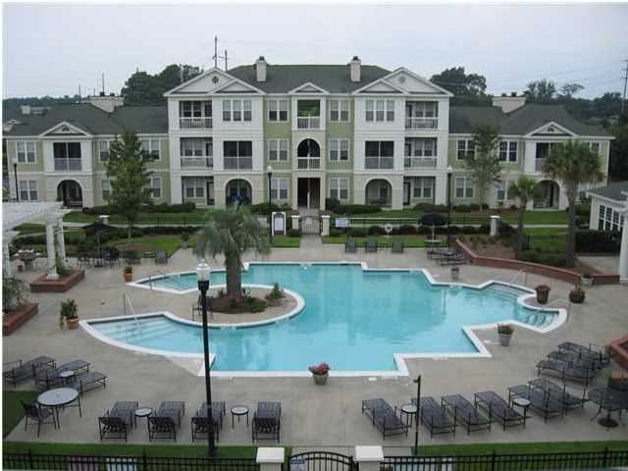
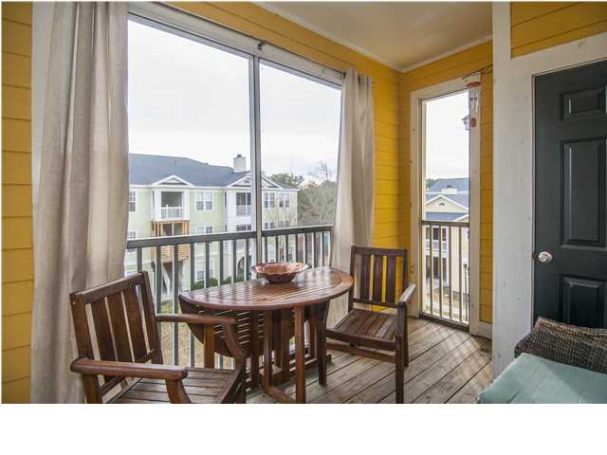
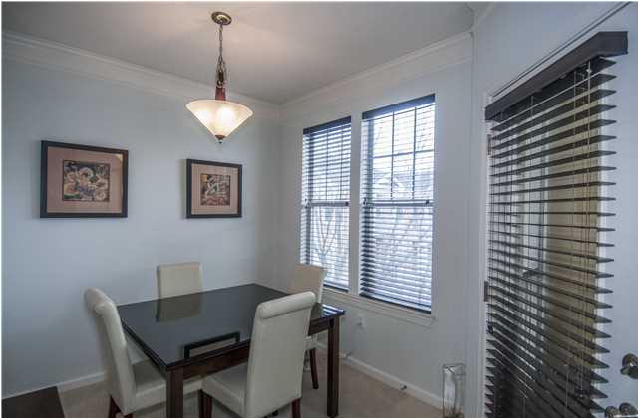
SPACIOUS DINING AND KITCHEN AREA
COURTYARD VIEW!
GREAT AMENITIES
CONSTRUCTION COMPLETE ON THIS BUILDING!
$190,000
CarolinaOne Real Estate
843.810.8398
glipps@carolinaone.com
- Gated Community in the Heart of Mt Pleasant
- Top Floor Unit with Screen Porch
- 2 bedroom 2 bath
- Upgrades Throughout
- Granite in Kitchen
- Wood Burning Fireplace
  - 2432 Chatelain Way

Luxury Living in Mt Pleasant $190,000

Southampton Pointe

