





WELCOME HOME TO THIS BRIGHT, SINGLE STORY, END UNIT VILLA IN THE ELMS OF CHARLESTON ! ONE OF THE LARGER UNITS, 2459 DEER RIDGE LANE OFFERS 2 MASTER BEDROOMS AND FLEX SPACE THAT COULD BE A 3RD BEDROOM! OR WHATEVER YOU NEED ! STUDY / DINING !

THIS CONDO IS PRICED TO MOVE ! JUST CHECK THE SQ FT PRICE TO SEE THE VALUE!

THE ELMS OF CHARLESTON ~ IS A GORGEOUS ` GATED ~ 55+COMMUNITY, WHICH OFFERS A FULL TIME ACTIVITIES DIRECTOR, CLUBHOUSE, POOL, TENNIS COURT, FITNESS AREA AND ORGANIZED EVENTS. CONVENIENTLY LOCATED TO HOSPITALS, RESTAURANTS, SHOPPING; I26 ACCESS IS LESS THAN ONE MILE!

IS CONVENIENTLY LOCATED LESS THAN 1 MILE

2459 Deer Ridge Lane
MLS # 15031383
Offered at $133,000

- 2Bdr / 2.5 Ba 1- STORY
- 1363 SQ FT – LOWEST PRICE PER SQFT IN THE ELMS OF CHARLESTON!
- FLEX SPACE CAN BE DEDICATED DINING, 3RD BDR OR DEN
- BRIGHT END UNIT
- ALL STAINLESS APPLIANCES
- SCREENED BACK PORCH
- GORGEOUS PLANTATION SHUTTERS

GREAT OPPORTUNITY IN THE ELMS ~ 55+ ADULT LIFESTYLE COMMUNITY!

FACTS & FEATURES

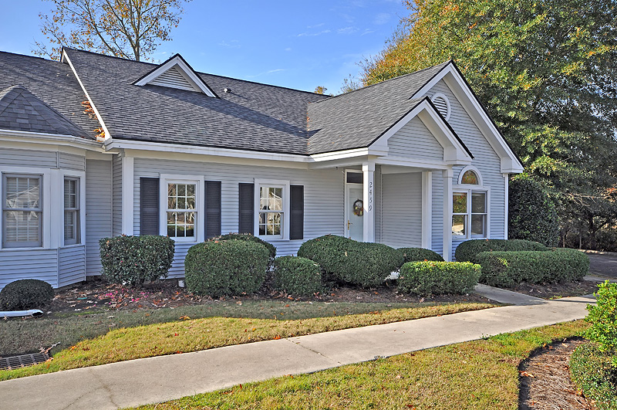
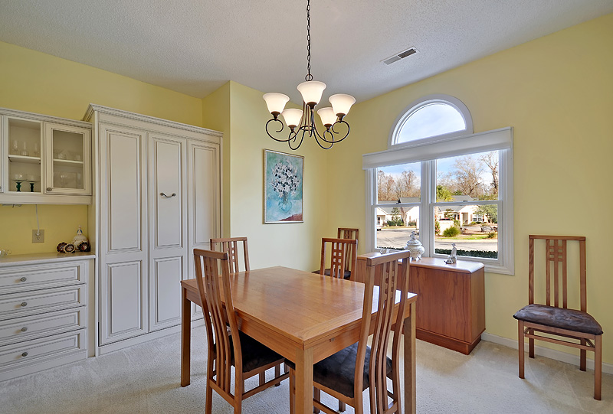
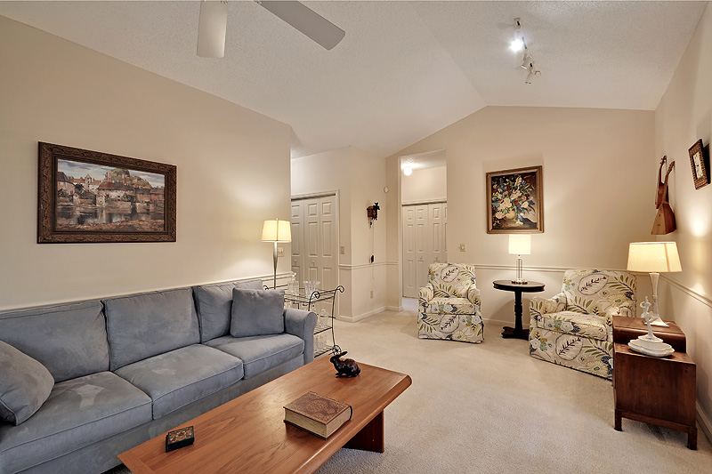
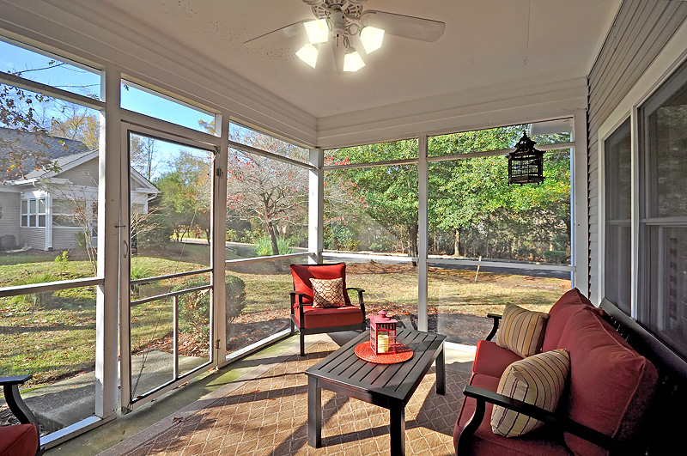
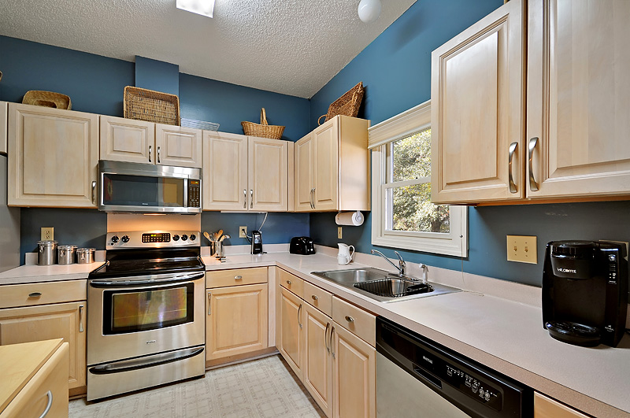
Welcome Home to DEER RIDGE in The Elms of Charleston !
“Charleston is your forever love. It is a perfect blend of character and class. There is always something, but not too much. It is playful and it romances you.”
– Rebekah Phillips
Heather Lord
Broker Associate GRI, e-PRO, RSPS
Keller Williams Realty Charleston
www.heatherlord.com
heather@heatherlord.com
Phone: 843.810.9414

