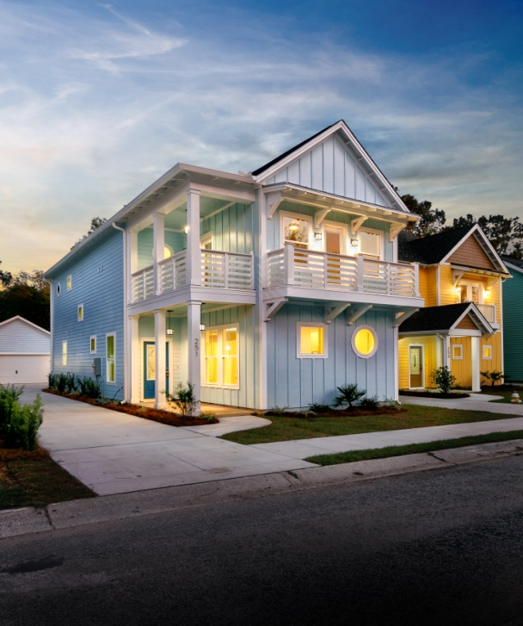
Riverland Place
Agents Open House
Wednesday Oct. 30, 2019
251 and 253 Stefan Drive
James Island (across from the Terrace Theater on Maybank Hwy.
11:30 to 1:30
Please come see these Beautifully finished Brand New Homes that are priced from $425K.
Builder will pay 3% of the sales price towards the buyers closing costs.
$50.00 Dollar gift card drawn for one lucky agent
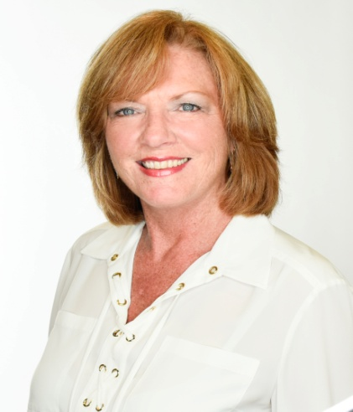
Lori Nolan, GRI
Trademark Properties
2070 Sam Rittenberg Blvd.
Suite B276
Charleston, SC 29407
843-343-5700

