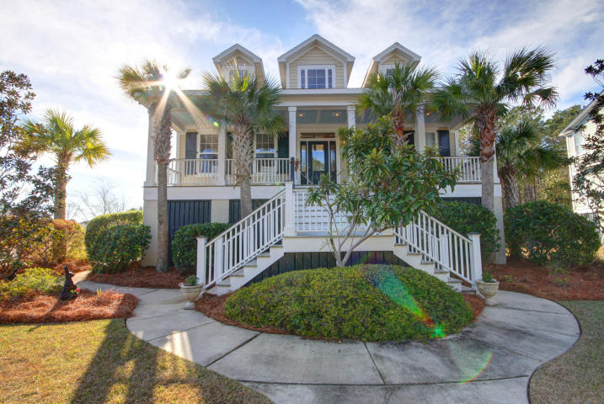
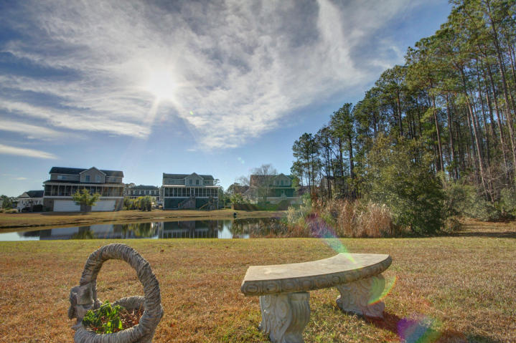

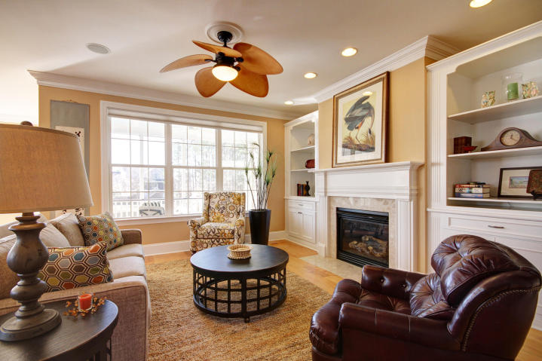

glipps@carolinaone.com | (843) 810-8398 | www.gerilipps.com

Downstairs Master Suite with a sitting room opens to the porch and overlooks the pond. Upstairs is a media room two more bedrooms and home office with extra storage. 3 car garage plus lots of storage complete the package!
Stunning elevated home in Planters Pointe with Everything you need for LowCountry Living at its BEST! Two story foyer, formal dining and beautiful oak floors throughout main level. The family room with gas fireplace and built-in is open to the beautiful custom kitchen.

Pondside Home

In Planters Pointe

2600 Ringsted Lane

MLS# 17000713

  - $605,000
$184/SF in Mt Pleasant!

