






- SINGLE STORY LIVING
- 2 PARKING SPACES PLUS A GARAGE!
- 3BDR/2BATH
- BRAND NEW HARDWOOD FLOORS
- SEP SHOWER/TUB IN MASTER BA
- PRIVACY FENCED PATIO

IF YOU PREFER A PEACEFUL, NATURAL SETTING WITH SPACE TO WALK/JOG/FISH YOU NEED TO CONSIDER WHITNEY LAKE.

Offered at $1575/mth
With a Garage! Or $1500 / mth with NO Garage!
DEVELOPED AROUND A 25 ACRE LAKE, WHITNEY LAKE OFFERS A NATURAL SETTING, WITH WALKING/JOGGING TRAIL, LUSH VEGETATION, FISHING AND KAYAKING.

WHITNEY LAKE IS CONVENIENTLY LOCATED LESS THAN 20 MINUTES TO DOWNTOWN CHARLESTON – OR FRESHFIELDS VILLAGE ON KIAWAH OR THE BEACH AT FOLLY.

For Lease ~ Single Story ~ 3bdr/2ba in Gorgeous Whitney Lake, Johns Island SC !
2865 Sweetleaf Lane
MLS 17003611
FACTS & FEATURES

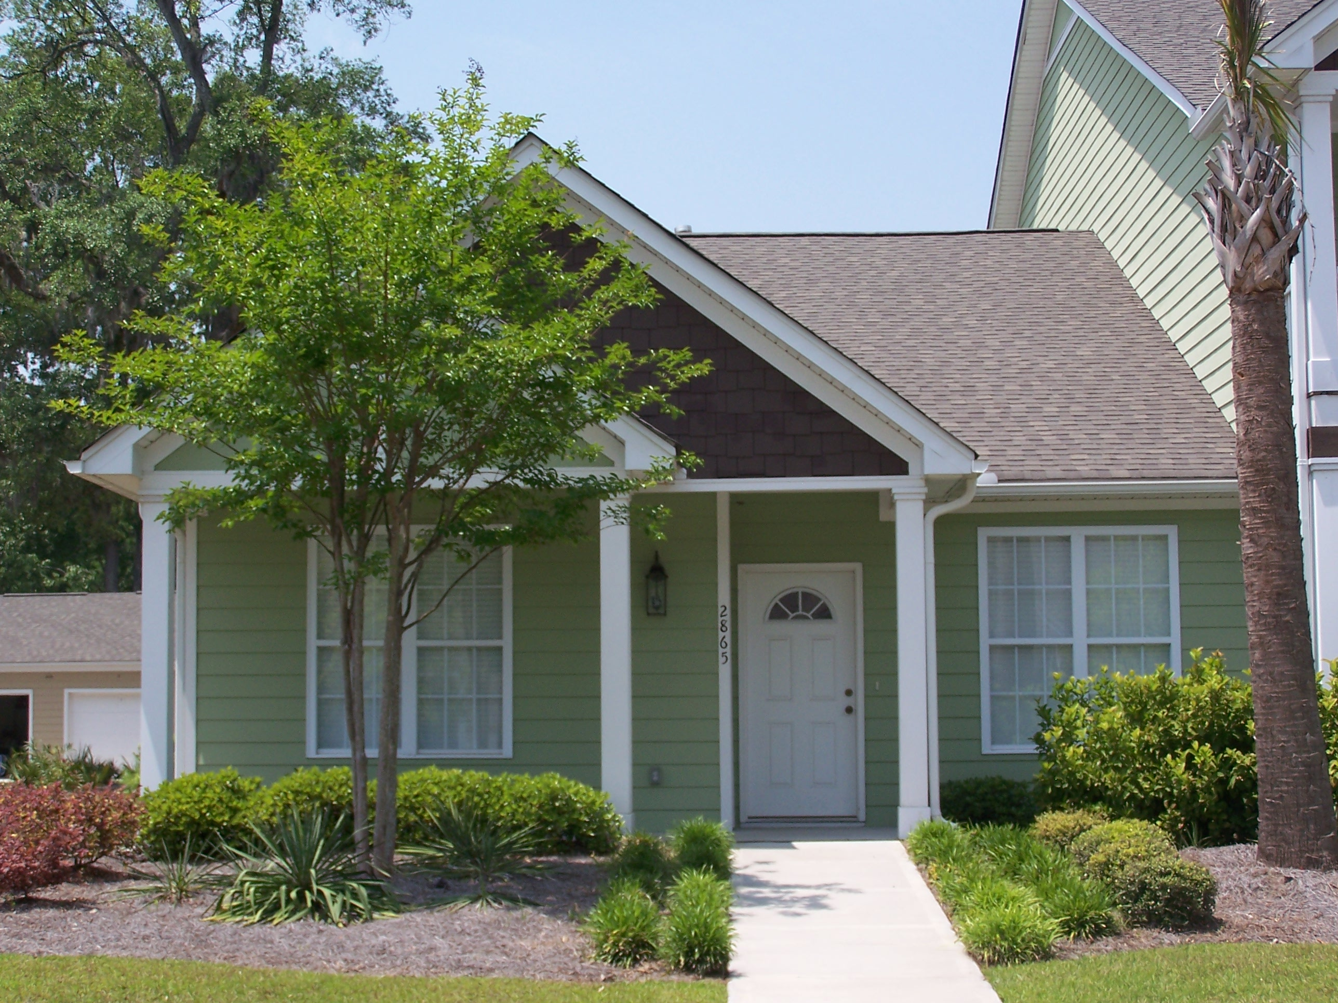
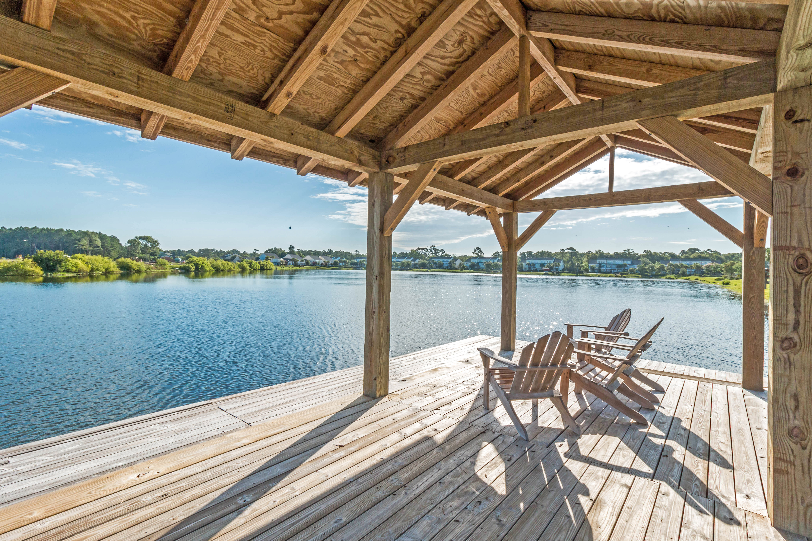
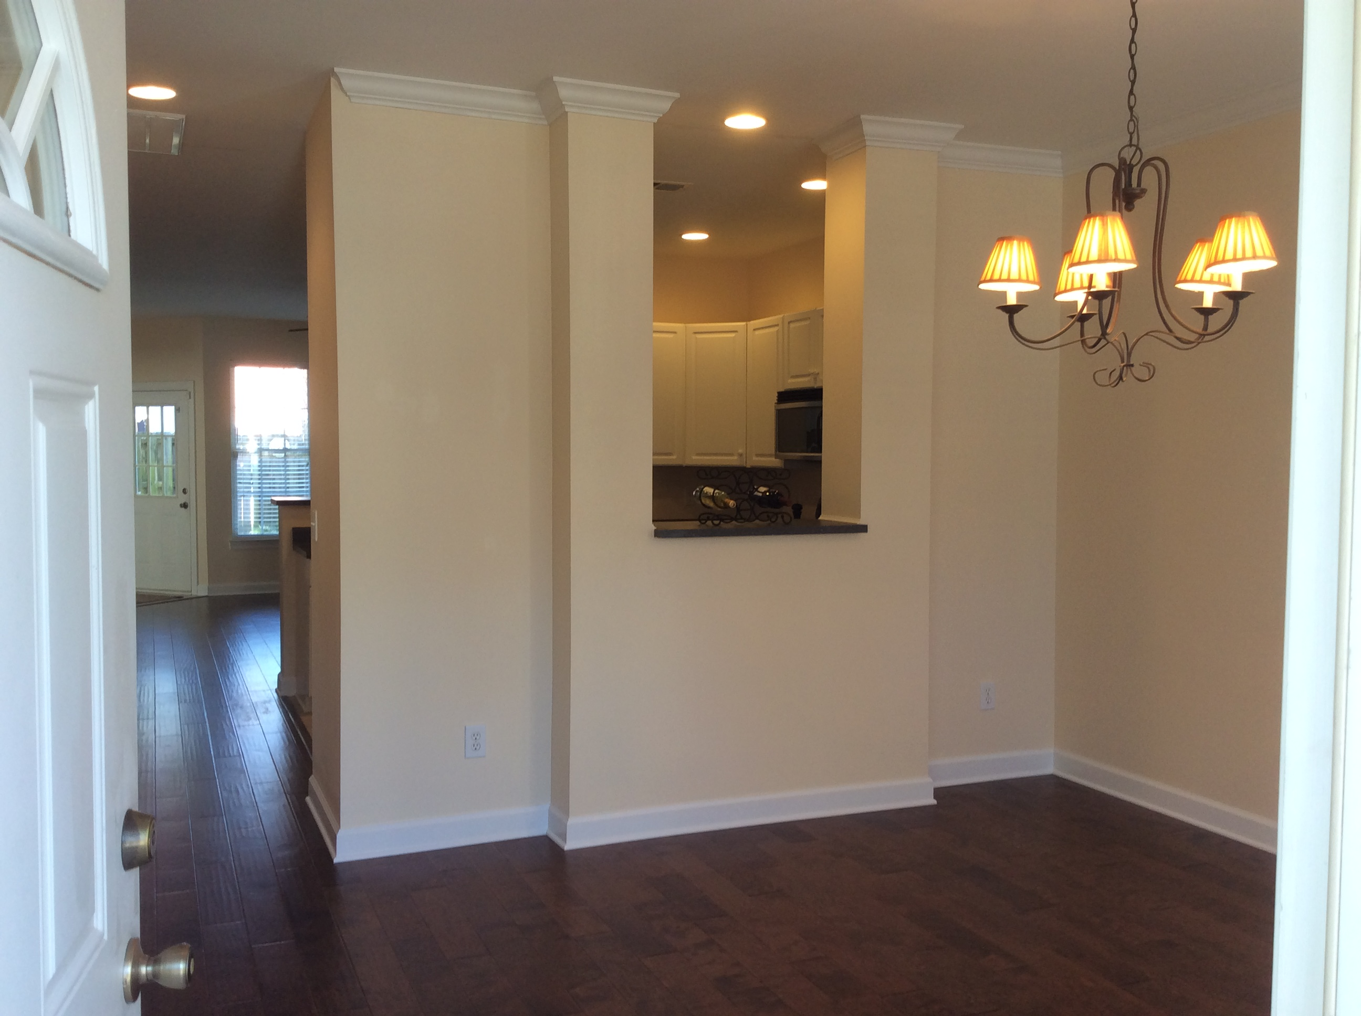
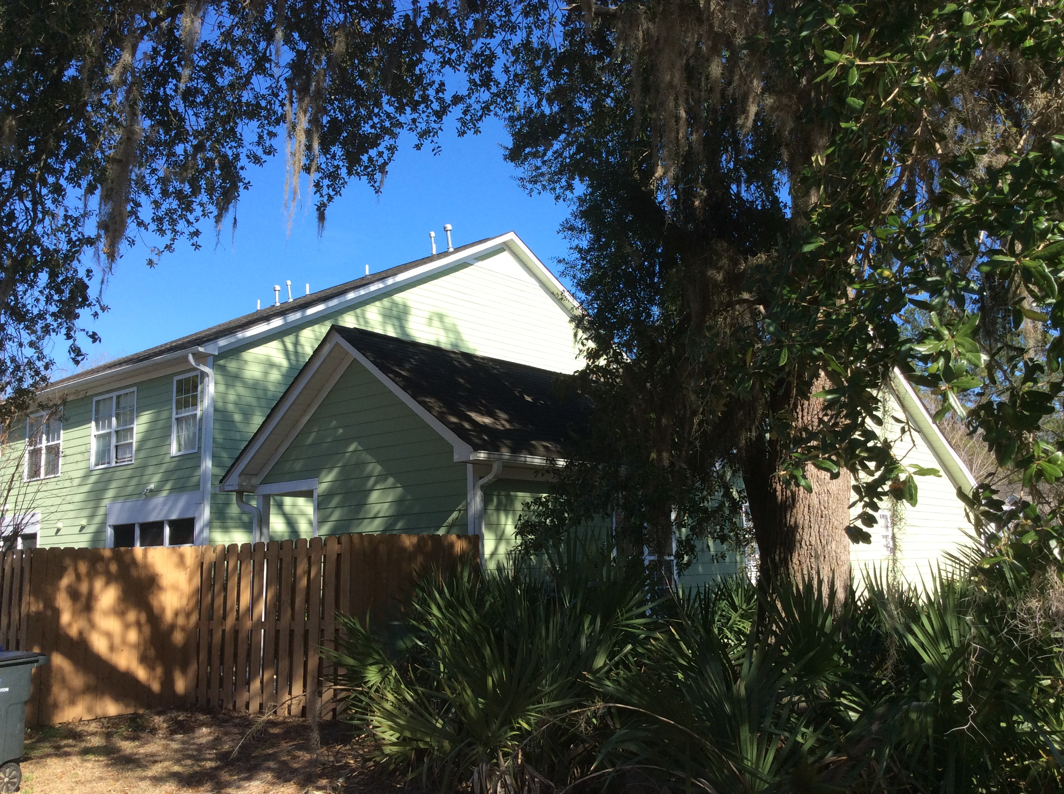
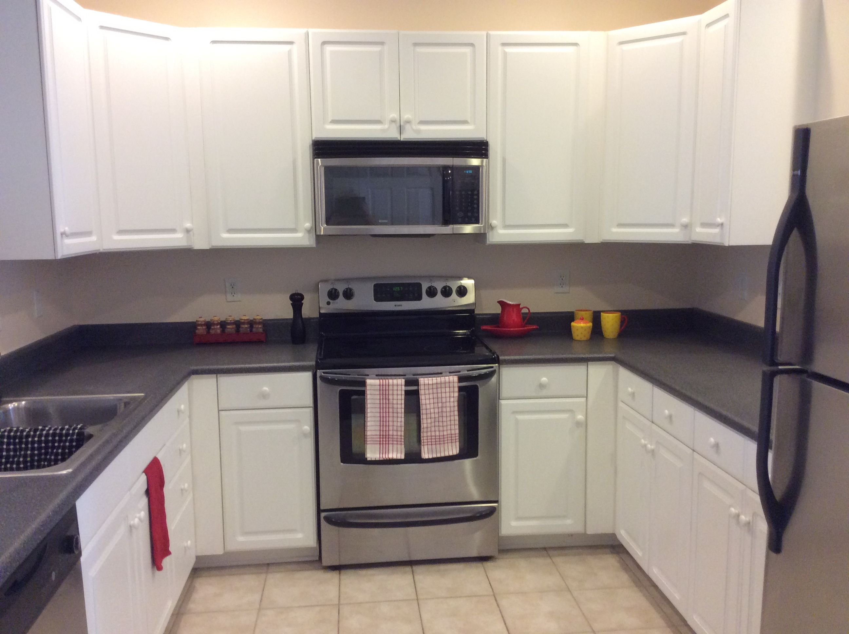
“Charleston is your forever love. It is a perfect blend of character and class. There is always something, but not too much. It is playful and it romances you.”
– Rebekah Phillips
Heather Lord
Broker Associate GRI, e-PRO, RSPS
The Boulevard Company
Phone: 843.810.9414
Email: heather@heatherlord.com
Web: www.HeatherLordc.om

