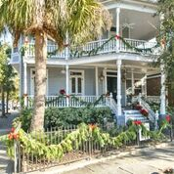
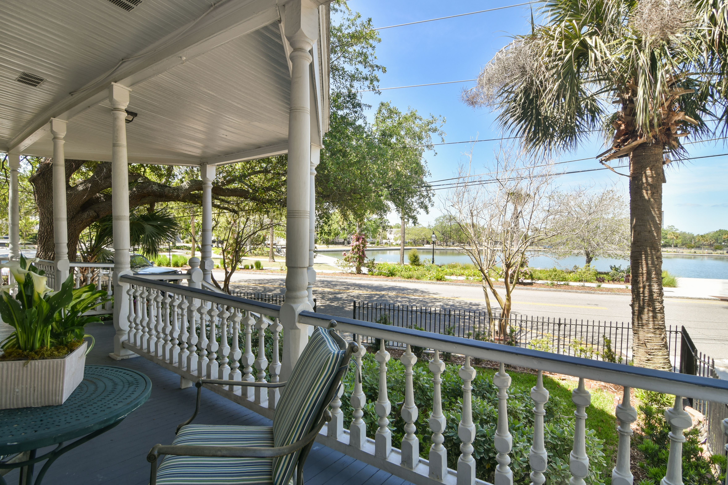
28 Rutledge Avenue
on Colonial Lake
New Price $1,250,000
Robyn Hall-Carolina One Real Estate (843)906-5200

Ne
LakeLake

28 Rutledge Avenue
- 4br, 4ba, 3822 sf
- on Colonial Lake
- 3 off-street parking spaces
- 2 electric meters so could be 2 units
- piazzas galore!
- Original hardwoods
- 6 fireplaces
- original pocket doors

- Sunset views
- Rear courtyard
- Incredible price to live on the lake!
- NOW $1,250,000

