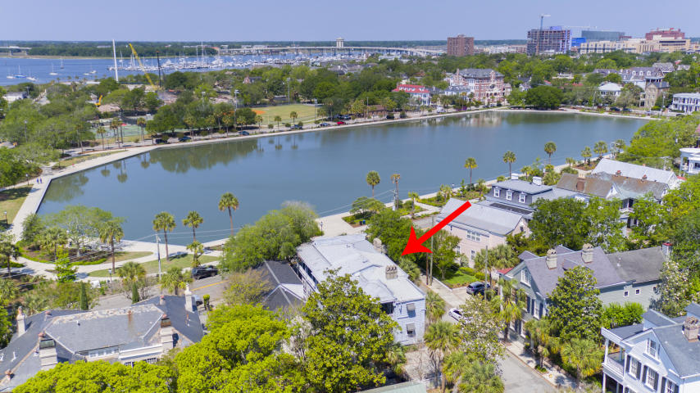
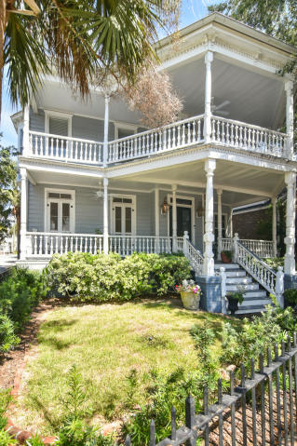
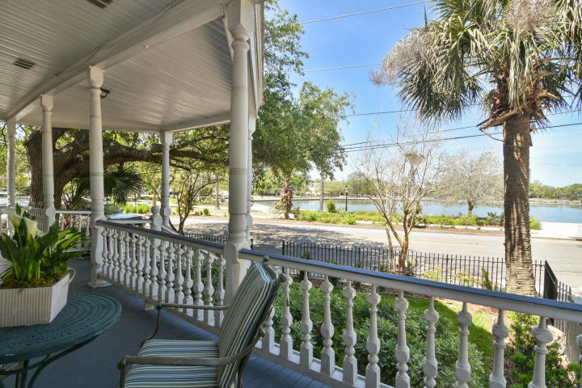
28 Rutledge Avenue on Colonial Lake
New Price $1,250,000 ~ MLS# 18013601
$10,000 agent bonus at closing with ratified contract by 8/31/19
- 4 Bedrooms
- 4 Baths
- 3,822 Square Feet
- On Colonial Lake
- 3 Off-Street Parking Spaces
- 2 Electric Meters So Could Be 2 Units
- Piazzas Galore!
- Original Hardwoods
- 6 Fireplaces
- Original Pocket Doors
- Sunset Views
- Rear Courtyard
- Incredible Price For Living On The Lake!
Robyn Hall ~ robyn.hall@carolinaone.com ~ (843)906-5200
Carolina One Real Estate

