





2945 Sugarberry Lane
MLS # 15019374
Offered at $212,000

- End Unit ~ 3Bdr ~ Townhome
- Granite ~ Stainless Appliances
- Built in 2012
- HOA Fee: $130

- Fireplace
- Flooring: Hardwood, Ceramic, Carpet
- Screened in Porch
- Fenced Patio/Courtyard

FACTS & FEATURES

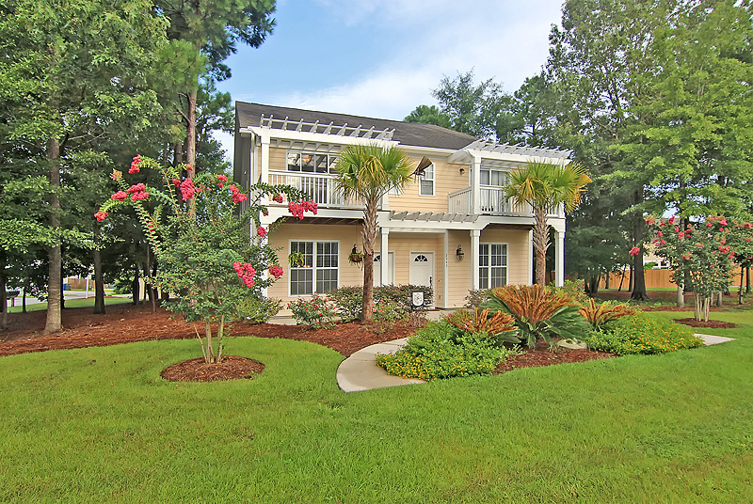
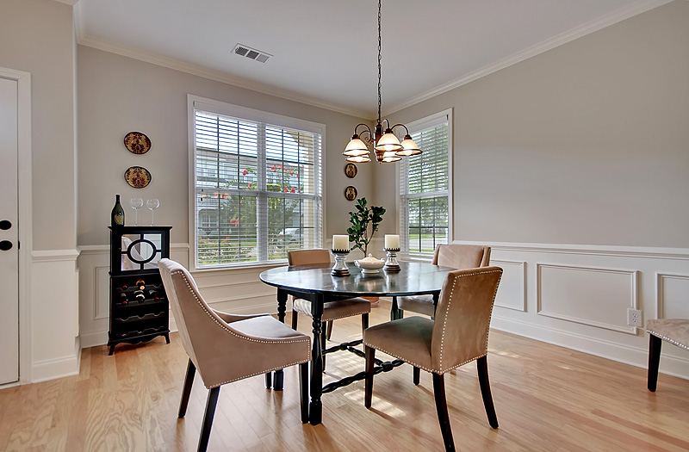
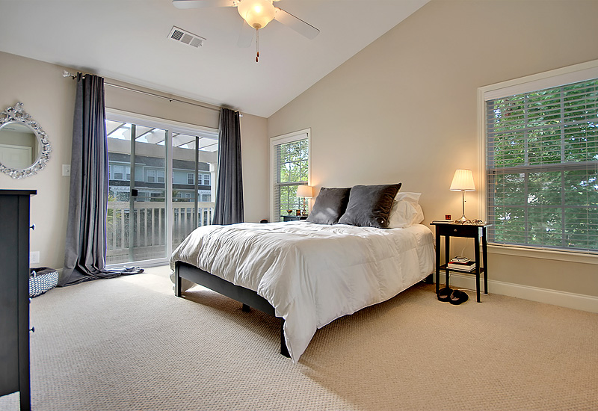
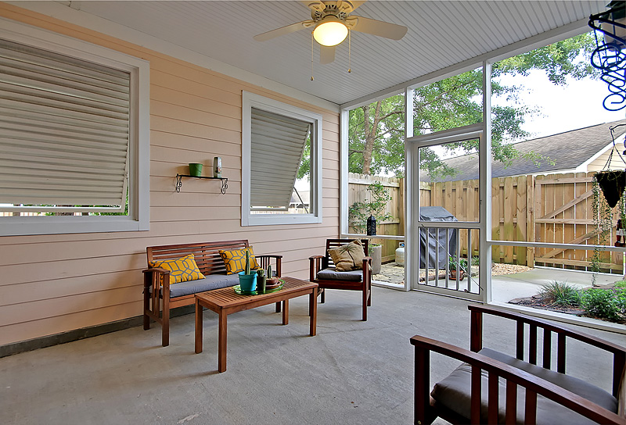
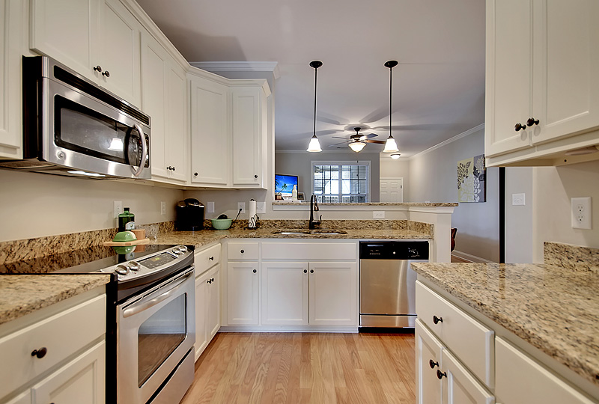
Highly Desired Whitney Lake offers a Gorgeous Natural Setting Where You Can Enjoy Kayaking, Walking Trails, Fire Pit, Dog Park & Gorgeous Sunsets... Located Just 15 Minutes to Historic Charleston & 20 Minutes to Folly Beach the Community is Very Conveniently Located !

This 3Bdr Townhome has all the Bells & Whistles ... Over 13K in Upgrades : Hardwoods, Granite, Upgraded Cabinets, Rubbed Bronze Fixtures, Screened Porch w Bahama Shutters, Fenced Courtyard, Fireplace ... Master Bdr has Private Balcony. Exceptional Unit and definitely worth Showing!
Welcome Home to the Gardens of Whitney Lake on Johns Island SC
“Charleston is your forever love. It is a perfect blend of character and class. There is always something, but not too much. It is playful and it romances you.”
– Rebekah Phillips
Heather Lord
Broker Associate GRI, e-PRO, RSPS
Keller Williams Realty Charleston
www.heatherlord.com
heather@heatherlord.com
Phone: 843.810.9414

