Open House Saturday Oct 3rd Noon – 3PM
304 Lakeview Drive Eutawville, SC 29408

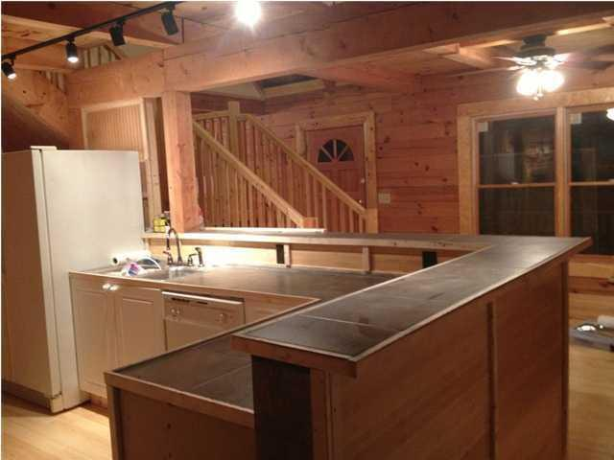
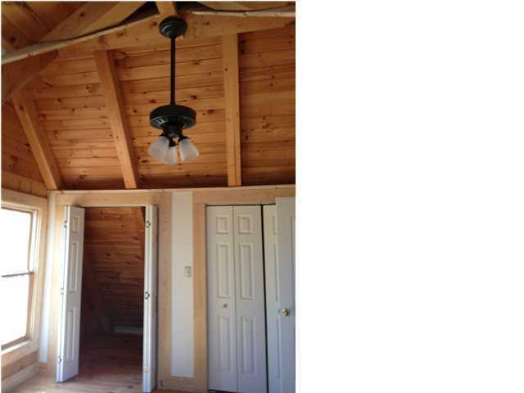
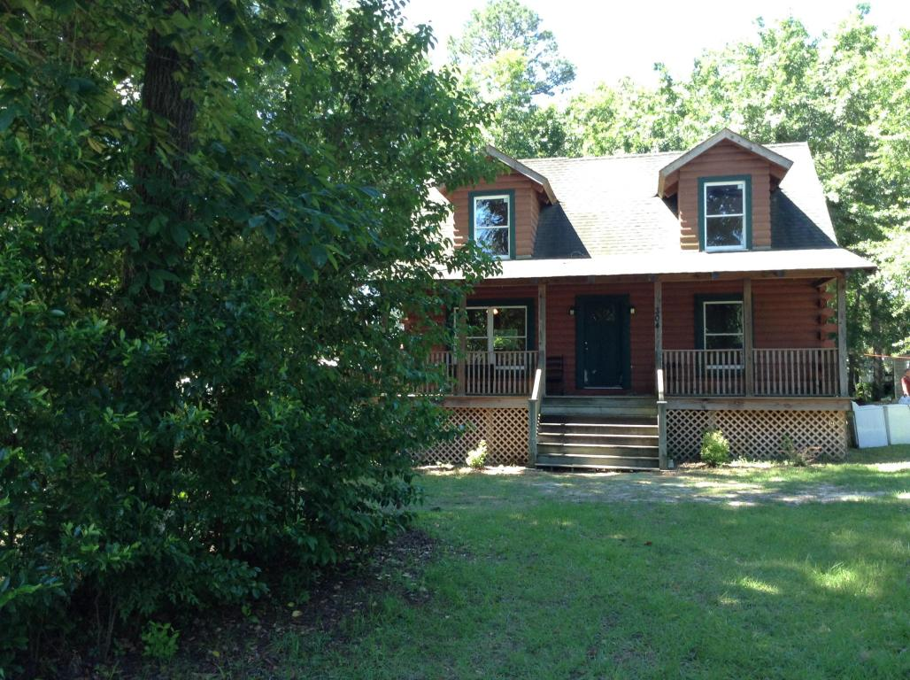
2 Bedrroom
2 Full Baths
Large Kichen
Large Front Porch
129, 000
2 blocks from Public Boat Landing

