You’re invited to an Agent Luncheon
Thursday, December 3
11:30 – 1:30
308 Sumter Ave.
In Historic Downtown Summerville
$1,200,000

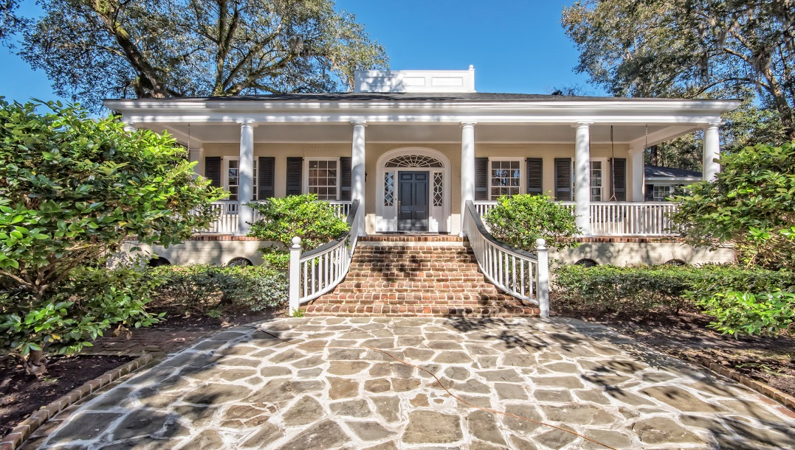

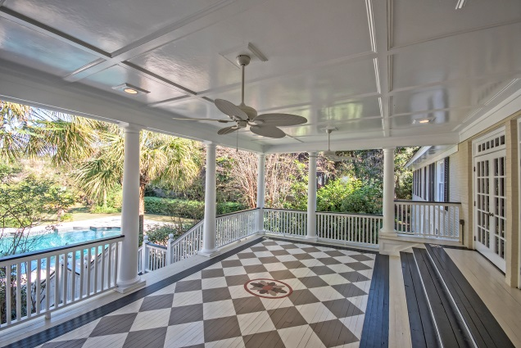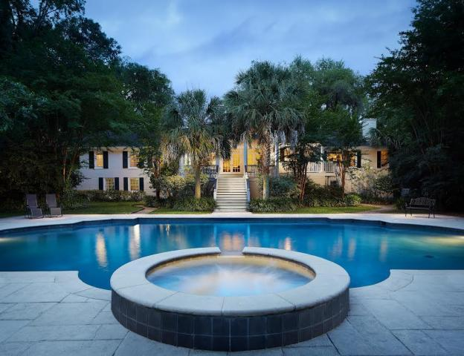

Built in 1890 but completely renovated In-ground Pool with Spa
6538 Square Feet On 1.67 Acres
5 Bedrooms/ 5.5 Bathrooms 4 Fireplaces
Downstairs Efficiency Apartment

Pam Bass
Century 21 Properties Plus
843-259-4926
