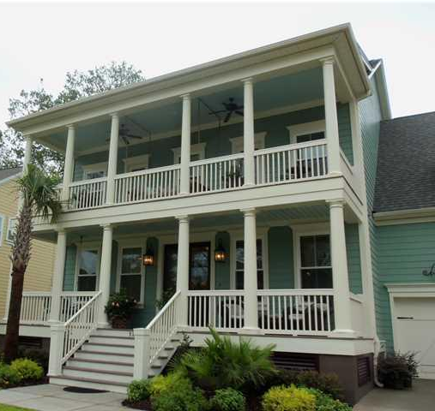
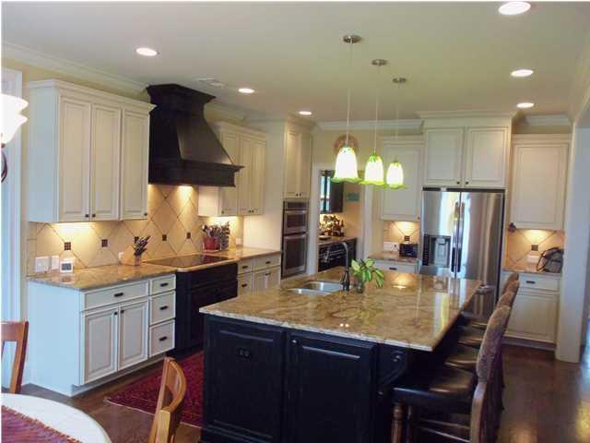
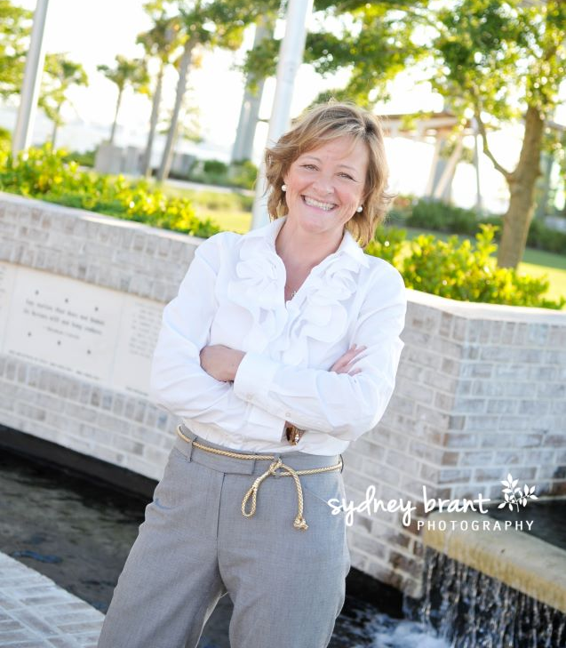
$50 Gift Card
$50 Gift Card
Thursday
Noon-2PM
April 23
Agent Open House
843.810.8398
glipps@carolinaone.com

3216 Hatchway Drive
  - The Harbour at Dunes West

