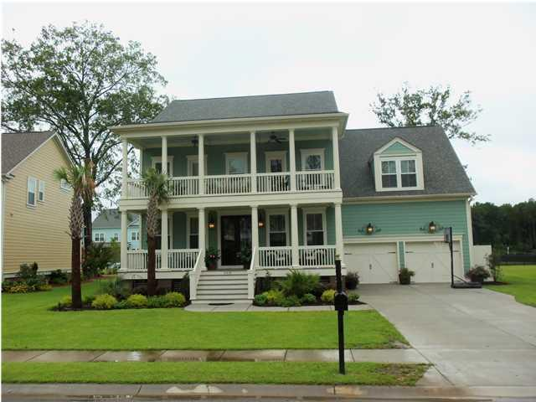
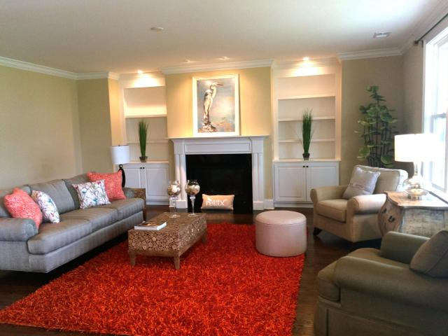
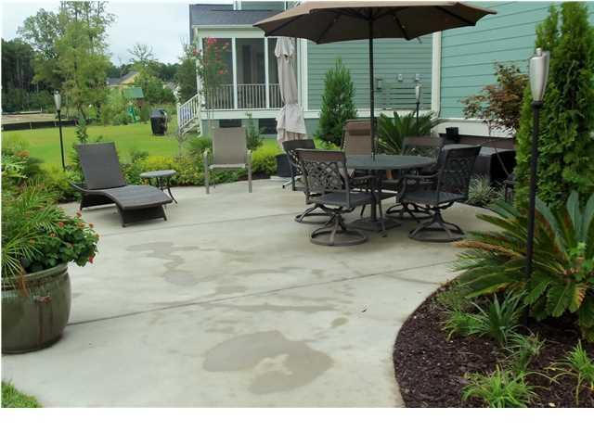
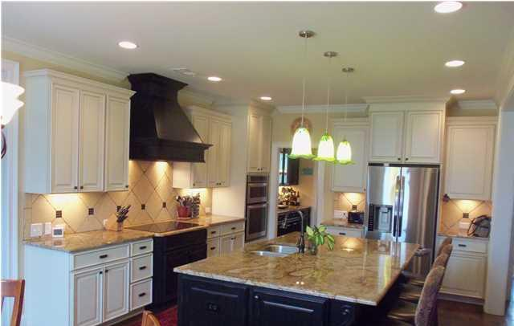
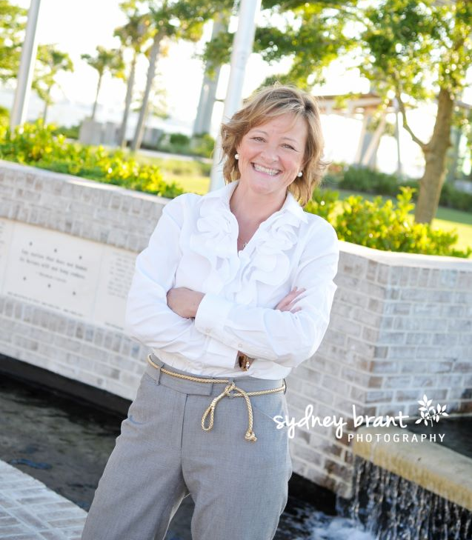
6 Bedrooms
843.810.8398 glipps@carolinaone.com

$153/SF

Price reduction

Motivated sellers

2013 Build

$629,900

+
One of the
Best Buys
In The Harbour!

Move In Ready
TODAY!

