Your Home away from Home…

“Stowaway” is a peaceful home located in the sought after Park West Subdivision of Mount Pleasant, SC. Relax on the back porch overlooking a pond, stroll on scenic nature paths, enjoy the Olympic size neighborhood pool, play on acres of recreational land, find convenient shops, gyms, and medical facilities, enjoy excellent schools, in our live, work, and play neighborhood.. The Villages at Park West.

How our guest feel…
“My wife and I lived at 3264 Beaconsfield Rd. for the past year. It was a great experience and really enjoyed our time there. I highly recommend Dominique Milton as a great landlord, who really takes care of her place.” J. Otte, Southeastern Accounts Manager. 2013
“I must say this is a wonderful rental home full of extras. The place was well equipped for all ages; we had a 2 month old and an 80 yr old staying with us. Also, the home is nestled in a resort like community with palm trees and all a person could ask for. The home is close enough to downtown Charleston to make it good location as well as the proximity to the beach, and other Mt. Pleasant sites. The owners were extremely helpful and accommodating to all of our requests. My whole family would highly recommend this rental. “Yeats, P. 2012
“Our stay at this home was perfect! The owner was very informative and helpful with all our questions prior to our arrival. The home was clean and well stocked with all necessities. The neighborhood was beautiful and quiet. The home was close to a Harris Teeter and only about 25 minutes from downtown Charleston. We would recommend this home to anyone. Thanks for a great time.” C. Petigrew 2012
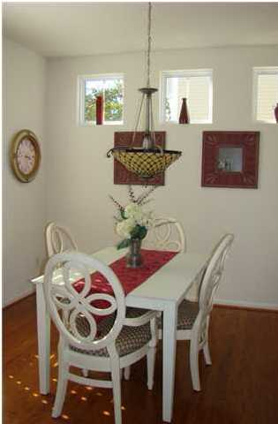
“..GREAT LOCATION, VERY CLEAN, AND THE OWNERS ARE VERY VERY NICE AND THEY TREATED US LIKE WE WERE THEIR FAMILY!!!...” T. Charles 2012

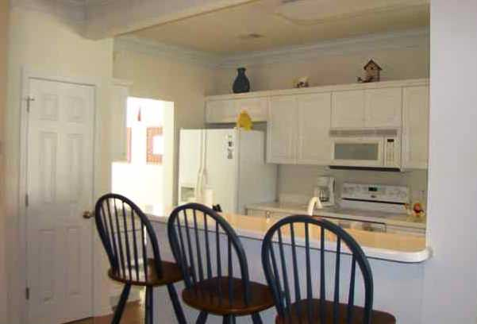
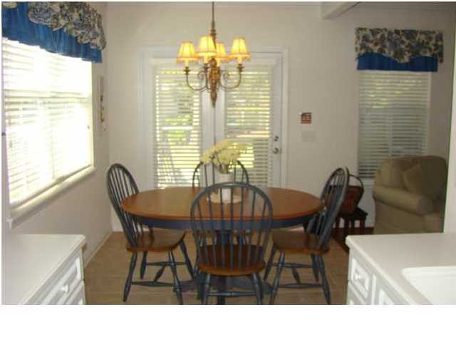
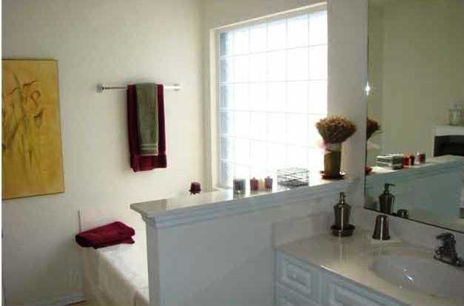
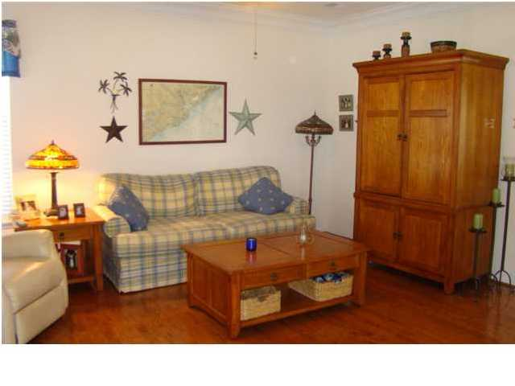
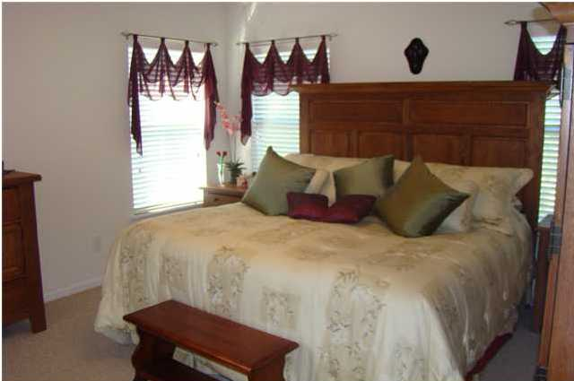
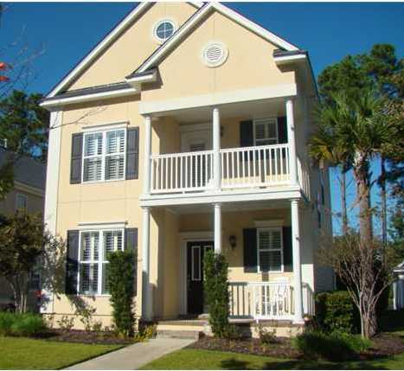
Quiet Neighborhood with a Pond View

Just Bring Your Clothes

Fully Furnished with or w/o Utilities 3 Bedroom/ 2.5 bath
Dominique Milton
(843)-693-1985 Cell & Text
dominiquemilton@aol.com

Executive & Military Rentals

3 Bedroom 2.5N Homes Rentals MilitaryRentals Works

Date of publication
Are you are waiting for your house to be built and need a place to stay…
On a corporate assignment and want some space ….
Looking to relocate but need to select the proper neighborhood…
Need to enroll in a great school district…
Prefer a home to a hotel …
This home is for you
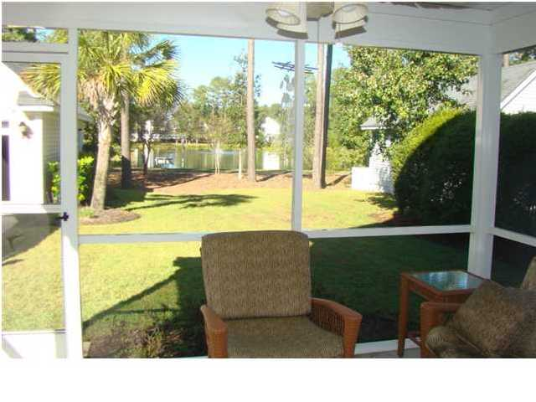
Enjoy a pond view from the rear of the house While Relaxing on the screened porch

.
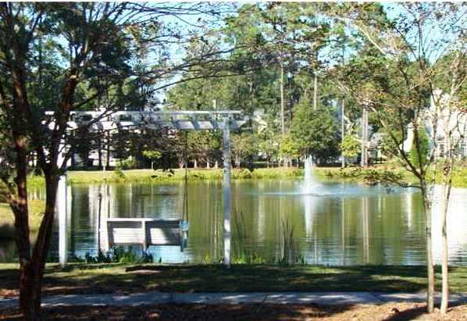
Owners are local residents with multiple rental properties, 35 years of corporate rental experience and very responsive to guest needs.
Contracts terms can be flexible based on your short term or long term requirements.
Utilities are included for rentals under 9 months and are optional for 10 month + contracts.
NOTES:
Contact: Dominique Milton
(843)-693-1985 Cell & Text
dominiquemilton@aol.com

Company Name
Street Address
Address 2
City, ST ZIP Code
Phone (555)555-0125
Fax (555)555-0145
Web site address

