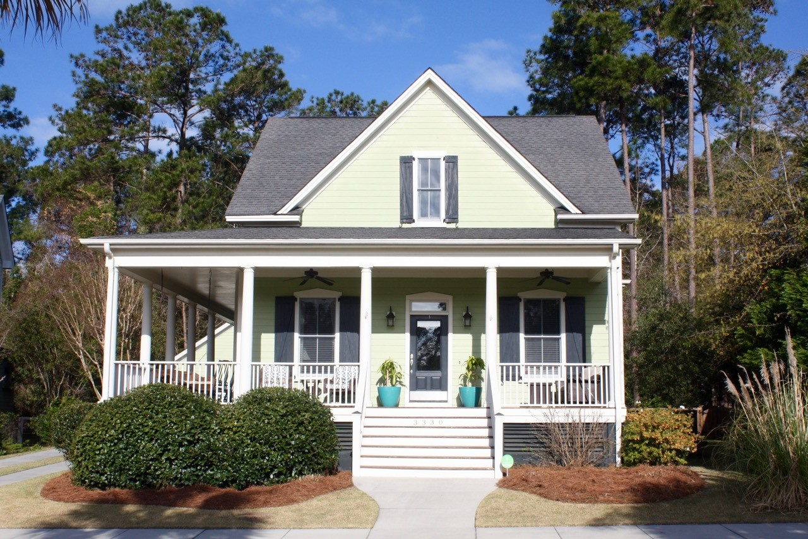  $412,000  3330 porchview place  The Villages in St. Johns Woods  “Warm Sophisticated Cottage”  Prime Location: “On the Green” with gazebo  1. Full front porch- light filled open floor plan  2. 10’ ceilings, Australian Cypress floors, handsome fireplace in spacious great room, and spectacular kitchen with granite countertops, and cozy adjoining screen porch!  3. Downstairs Master Suite and a separate private study  4. Upstairs boasts: two bedrooms with Jack n Jill bath and private sitting room  5. Perks- termite bond, hardi plank painted in 2015, two car garage, community amenities that include: pool, pavilion, playground, dog park, and walking trails! | 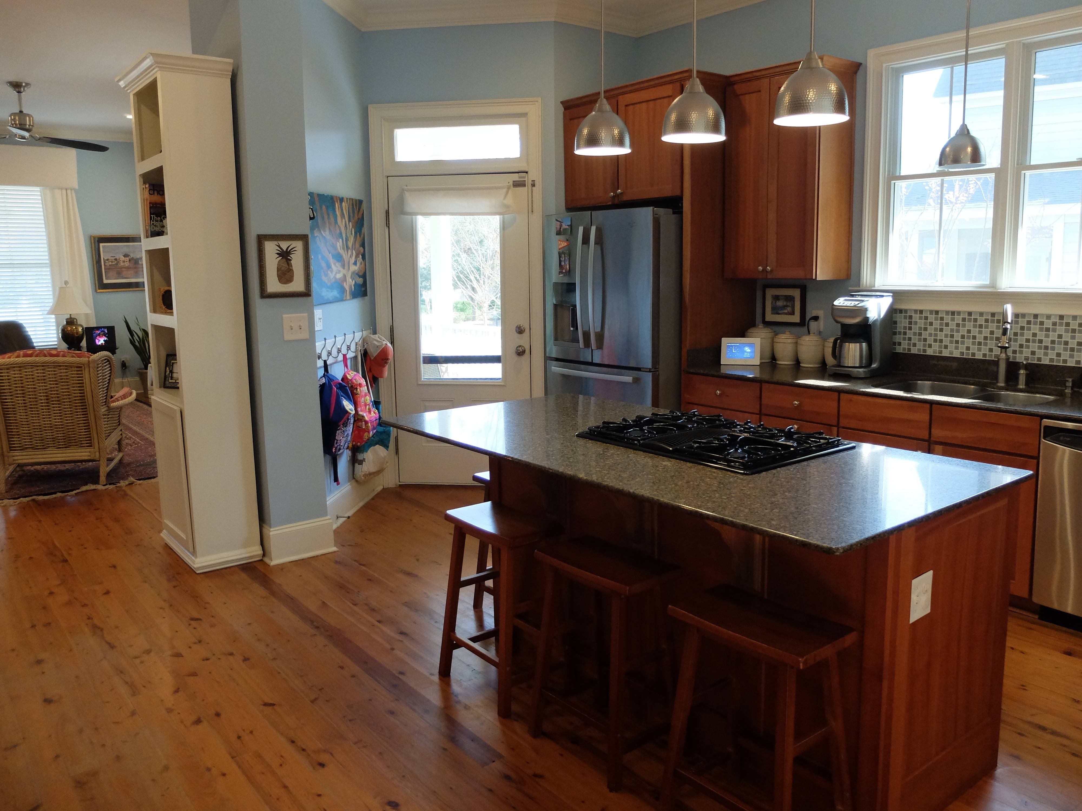  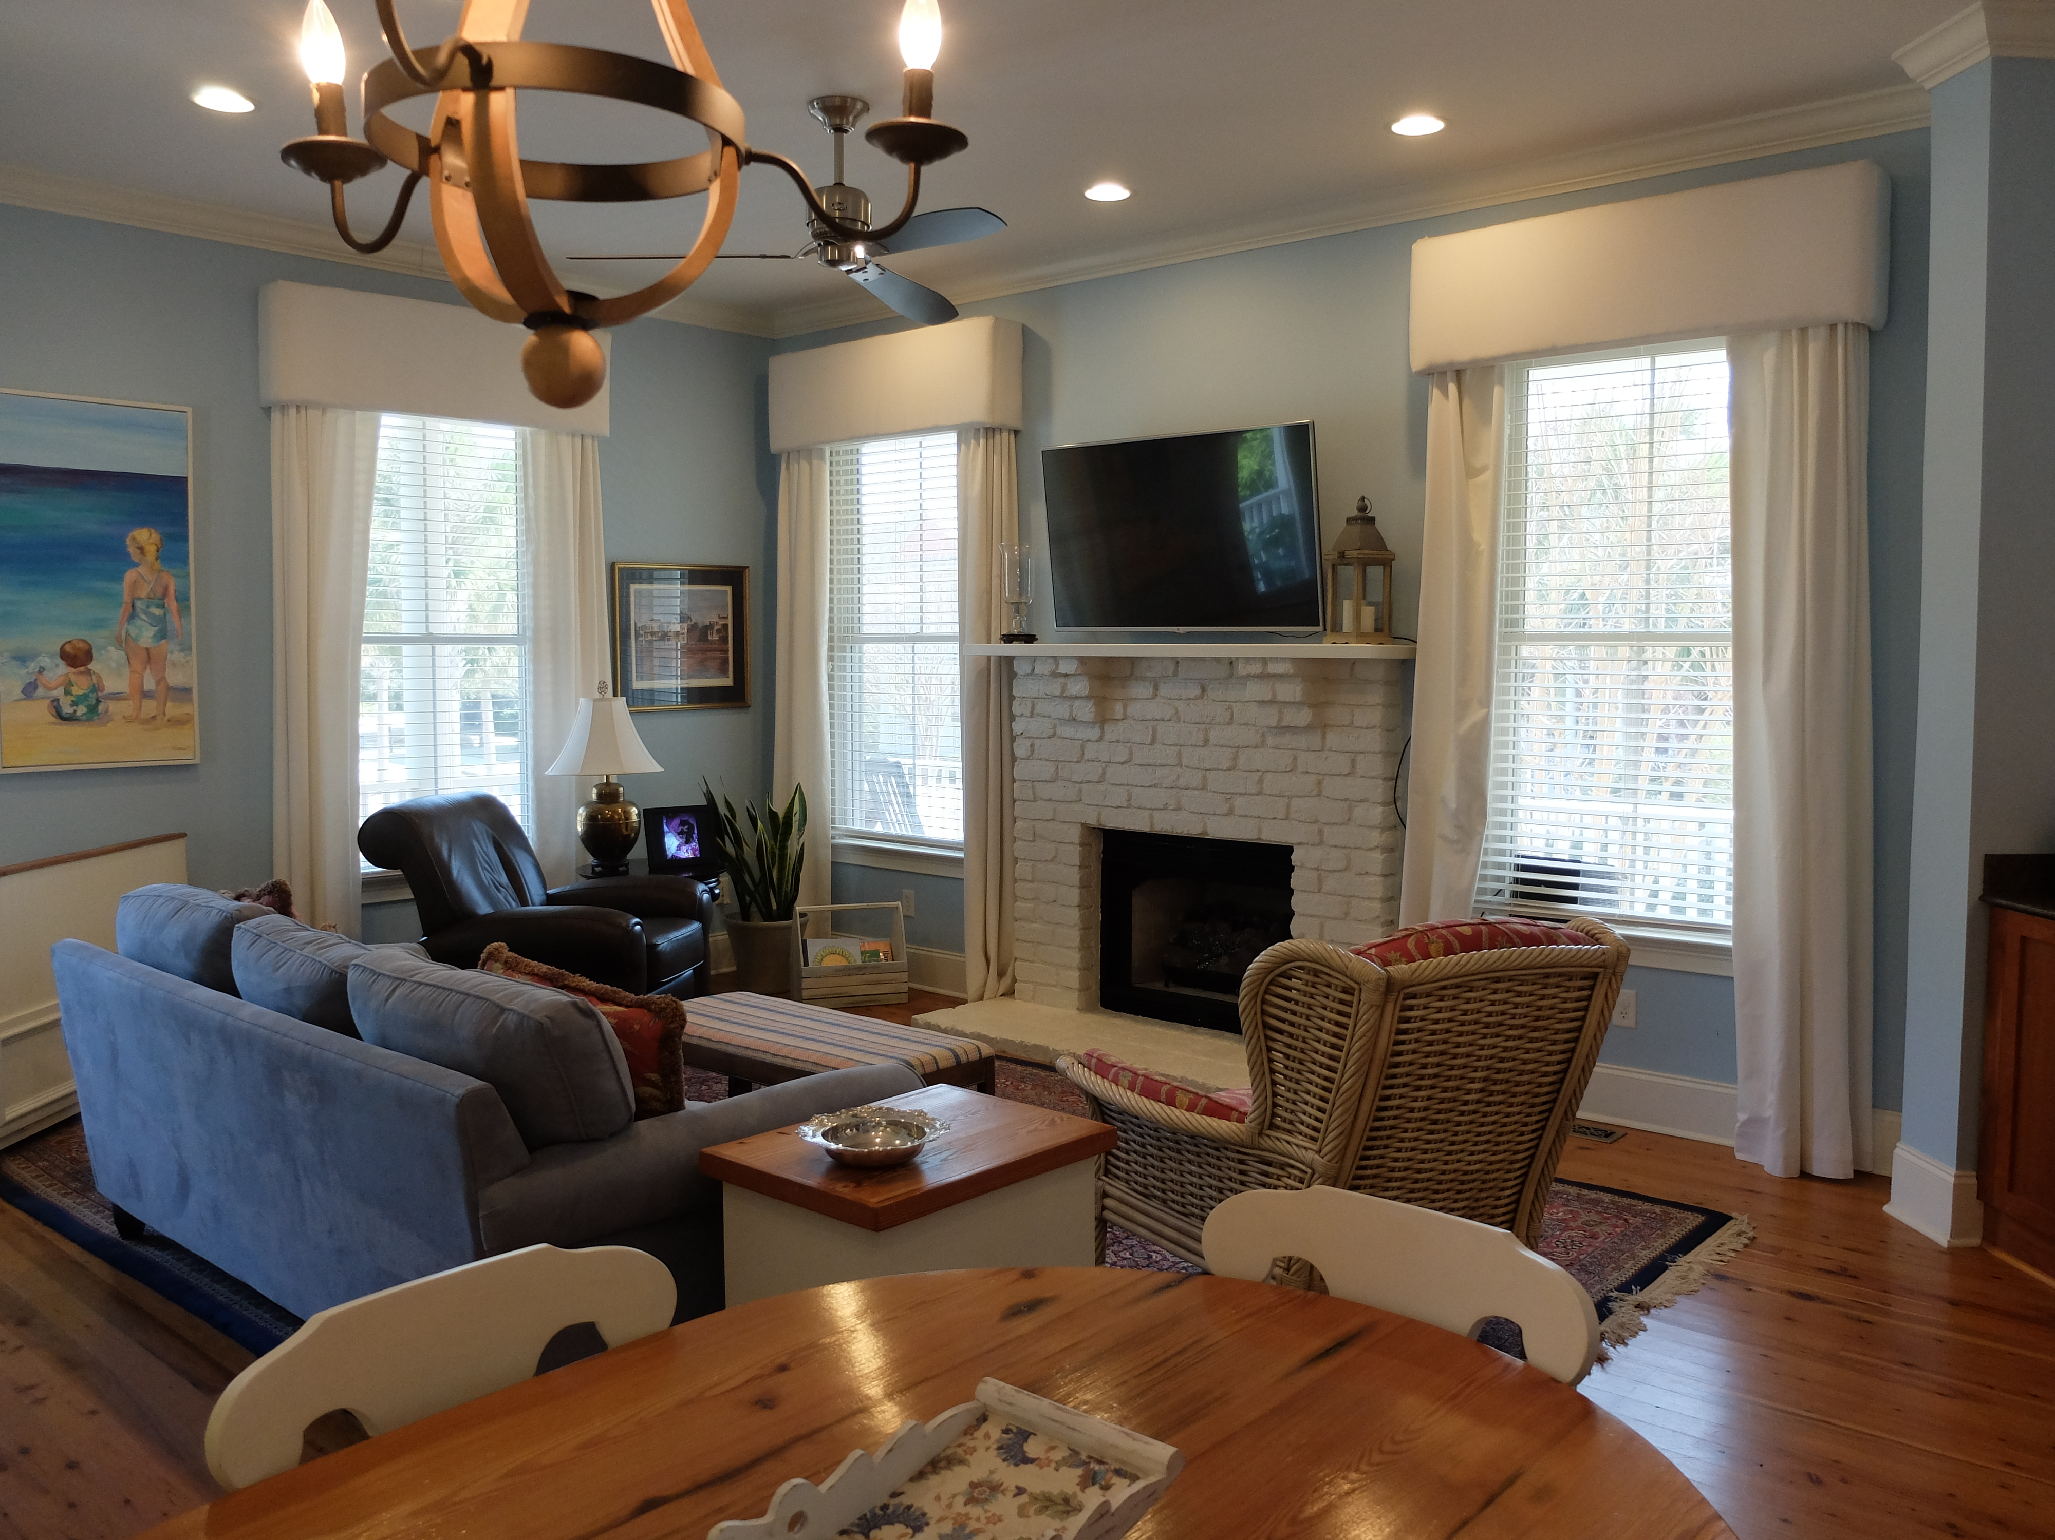  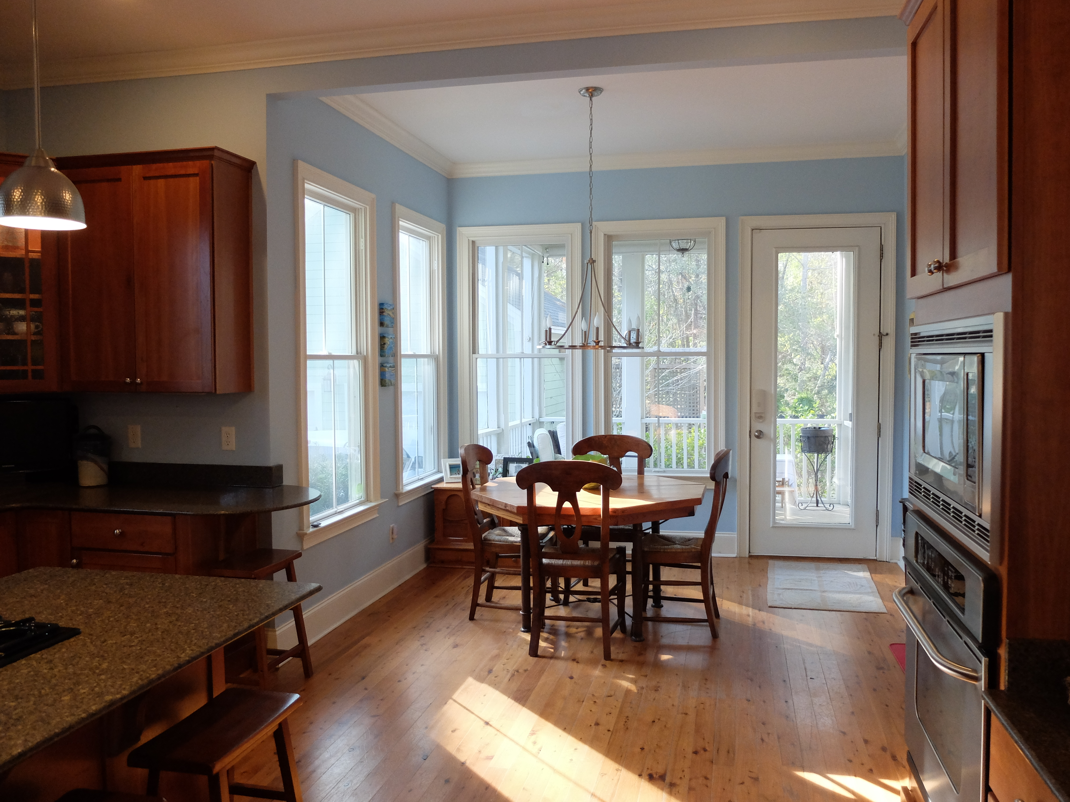  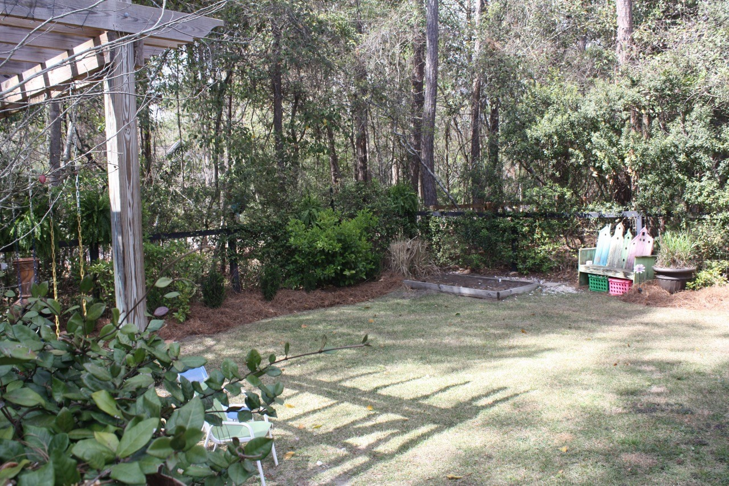  Old Dominion Realtors  Frances M. Horton  843-343-3901  fmhorton5@gmail.com  

