343 & 337 Broad River Blvd. Beaufort, SC
9.16 Acres Zoned C-3 Multi Use
$1,214,800
Beaufort SC Investment property

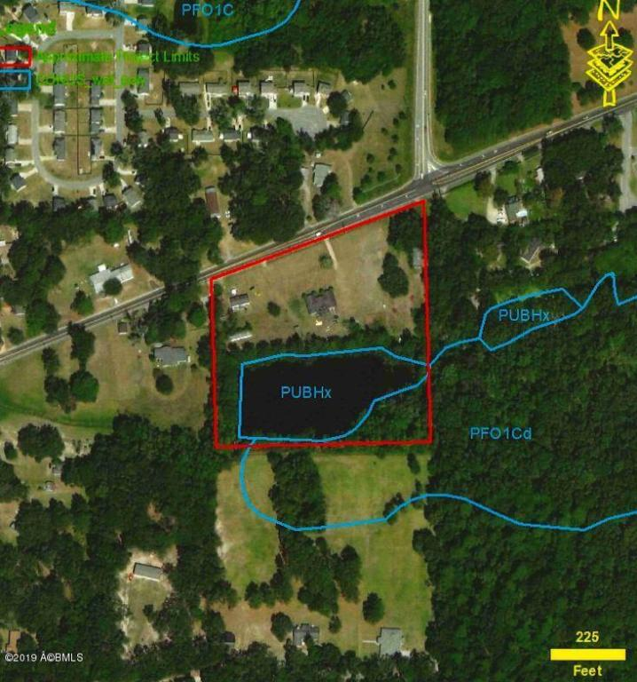



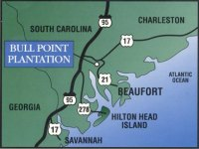
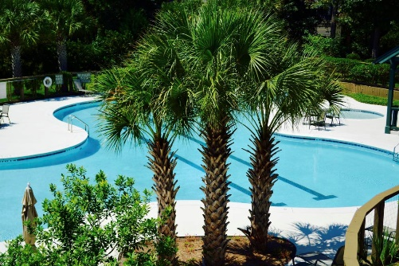


Sue LeFavi
(864) 603-3800
LeFavi.Sue@gmail.com
GIVEN THE DEMAND FOR AFFORDABLE HOUSING IN BEAUFORT , This is an Ideal Investment property for Multi-Unit Development! Centrally located in Beaufort off Broad River Blvd. midway between Parris Island and the Marine Corp Air Base. Approx. 9.16 Acres, 2 acres open water pond. MOTIVATED Seller!
C-3 Zoning allows for up to approx. 84 Multi-family units or approx. 18 Single family or Duplex housing.

