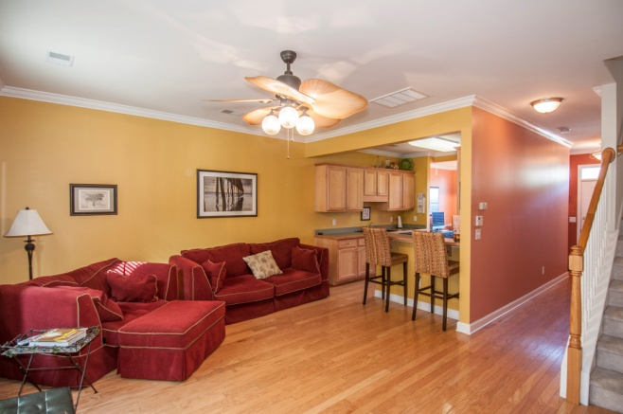
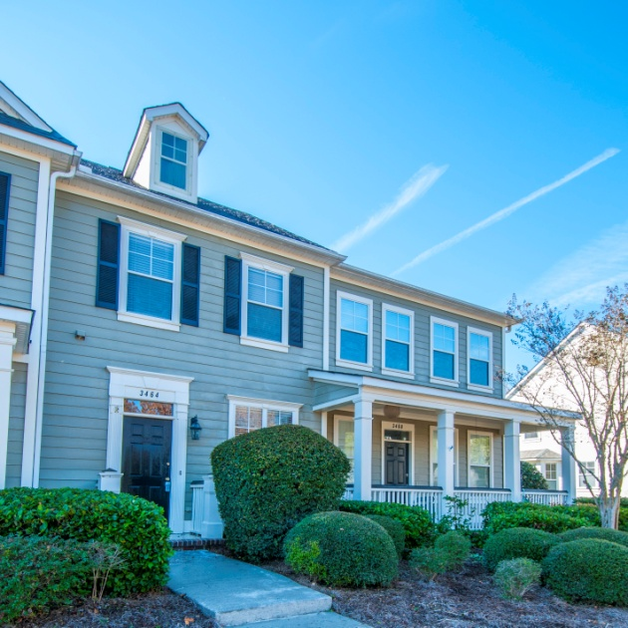
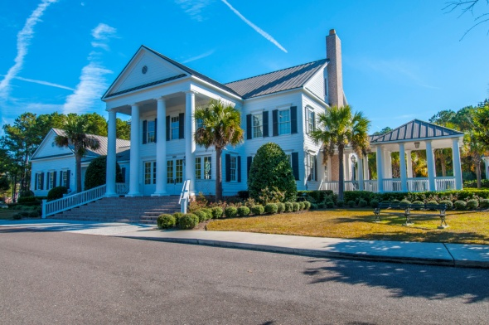
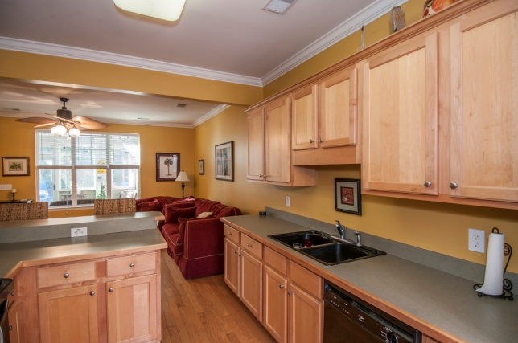

Reduced to $218,500
Madison at Hamlin Plantation
2 Beds - 2 1/2 Baths

- Excellent Location
- Minutes From Beach and Shopping
- Well Cared For
- Upgraded 42” Cabinets
- Hardwoods Throughout 1st Floor
- Sun Room
- 2 Storage Rooms

:

Community Includes
Clubhouse
Pool,
Tennis
Basketball
Sand Volleyball
Play Area,
Fitness Center
Walk/Jog Trails
Bob Hood
843-813-8108
bhood@carolinaone.com
Www.lowcountrybest.com
195 W Coleman Blvd
Mt Pleasant, SC 29464

3464 Billings St

