
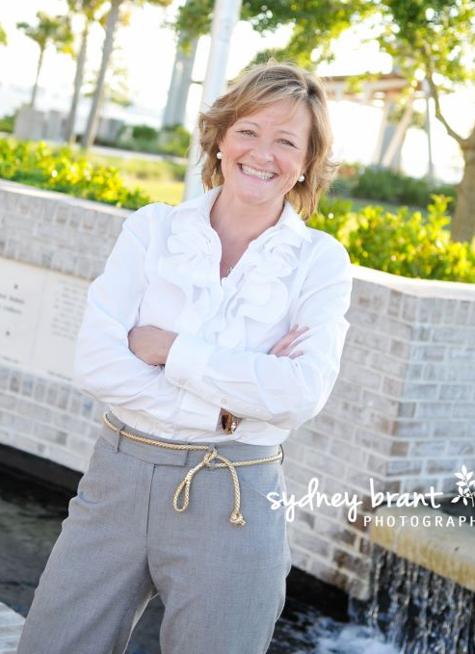
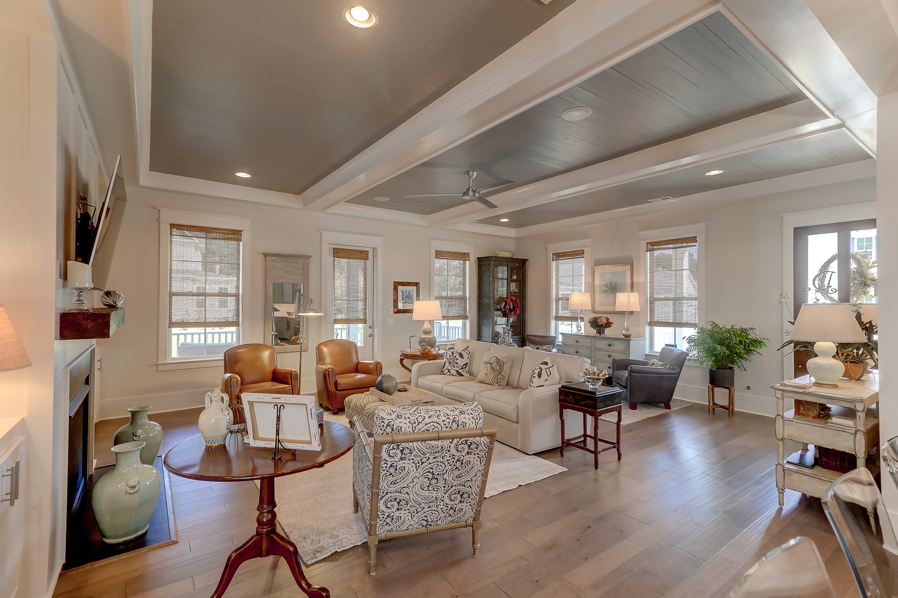

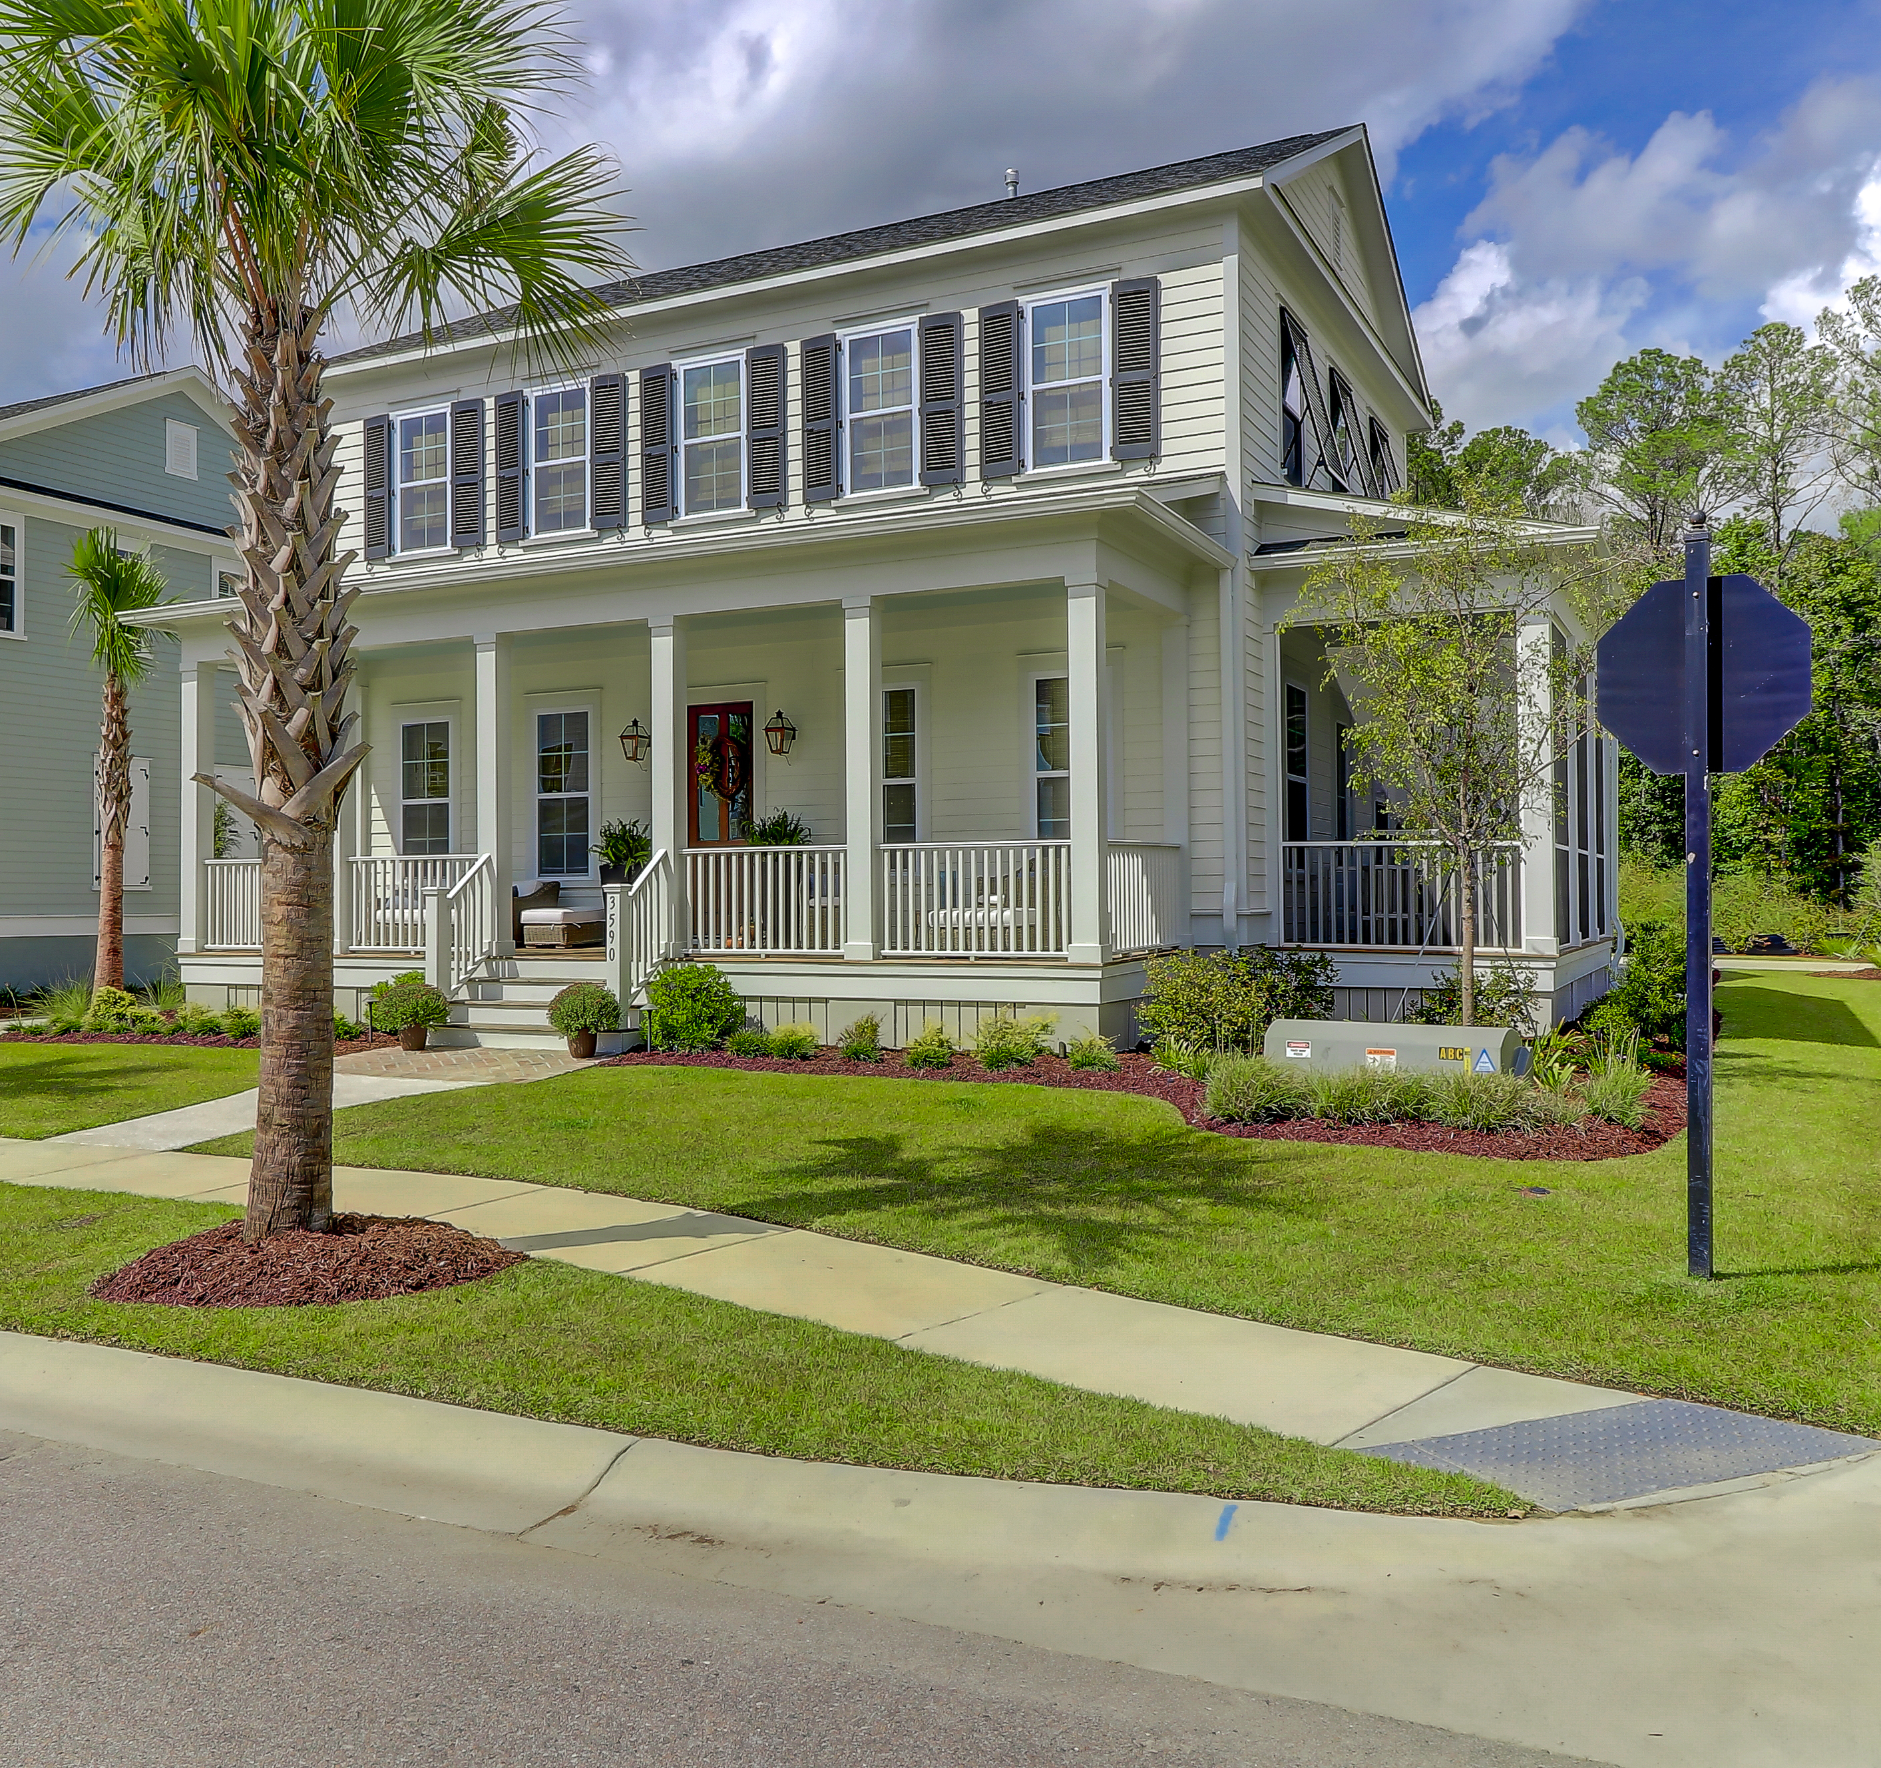
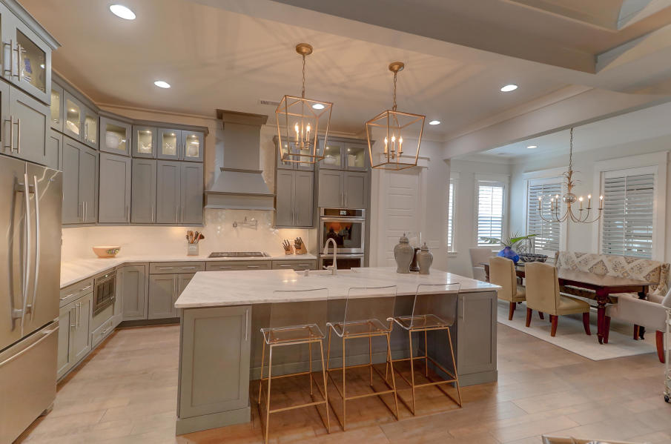
843.810.8398
glipps@carolinaone.com

Replicated Model Home with $60K+ in Upgrades after Closing:
- California Closets Throughout
- Pennysylvania Bluestone Path and Charleston Brick Patio
- Outdoor Shower/Custom Iron Gate and Fece
- Landscape lighting
- Seamless Gutters
- Functional Bahama Shutters
- Custom Window Treatments
- Extended Warranty on HVAC
- . . .And so Much More!
$710,000
Built by Front Door Homes in 2017.
One floor living for owners with MBR Down, great entertaining space and large open kitchen.
All the Bells and Whistles of New Construction – Ready NOW!
Mauris odio nisi, bibendum quis, vehicular sed, tempus at, orci. Vestibulum vel dolor non ante bibendum mollis.
Stunning Home in Carolina Park – 3590 Backshore Drive
byline
Lorem Ipsum

Praesent pretium lectus a dui.
Suspendisse lobortis, quam ac euismod sodales, diam turpis luctus nunc, vel porta mauris enim quis ipsum. Aenean pharetra elementum augue. Maecenas ante.

