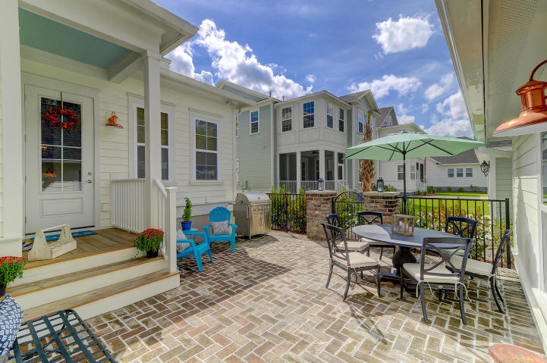
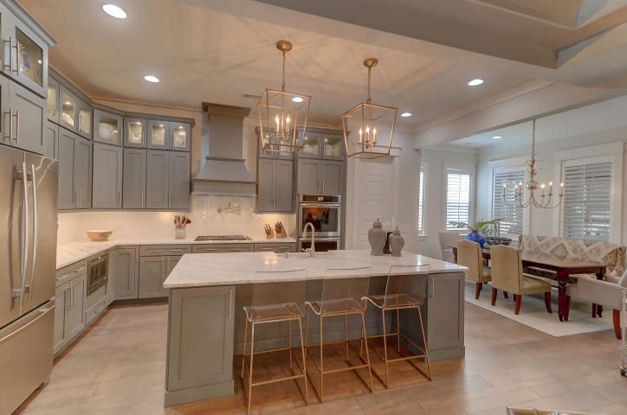
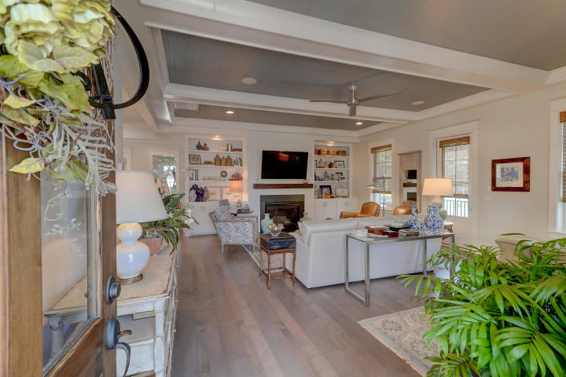
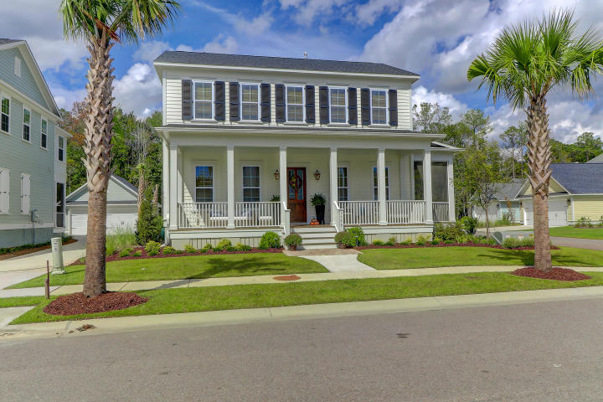


3590 Backshore Dr

Mt Pleasant, SC

MLS# 18026771
- 2,952 Square Feet
- 4BR/3½ BA
- $62K in Upgrades
- Open Floorplan
- Bright & Spacious
- Screened Porch + Patio
- $2,200 Lender Credit available

$710K Stunning Home in Carolina Park
Geri Lipps 843.810.8398
glipps@carolinaone.com

