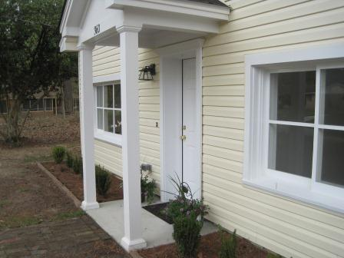
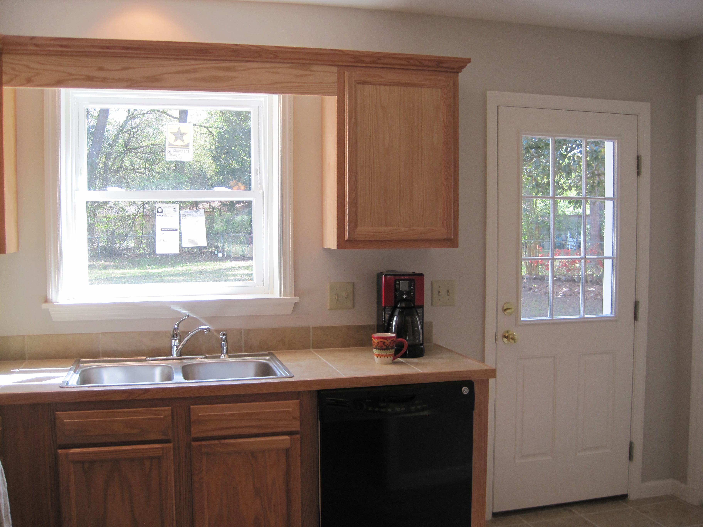
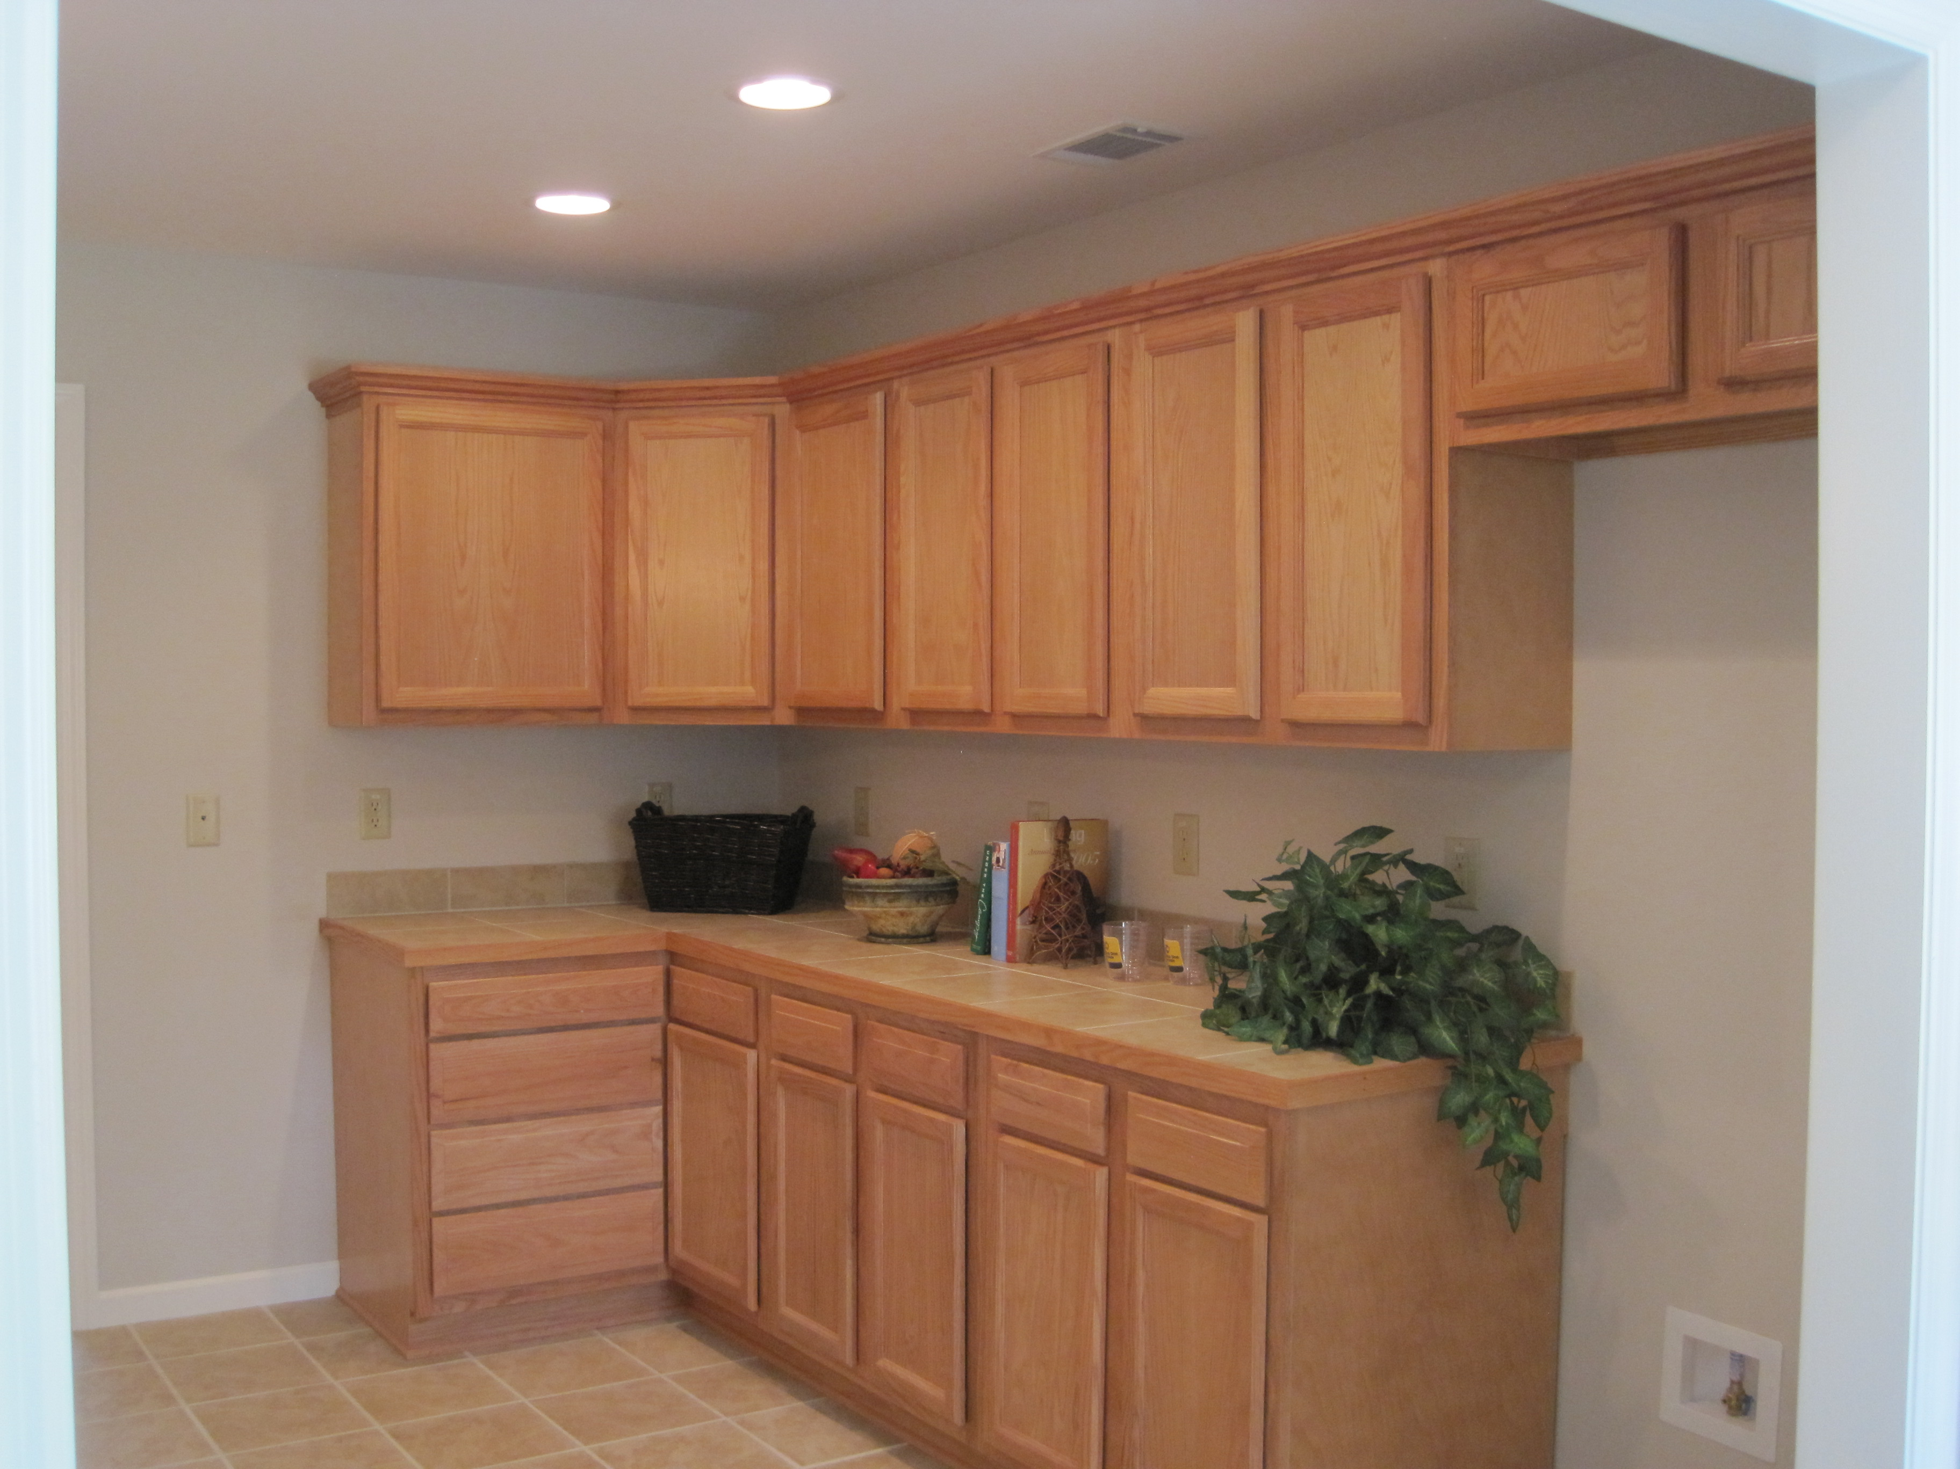
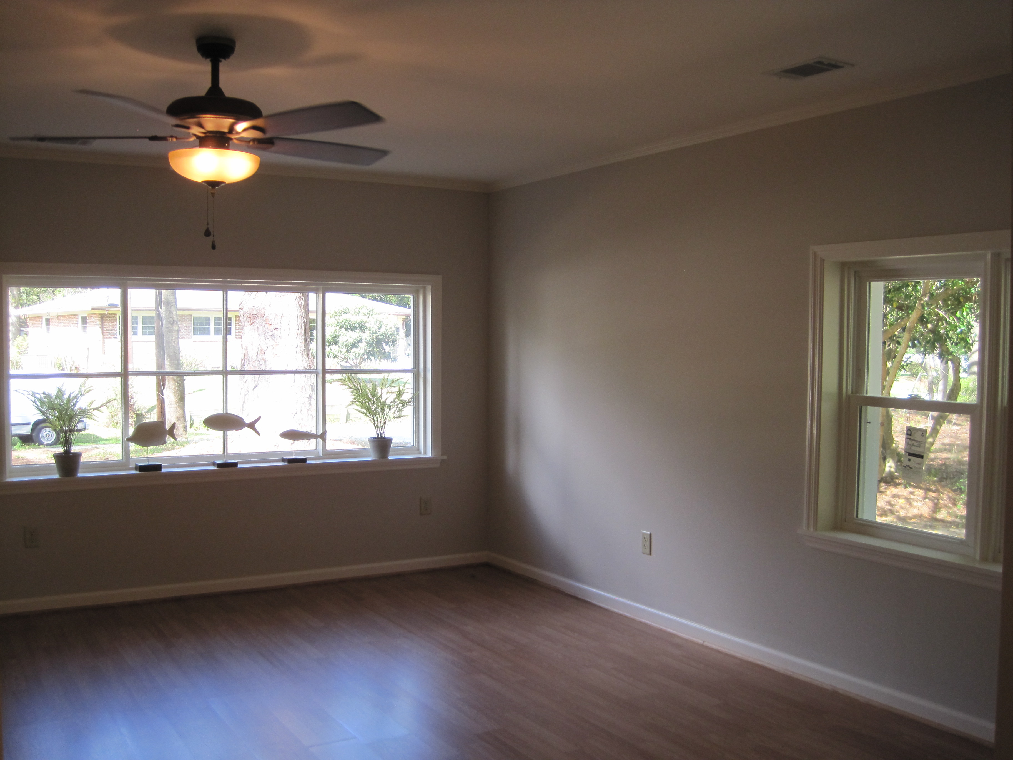

$149,900

360 Lynwood

NEW PRICE!
  - All New Home in Established Family Friendly Neighborhood
geri lipps
CarolinaOne Real Estate
195 W. Coleman Blvd
Mt. Pleasant, SC 29464

Phone: 843.810.8398
FAX: 843.746.4942
glipps@carolinaone.com
www.gerilipps.com

Picture Perfect!

New Roof

New Windows

New HVAC

New Electrical

New Plumbing

Wood Laminate, Tile, and Carpet

New Cabinets

Tile Countertops

GE Appliance Package

.25 Acre Lot with Mature Trees and Flowering Shrubs

2 Full Baths

Upgraded Lighting

