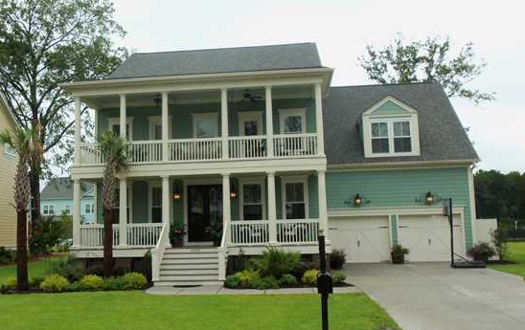
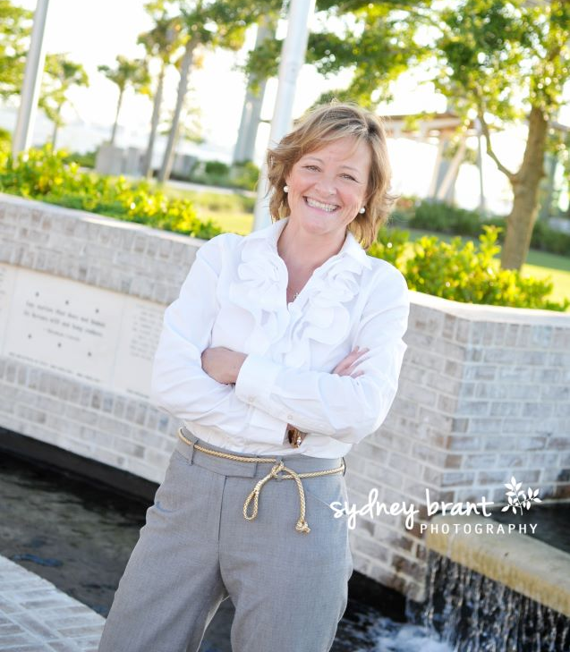
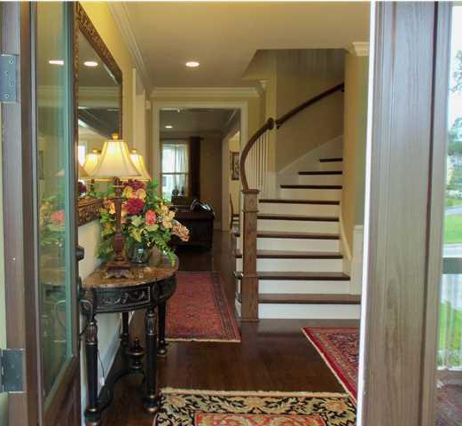
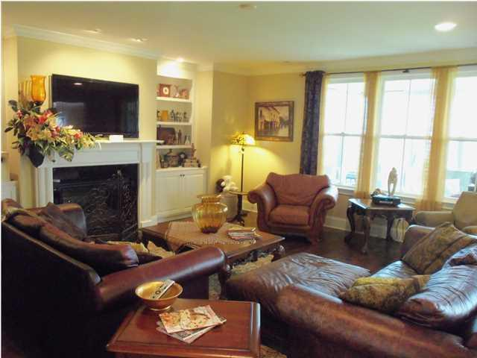
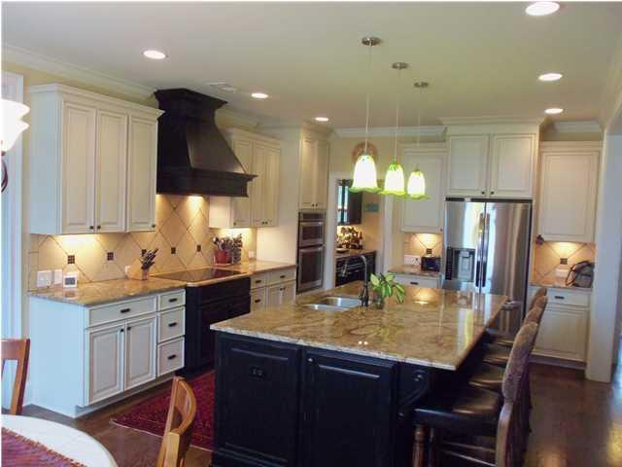

Ready Today!

- 6BR/5BA
- Media Room
- Finished 3rd
Floor
- Great Yard
$157/SF

843.810.8398 glipps@carolinaone.com

glipps@carolinaone.com

Why WAIT on New Construction

Your buyers can move in NOW!

2013 Build

$649,900

6BR/5BA
+

