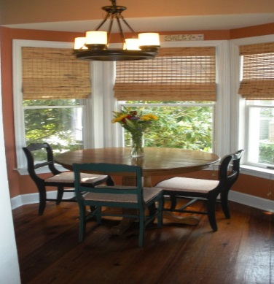
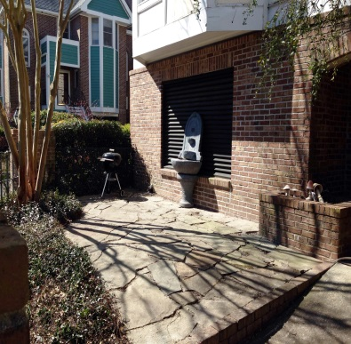
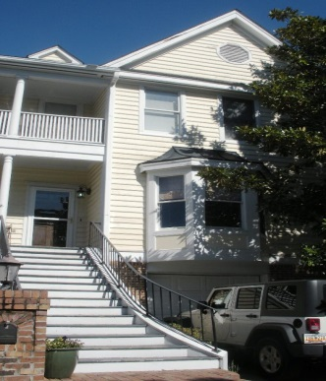
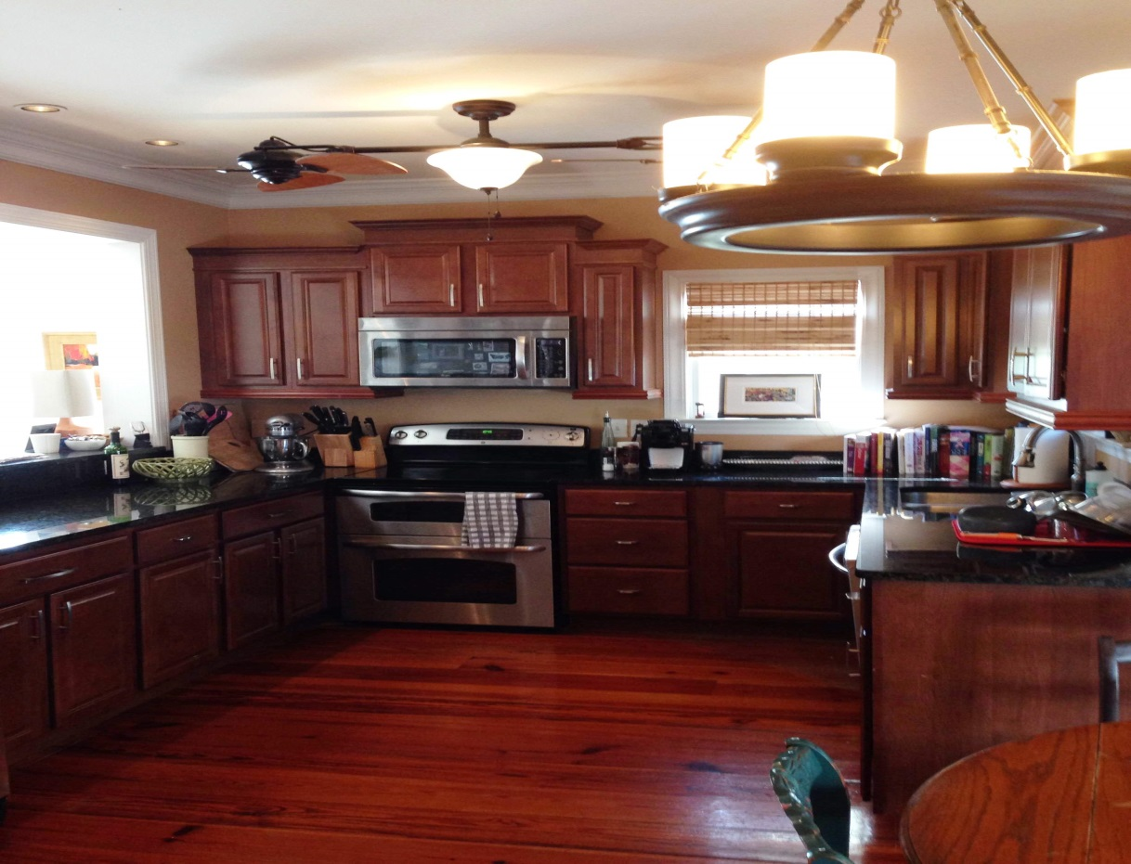

and
211 Wentworth Street

Visit both properties to be entered into our

$25.00 Gas Card Drawing
39 Harleston Place
Beautiful Downtown Charleston Townhome

Walking distance to Charleston City Marina, The Battery and Colonial Lake

4 Bedrooms/ 3.5 Baths
Heart Pine Floors
Elevator
2 Car Garage
Granite
Stainless Steel Appliances
Wet Bar
Freshly Painted Exterior
Quiet Courtyard for
Outdoor Entertaining

See Two Downtown Homes:
39 Harleston Place
211 Wentworth Street
Visit both for a chance to win $25 Gas Card
OPEN HOUSE
Light Lunch Served Thursday 6/5/2014 11:30-1:30
WIN A $25.00 GAS CARD
39 Harleston Place Charleston 29401
MLS # 1406217 $769,000
MLS # 1406217
$769,000

Stephanie Howard, Realtor 843-224-5912
Stephanie-Howard.com

Sale

COMPANY

