OPEN HOUSE
July 13, 2024 from 11am – 3pm

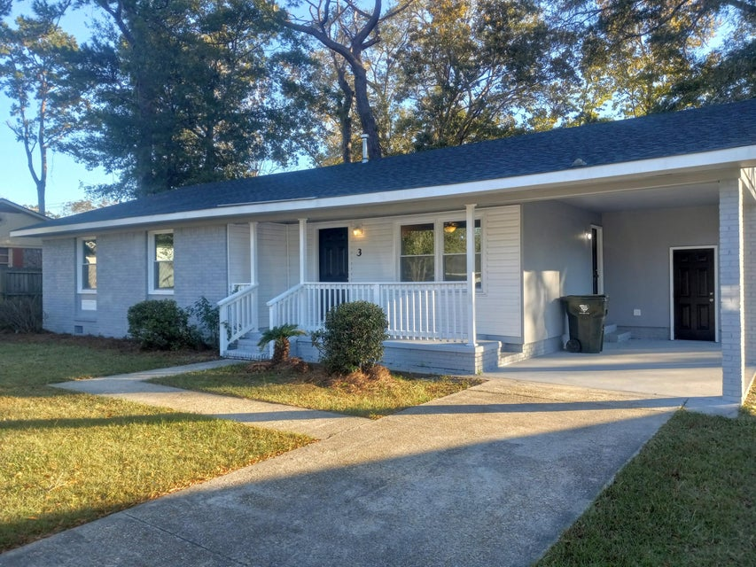

Welcome to this beautiful brick ranch home, located in an established neighborhood, without HOA fees. This home has three (possibly four) bedrooms and two bathrooms and has been completely renovated and just waiting for its new owners. Great location, just minutes from the Naval Weapon Station, shopping, schools and restaurants.

Presented by:
Tiffanie M. Jowers, Realtor
The Goodwin Group Inc.
78 Ashley Point Drive, Ste. 105
P.O. Box 40926
Charleston SC 29407
(843) 437-0351

