





WELCOME HOME TO THIS MOVE IN READY ~ SINGLE LEVEL ~ GEM! THE OPEN FLOW PLAN OFFERS A SPACIOUS LIVING/DINING AREA, KITCHEN WITH MAPLE CABINETRY, BLACK WHIRLPOOL APPLIANCES & CORIAN SOLID SURFACE COUNTER TOPS.

MASTER SUITE IS LOCATED AT THE REAR OF THE HOME & YOUR HOME BACKS TO PROTECTED WOODLANDS SO THERE IS WONDERFUL PRIVACY.

FOXBANK AMENITIES INCLUDE A RESORT STYLE POOL THAT OVERLOOKS A 67 ACRE LAKE - PERFECT FOR KAYAKING! OR PACK A LUNCH AND PICNIC UNDER THE OPEN AIR PAVILION. FOXBANK ELEMENTARY SCHOOL COMING SOON! FITNESS CENTER UNDER CONSTRUCTION.
413 Farrow Court
MLS # 15019649
Offered at $139,000

- 3Bdr / 2 Ba SINGLE STORY
- Corian ~ Maple Cabinets
- Built in 2006
- HOA Fee: $440 / Year

- Protected Woodland for Privacy
- Front & Back Porches
- Great Foxbank Amenities

FACTS & FEATURES

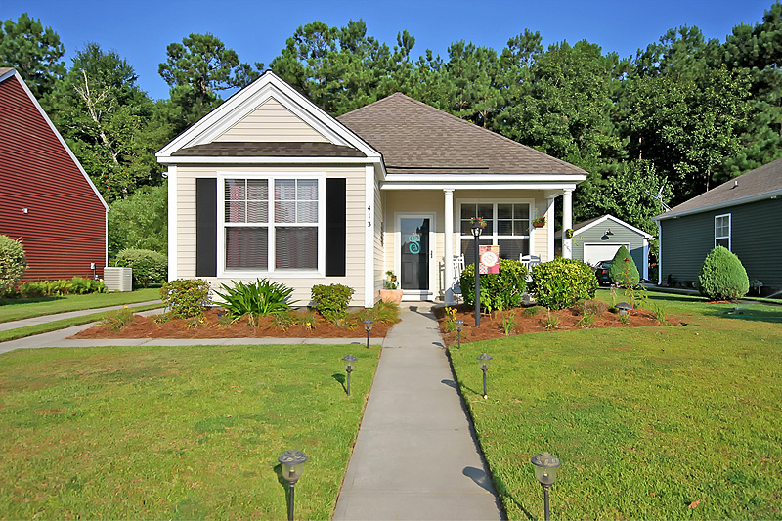
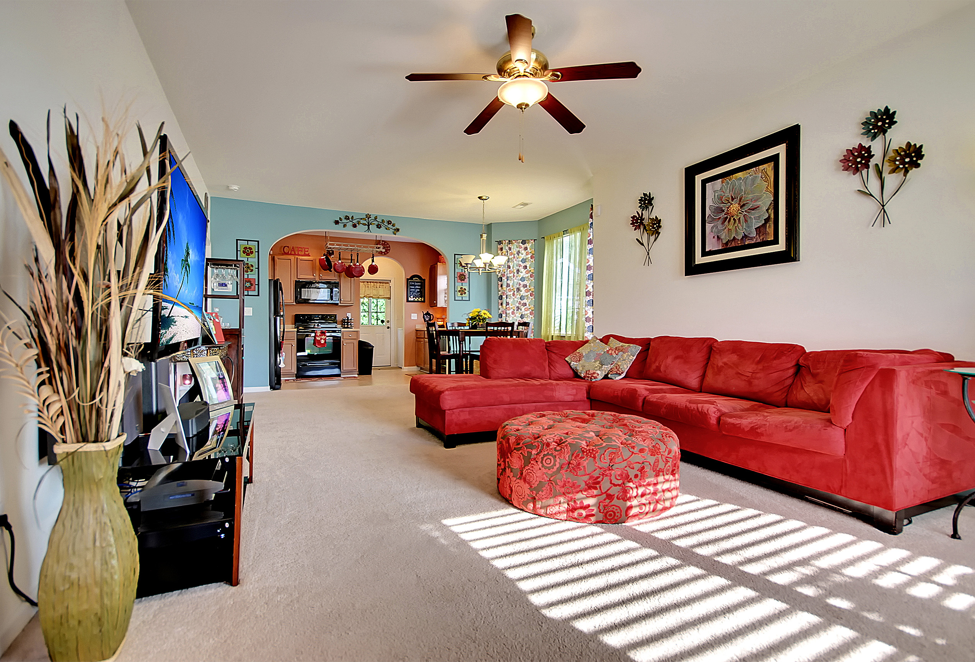
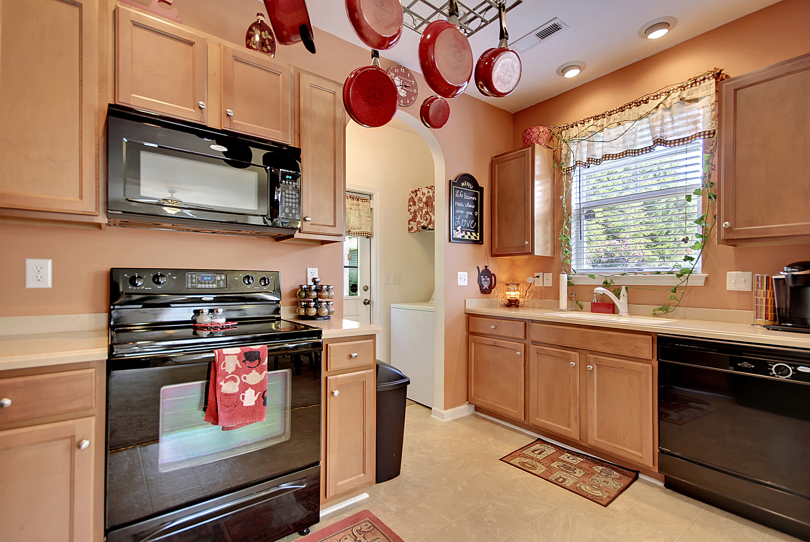
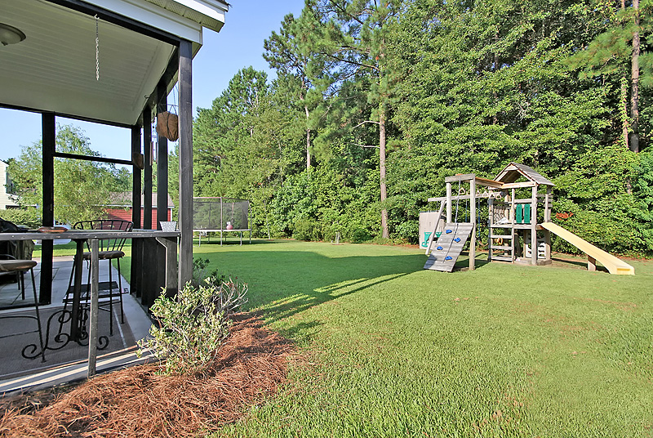
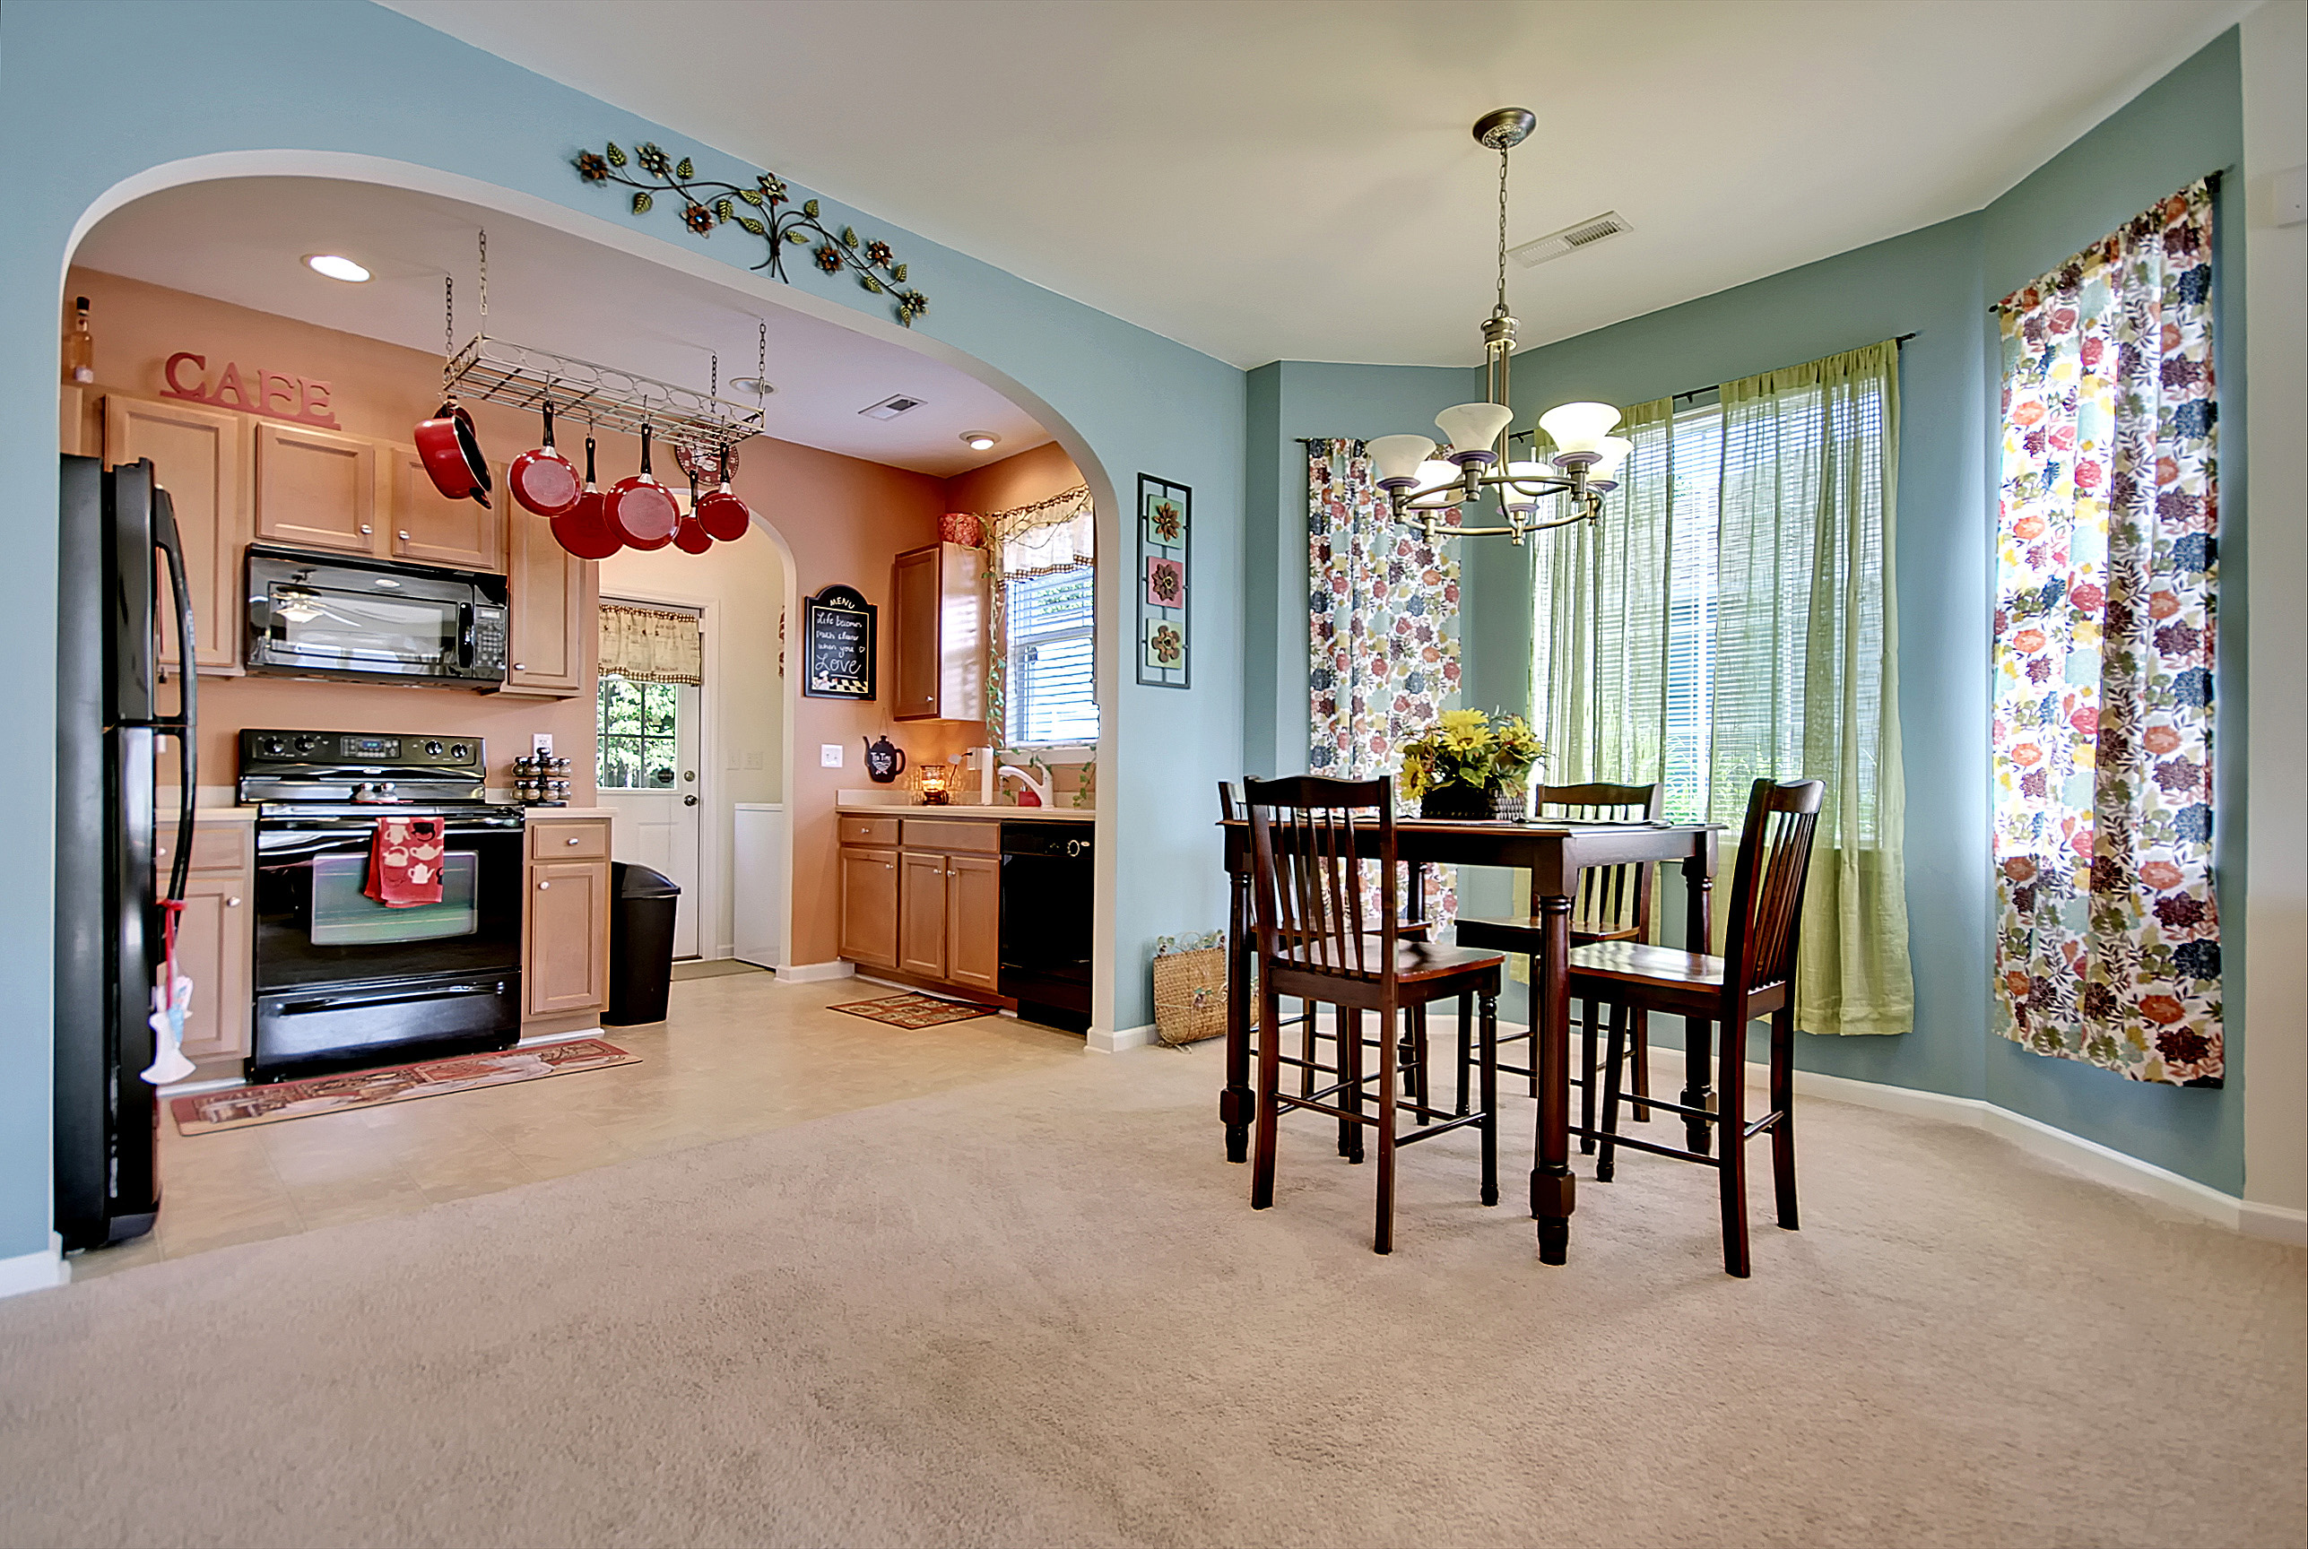
Welcome Home to Gorgeous Foxbank Plantation
“Charleston is your forever love. It is a perfect blend of character and class. There is always something, but not too much. It is playful and it romances you.”
– Rebekah Phillips
Heather Lord
Broker Associate, GRI, e-PRO, RSPS
Keller Williams Realty Charleston
www.heatherlord.com
heather@heatherlord.com
Phone: 843.810.9414

