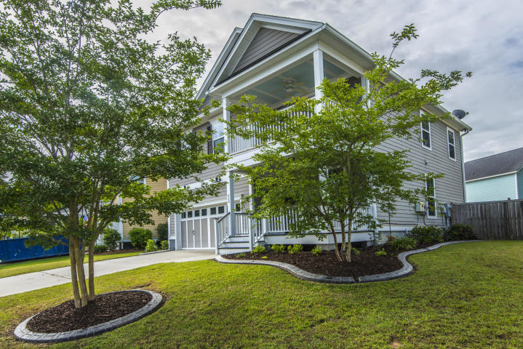

Geri Lipps Carolina One Real Estate
843.810.8398 glipps@carolinaone.com
CarolinaOne Real Estate

Sabel Built Home in Beautiful Branch Creek

Minutes to downtown Summerville or I-26 for Easy Commute Anywhere!

PAID Solar Panels for Added Savings

GOURMET KITCHEN, Engineered Hardwoods throughout Main Level

Media Room and Fenced Yard

WOW House for under $300K

$290,000

Beautiful Home with Paid Solar Panels in Place
[Street Address]
[Date and Time]

Own Your Dream Home Today

