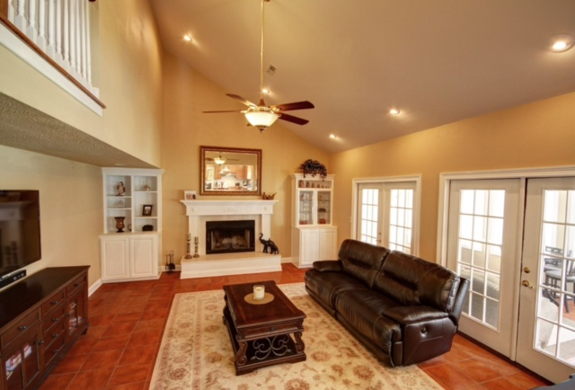
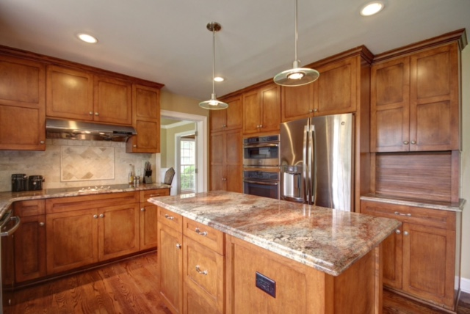
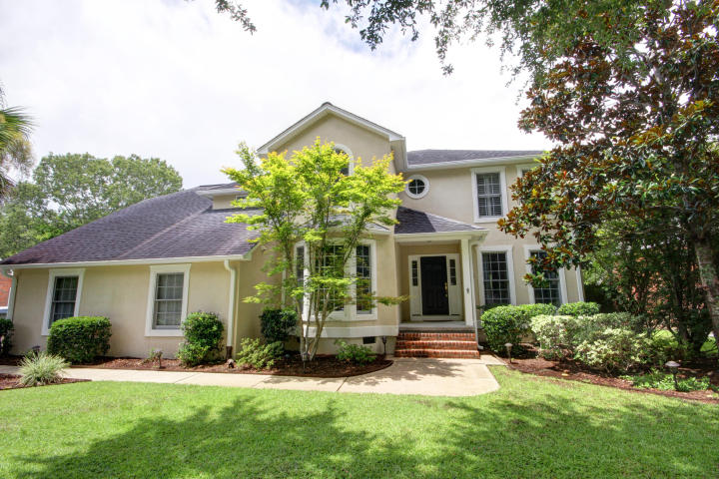


Charleston, SC 29414
MLS# 17022105
$2300 in Closing Costs PAID!

421 Meadow Breeze Lane
This Stunning home in Sylvan Shores is READY TODAY! A complete remodel in 2015 with gorgeous walnut floors throughout. The kitchen features custom cabinets, granite, a wine fridge, plus $12K appliance package!

Comfort, style and access to water – This is LowCountry Living! Sylvan Shores has an optional HOA which allows you access to the boat ramp, dock, tennis courts, basketball courts and bird sanctuary. $2300 credit available toward buyer's closing costs and pre-paids with acceptable offer and use of preferred lender.
  - $450,000

glipps@carolinaone.com | (843) 810-8398 | www.gerilipps.com

