GAS CARD

Drawing
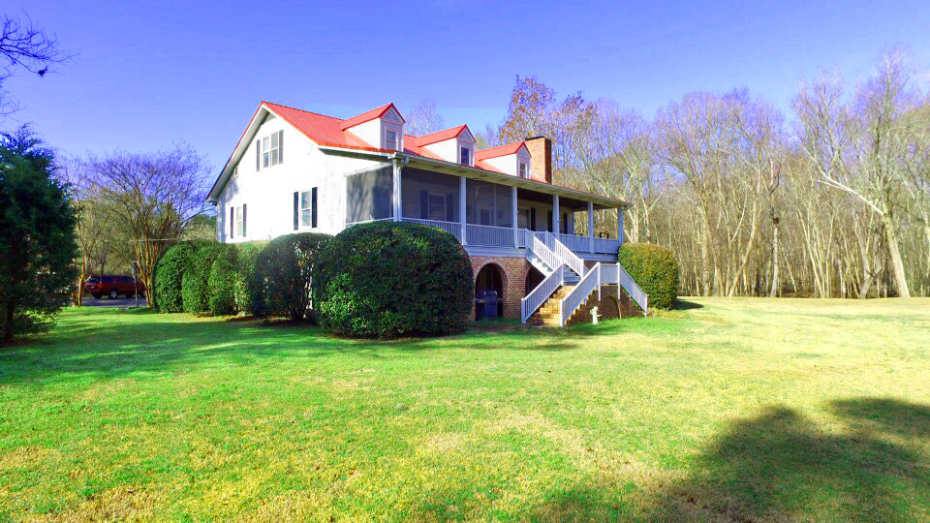
  - Preview this home and be put in for GAS CARD Drawing
Who does not need FREE GAS? Be entered in to a drawing for a $50 gas card if you preview this home before March 6th. Use showing time to make appointments.

See before March 6th 2019
436 Arrowhead Lane, Round O, SC

Kristie Anderson – Lake Homes Realty
803-387-9459

