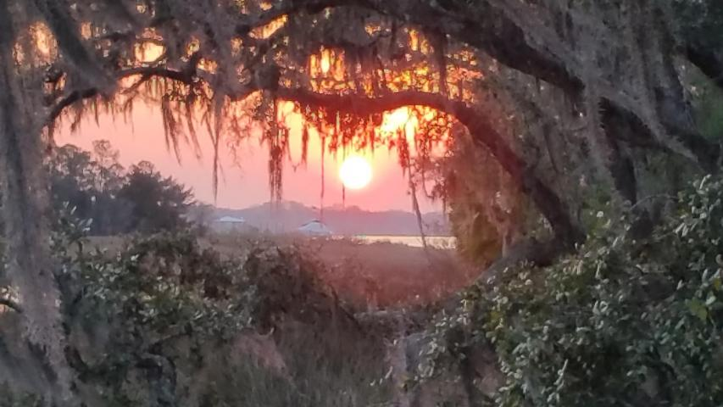
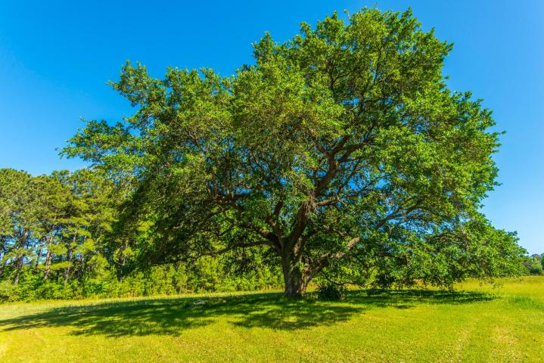
* 3.3 Miles Past Wando HS

* Bull’s Bay will be on the right.

* Left at the Next Crossover.

* Enter through the Gates and
Follow Signs for 1 Mile.
The Amazing Experience of Wando Farms.

Tour this Exclusive Private Estate, while sipping Mint Juleps, Enjoying LowCountry Favorites – Crab, Fish and Shrimp, and sampling Wando Farm’s Own Organic Fruits and Vegetables.

Very few people will ever experience the prestigious lifestyle found on this 573-acre nature conservation easement.
The peace and quiet, the gorgeous nature, the sense of well being shared by only 14 fortunate owners, (no more ever).

This is Wando Farms . . .

4400 Wando Farms

RSVP:

aevans@carolinaone.com

843-452-4605
Food From The Farm

  - A Taste of Wando Farms
  - May 16 6:30-9PM

Lorem Ipsum Dolor
Lorem ipsum dolor sit amet, consectetuer adipiscing elit. Nulla lectus mi, sodales ac, consectetuer sed, luctus sit amet, risus. Mauris tempus quam sit amet mi. Mauris sagittis augue nec augue. Fusce ipsum.

Shrimp
Crab
Fish
Organic
Fruits & Vegetables
Mint Juleps
Nunc cursus magna quis
Justo id eleifend faucibus, urna dolor consectetuer dui, vel pretium risus purus sed pede. Integer diam elit, facilisis eget.
Morbi justo. Cras rutrum sapien non risus. Nam nibh erat, auctor sit amet, commodo ut, ornare id, ante. In imperdiet.
Donec varius, felis eget lobortis vehicula, magna sapien elementum tellus, ut iaculis dui orci sed arcu. Nullam semper leo.

