JUST REDUCED
444 Indigo road
Goose creek, sc 29445
$336,000
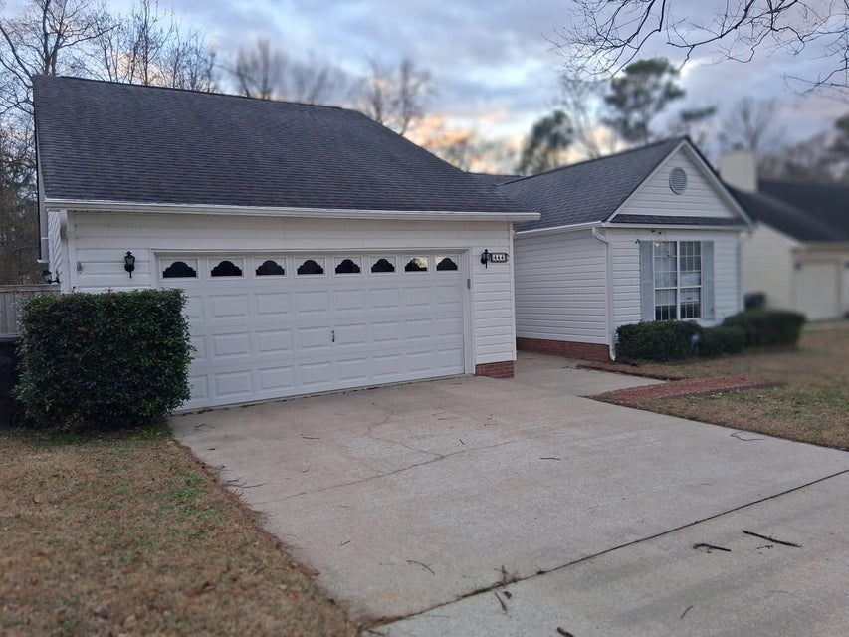
Welcome to this beautiful ranch style home, located in an established neighborhood, without HOA fees. This home has three bedrooms, two bathrooms and a two car garage. You are greeted with an open floor plan with vaulted ceilings and a fireplace. Just minutes from a Super Walmart, Lowes and a variety of casual dining and restaurants.
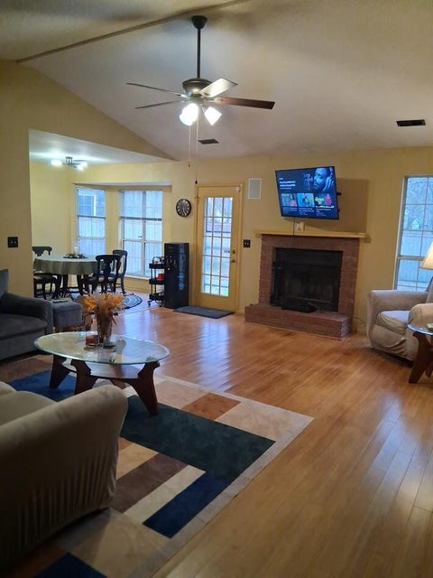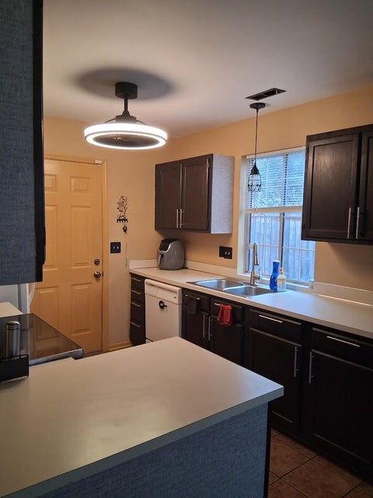

Presented by:
Tiffanie M. Jowers, Realtor
The Goodwin Group Inc.
78 Ashley Point Drive, Ste. 105
P.O. Box 40926
Charleston SC 29407
(843) 437-0351

