Price Reduced!!!!!
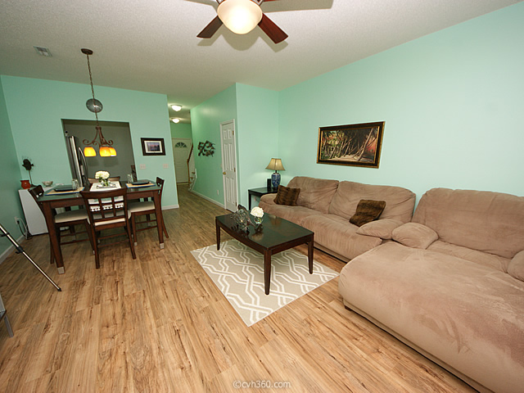
3 bedroom | 2 bathroom | 1455 sq ft | The Park at Rivers Edge
$119,500
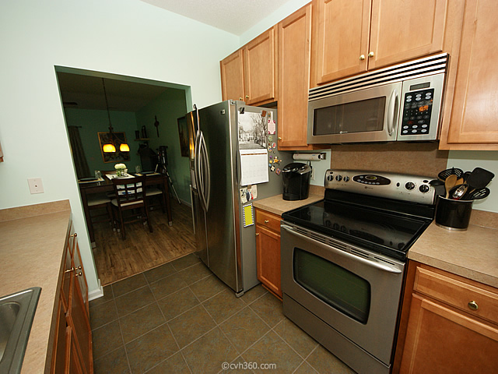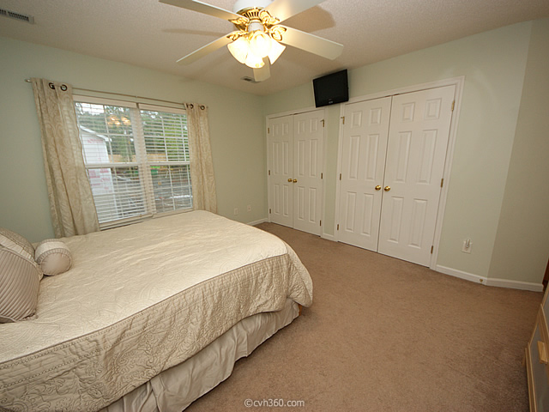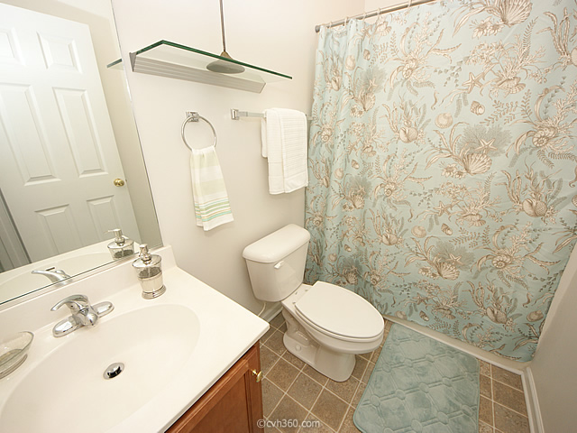
The Buying Process
This beautiful 3 bedroom 2 bathroom townhouse in the desirable Park at Rivers Edge neighborhood is a must see. Upon entering this meticulously maintained home, you will love the new floors and fresh paint. Downstairs includes one bedroom, a full bath, a large family room, with plenty of room for dining, and a kitchen with 42'' cabinets, smooth top range, dishwasher, and built in microwave, all stainless steel. Upstairs you will find the spacious master bedroom and third bedroom. Enjoy the Charleston weather on your covered back patio or throughout the neighborhood with the numerous amenities. This gated community includes a pool, club house, tennis courts, play park, fishing pond, softball field, private roads, and trash pick up. You're going to love your new lowcountry home

