CHARLESTON SOUTH CAROLINA PRIVATE EQUESTRIAN ESTATE
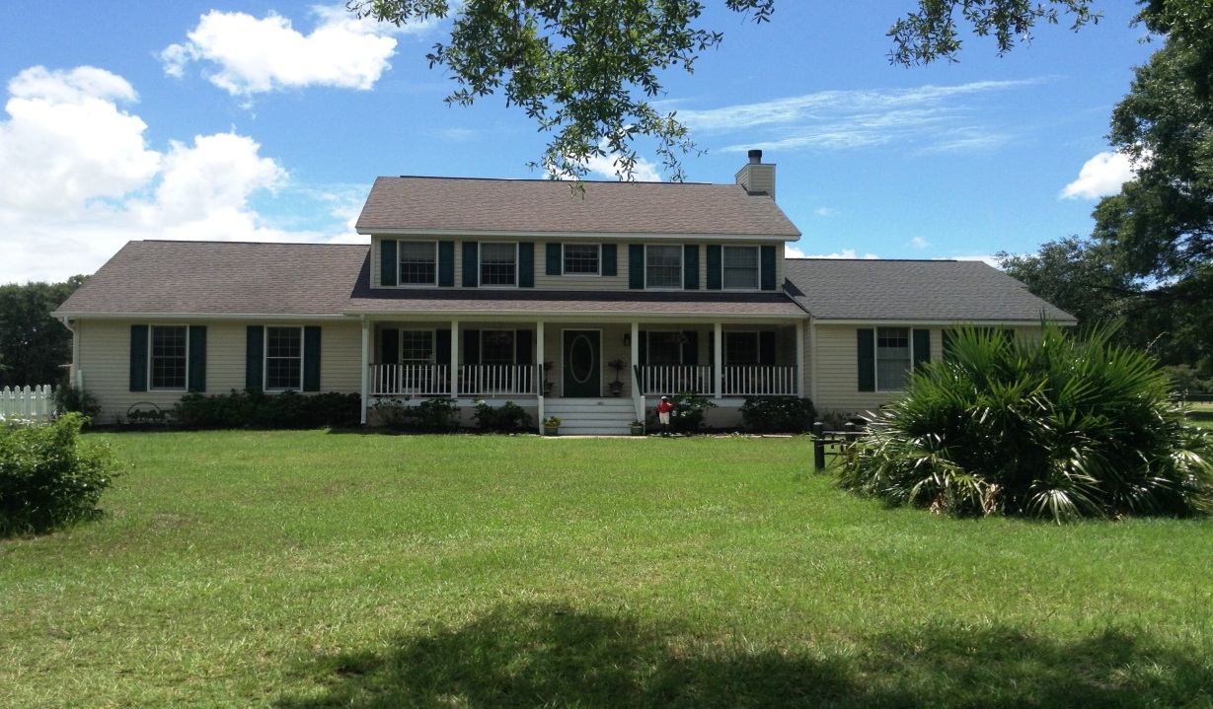
TRADITIONAL SOUTHERN HOME
4130+sq/ft; 5 Bedrooms, 3.5 Baths
Expansive Kitchen, Dining and Family Areas,
2 Master Suites, Home Office & Gym
Gated17 Acres..Lush Established Pastures.. Extensive Board Fencing..Grand Oaks For Shade
Two Barns..12 Stalls Total..Tack & Hay Storage..Training & Lunging Areas..Trails on Property
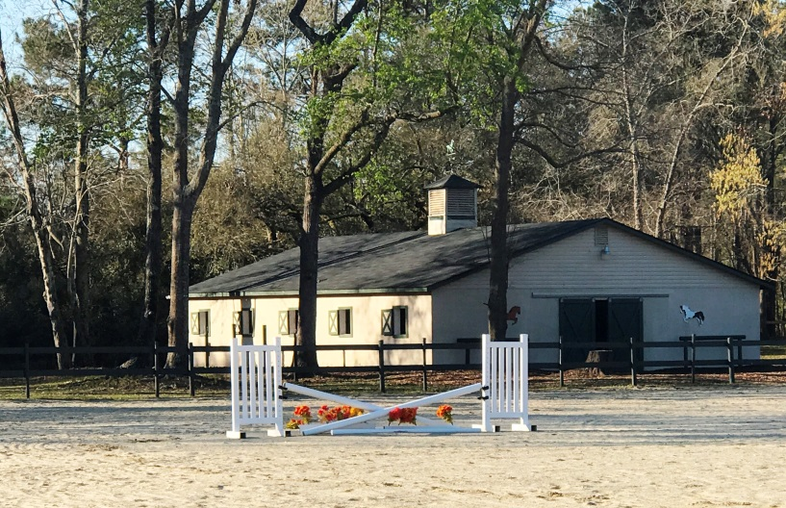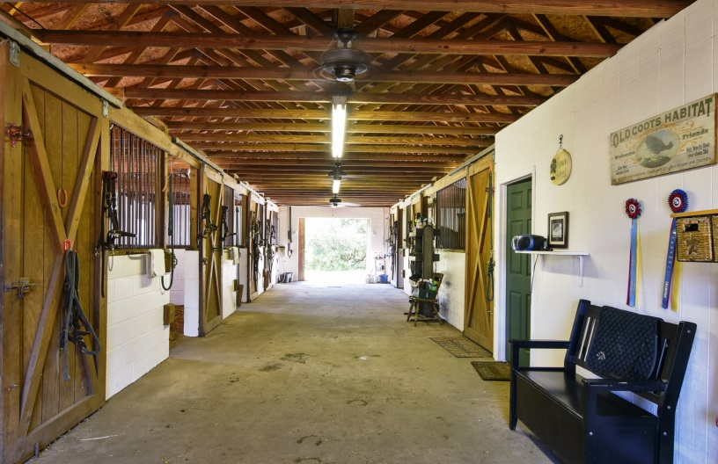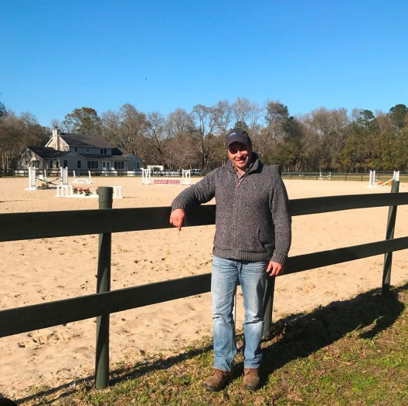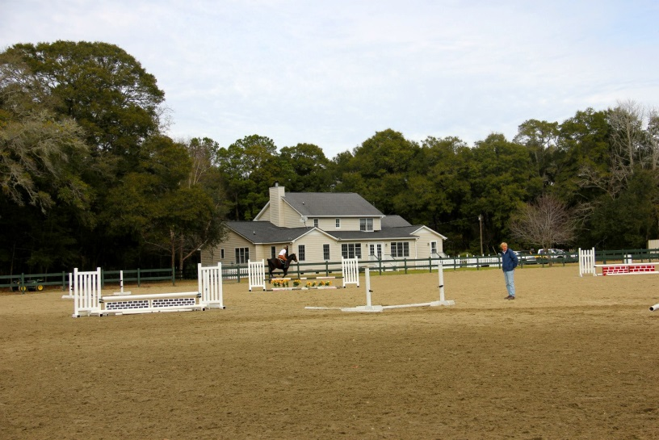
Dr. Justin Miller, DVM Charleston Equine Clinic ”This is by far the largest and nicest private equestrian riding arena I have seen in Charleston. The footing is great for exercising horses in any discipline. An absolute incredible property.”

Great Arena For Clinics & Lessons
or Clinics!
8 Stall Concrete Barn
w/ Kitchen; Laundry, Bath
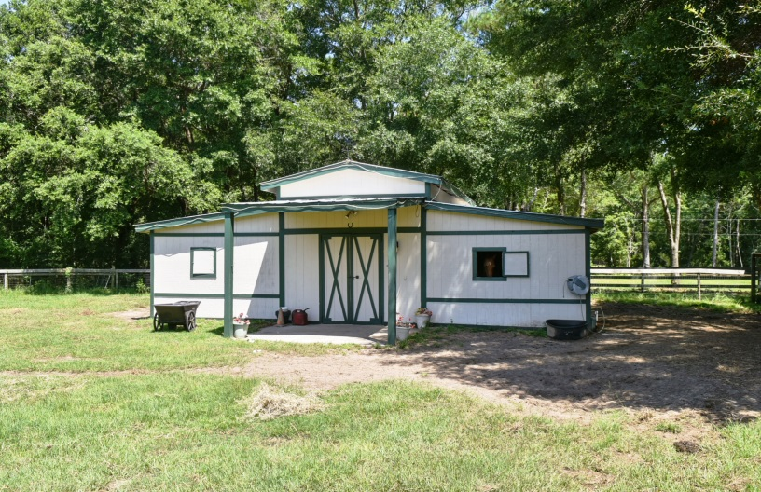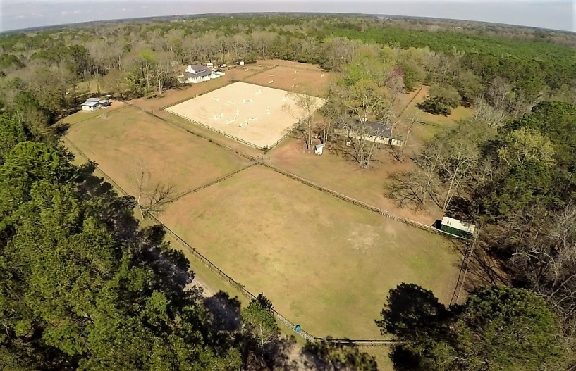
Mary Jo Roxon
Agent/Owner
843.708.0911
roxonm@bellsouth.net
Wendy Deitsch
Broker In Charge
843.270.0433
wendy@lifetreeliving.com


4 Stall Barn w/ Center Tack and Hayloft

