CHARLESTON SOUTH CAROLINA
TURN KEY PRIVATE EQUESTRIAN ESTATE

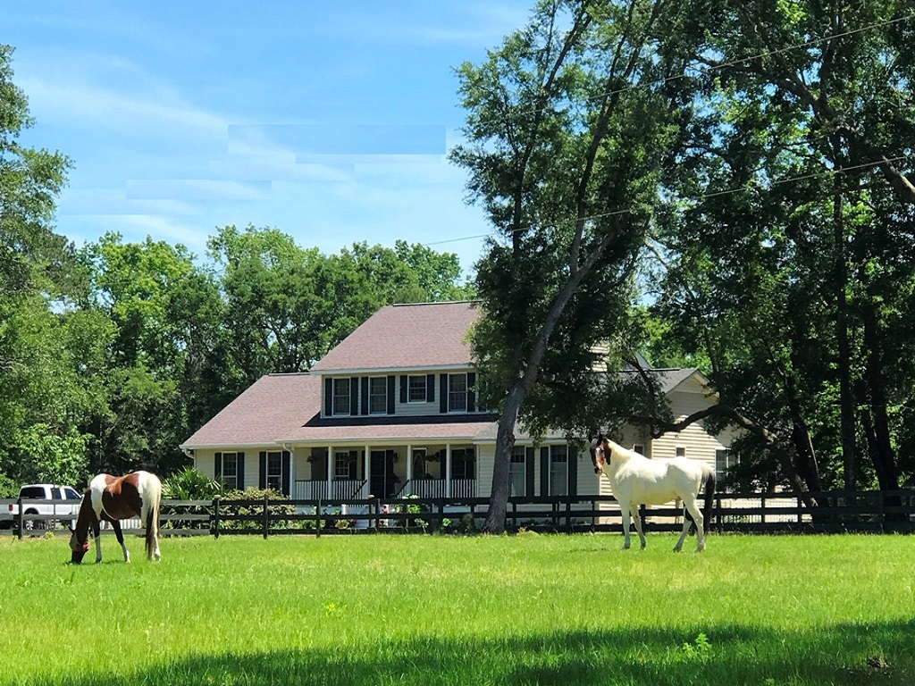

Featured in the January 2019 Dupont Registry Top 10 Luxury Equestrian Properties, this Wadmalaw Island gated equestrian estate is centrally located between historic downtown Charleston, acclaimed as the “south’s best city” for 2 years in a row by Southern Living Magazine, and Conde Nast 2018 Number 1 Small City, the fabulous beaches of Kiawah and Seabrook islands, and the regional airport and booming business community. If showing is your passion, this fabulous farm is just a short haul to “Mullet Hall”, Charleston’s Premier Equestrian Facility, and just a few hours from Tryon International Equestrian Center NC, home to the FEI World Equestrian Games. It’s an easy drive to Camden and Aiken SC as well as Savannah and Conyers Georgia for equestrian events. Plush accommodations and functionality for people and ponies, this low maintenance turnkey property is well suited for an equestrian family hobby farm. Because of the size, location, facilities and equestrian amenities, this property is also ideally suited for an income producing boarding or training operation.

The traditionally southern home has a welcoming front porch overlooking the front pastures and composite decks for viewing the back pastures and riding arena. Boasting a well-planned 4130+ sqft 5bd/3.5bath bright open floor plan, this home has a rear wall of windows that flood the great room, dining room and home office with natural light that showcases views of the pastures and riding arena. There is a spacious gourmet country kitchen with custom cabinetry, large island and raised breakfast bar. There are two master bedroom suites, the downstairs suite hosting a 100 gallon jetted tub and double jetted shower. The home has huge walk-in closets with custom built-ins, formal living room with a rustic fireplace, formal dining room, a roomy well organized pet area, a transition mudroom and immaculate home gym. Home is equipped with deep well reverse osmosis system and 22kw air cooled whole house generator with a 1000 gallon propane tank, which will fuel the house for a full two weeks.

Picture the possibilities this complete property has to offer, and appreciate the instant equity, as this property is offered @ $1,150,000 significantly below appraised value.
Mary Jo Roxon
843-708-0911
roxonm@bellsouth.net


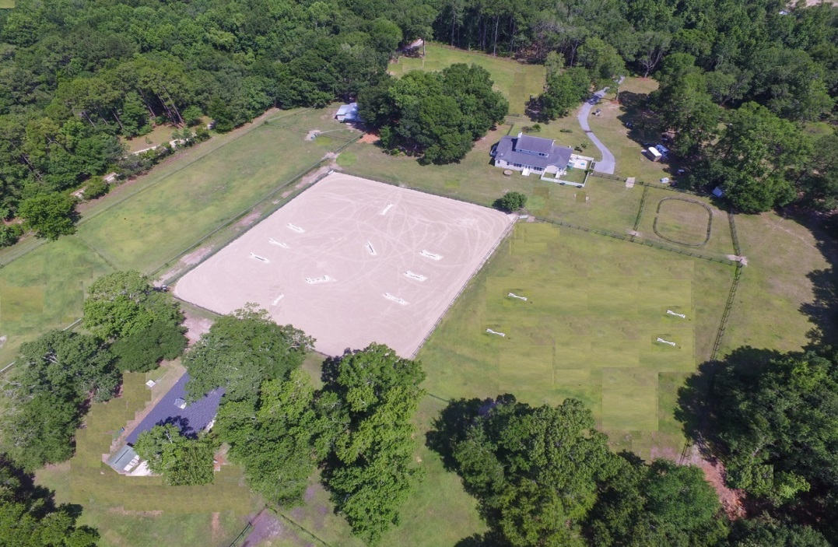

This picturesque property boasts 16.87 acres with nearly 14 acres in pastures with extensive board fencing. There are 2 barns with 12 (12X12) stalls total. The large 8 stall concrete barn is loaded with fans and mats and has a living area with laundry and full bath, wash area and detached tack room. This barn is on a separate well and septic system. The 4 stall barn, has a hay loft and center tack/storage area. Additional hay, tack and equipment storage on property. There are over a dozen lush and established paddock and pasture areas with mature oak trees for ample shade. Hitchcock and lunging area for training and exercise. The 220’X190’ riding arena is appropriate for any discipline and will fit two dressage rings. Trails on property for the evening ride or cool down
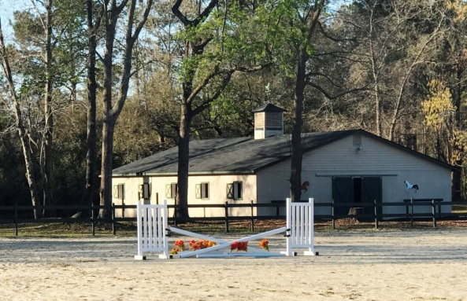
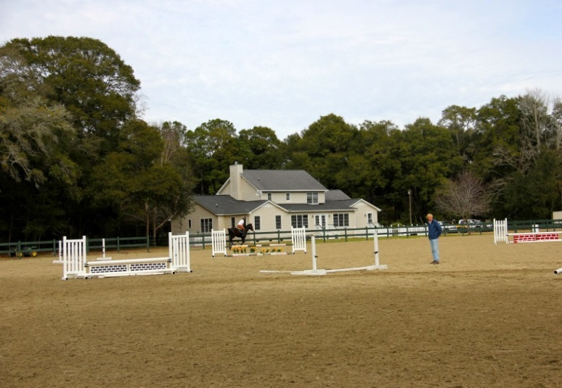
Jack Roth
803-341-8787
Jackroth1@yahoo.com
“This is by far the largest and nicest private equestrian riding arena I have seen in Charleston. The footing is great for exercising horses in any discipline. Great barns, numerous paddocks and pastures, incredible family home, a spectacular property.”
Dr. Justin Miller, DVM Charleston Equine Clinic

“Finest SC private facility I have had the pleasure of teaching clinics. Beautiful property, great arena and barns. Everything you need for horses, riders and their family….and you can’t beat the Charleston location for heading to the beach or downtown.”
Genevieve Edwards, Owner/Trainer Echelon Sport Horses, Guyton Georgia
More Photos

