National Association of Real Estate Brokers (NAREB)
Open House Weekend
June 26, 2016 ~ 2pm-4pm
498 Albemarle Road
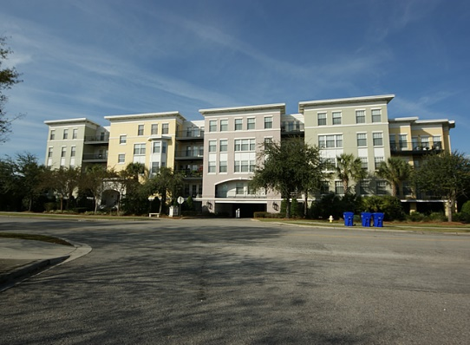
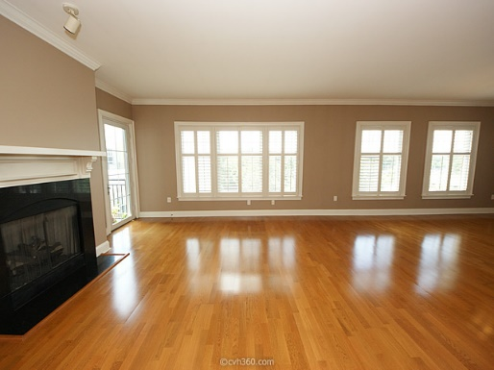 | 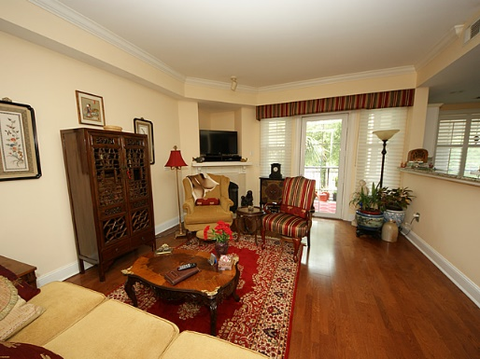
Unit #407 | Unit #211
$384,000 | $407,000

Terry Seabrook
Mobile 843 607-2490
Office 843 577-2676
seabrookspace@aol.com


