VERY NICE DEEP WATER WATERFRONT LISTING
49 Petigru Drive
Beaufort, SC
MLS# 161989
$749,000
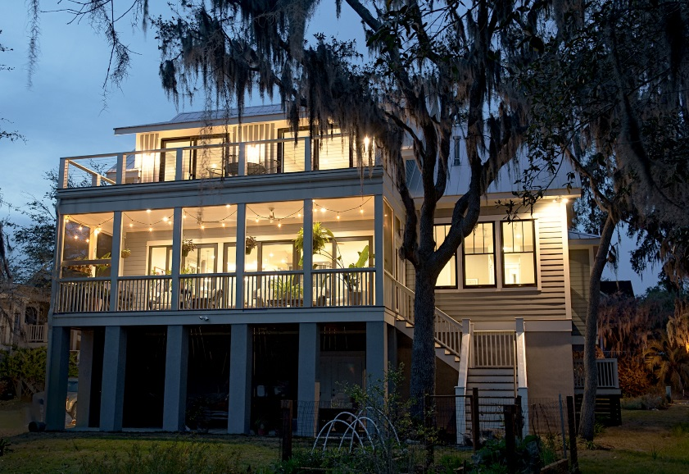

- Amazing custom-built 3BR/2BA home, 2 years old, looking like brand new
- Huge screened-in porch on main level facing the water and open upper deck
- Metal roof, elevator, hurricane rated doors and windows
- Awesome kitchen with very roomy walk-in pantry, top of the line appliances
- 3 Car garage AND a dedicated workshop
- Shared private dock w/ water and electricity
- Only 10 min. easy drive to Beaufort historic district, and 2 min. from all shopping.

Call Corinne Woodman at (843) 812-5424 or email at
corinnewoodman@embarqmail.com for additional information

