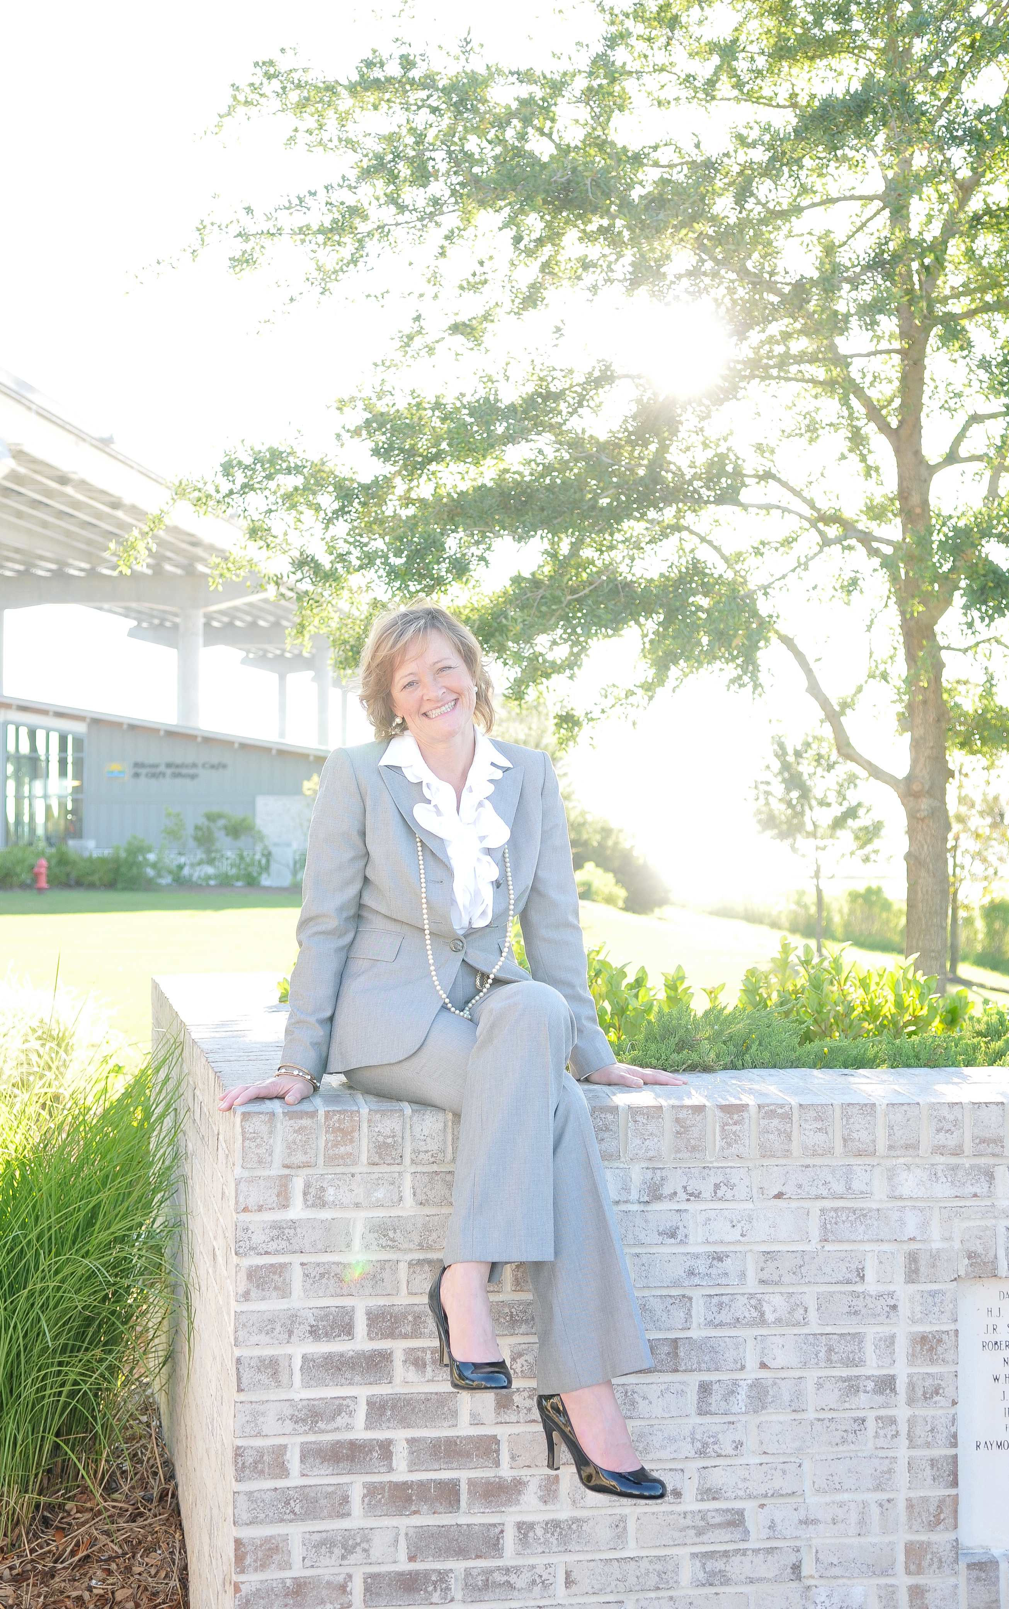
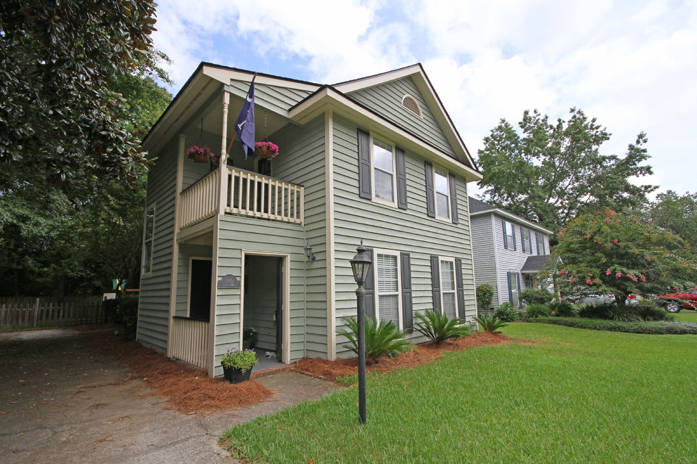
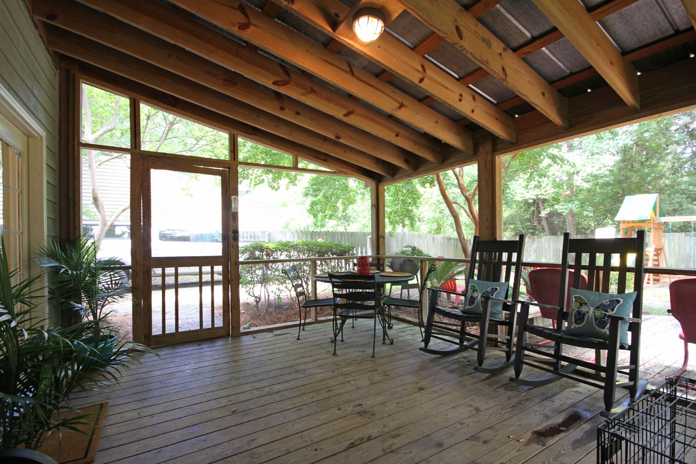
3 Bedrooms
2.5 Baths

AMAZING
Screen Porch &
Private
Fenced Backyard
With a GREAT House attached!
Charming
Charleston Single
NEW Carpet
NEW Roof
NEW HVAC
glipps@carolinaone.com
843.810.8398

843.810.8398
glipps@carolinaone.com
$325,000
Better Than
New!

340 Castle Hall Road
  - Longpoint Subdivision

