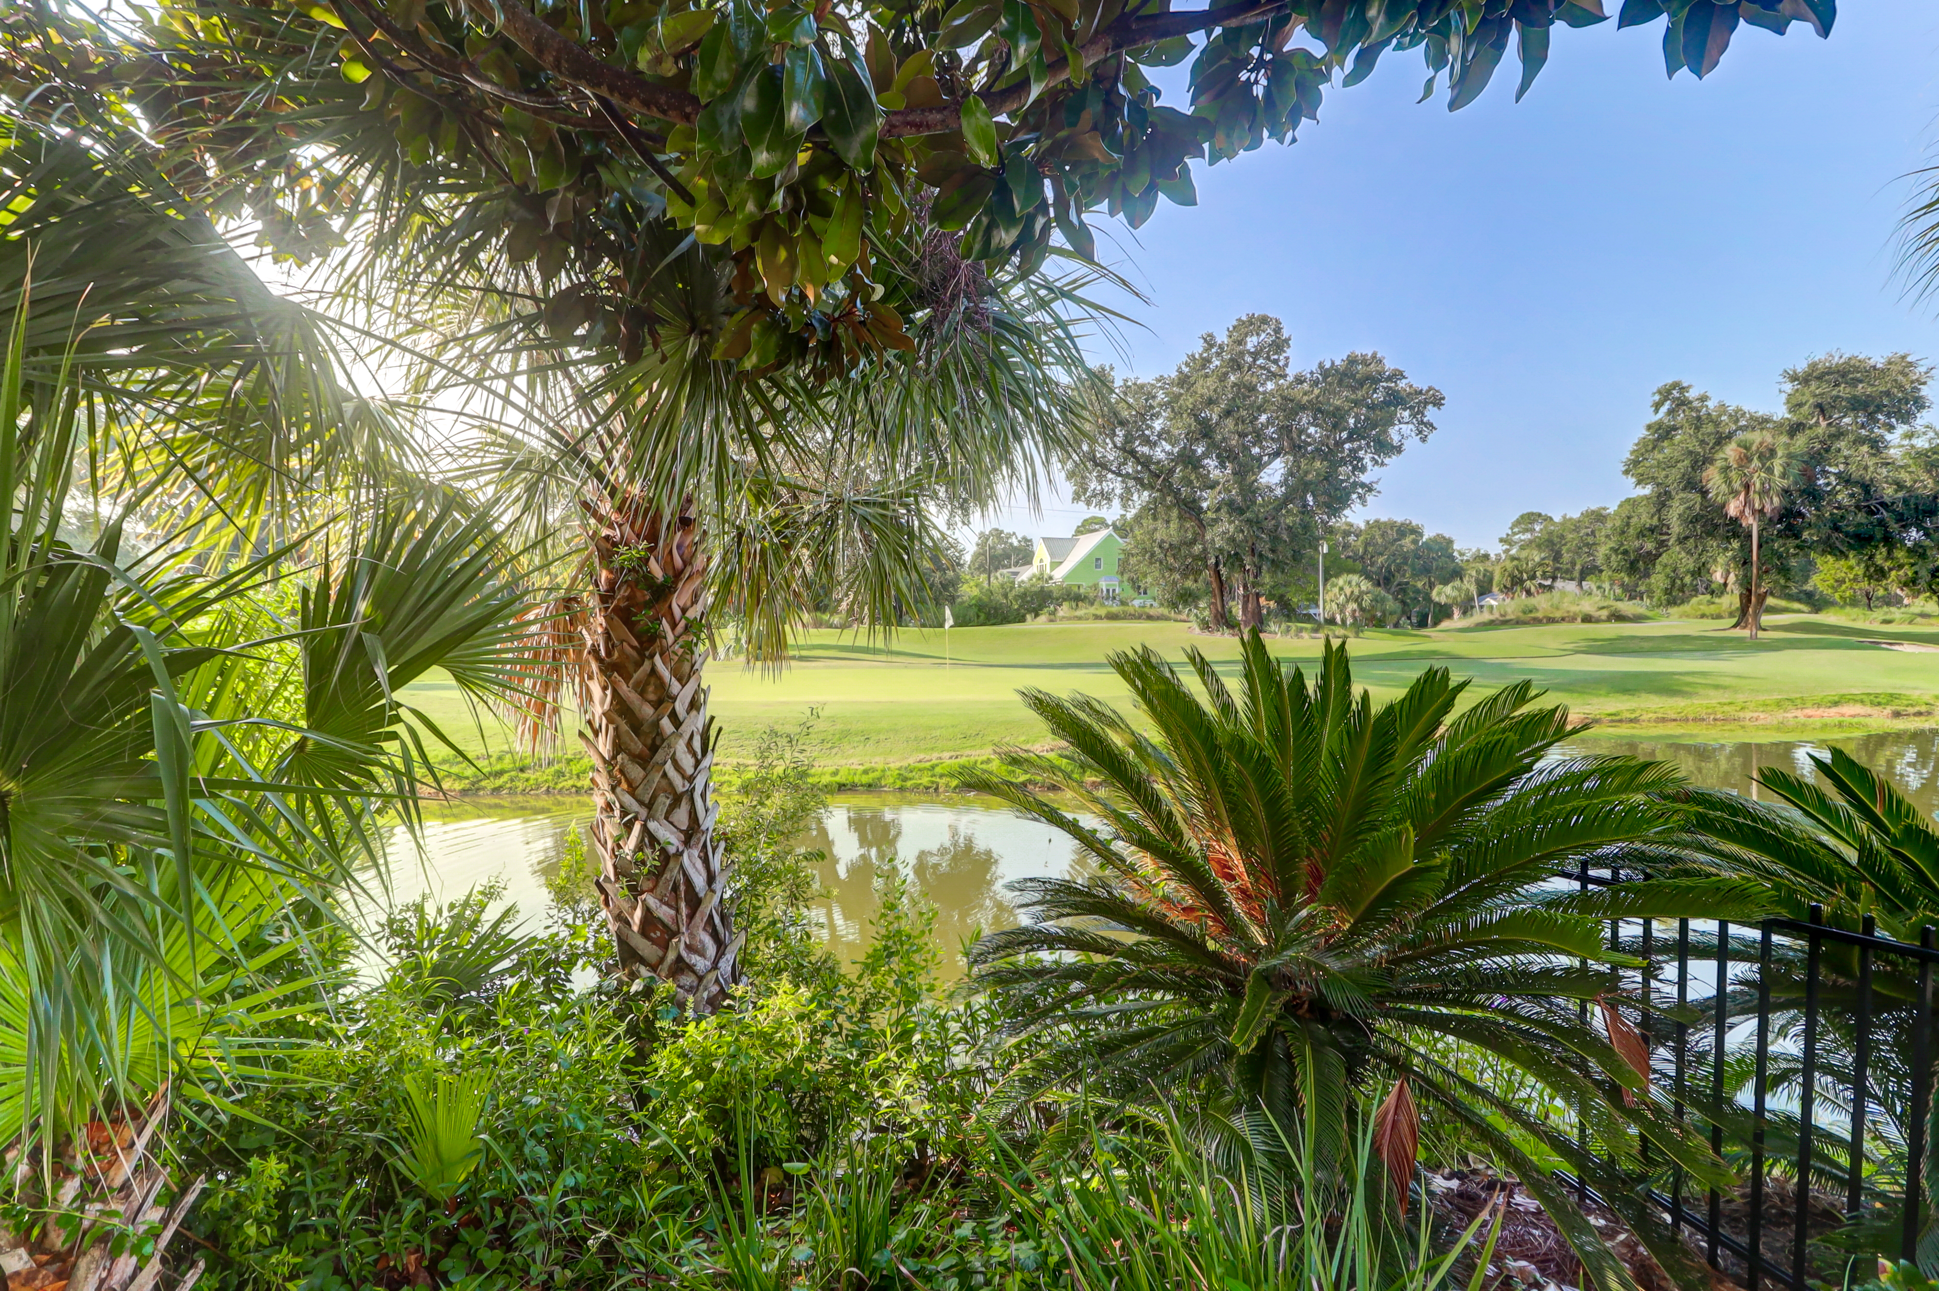
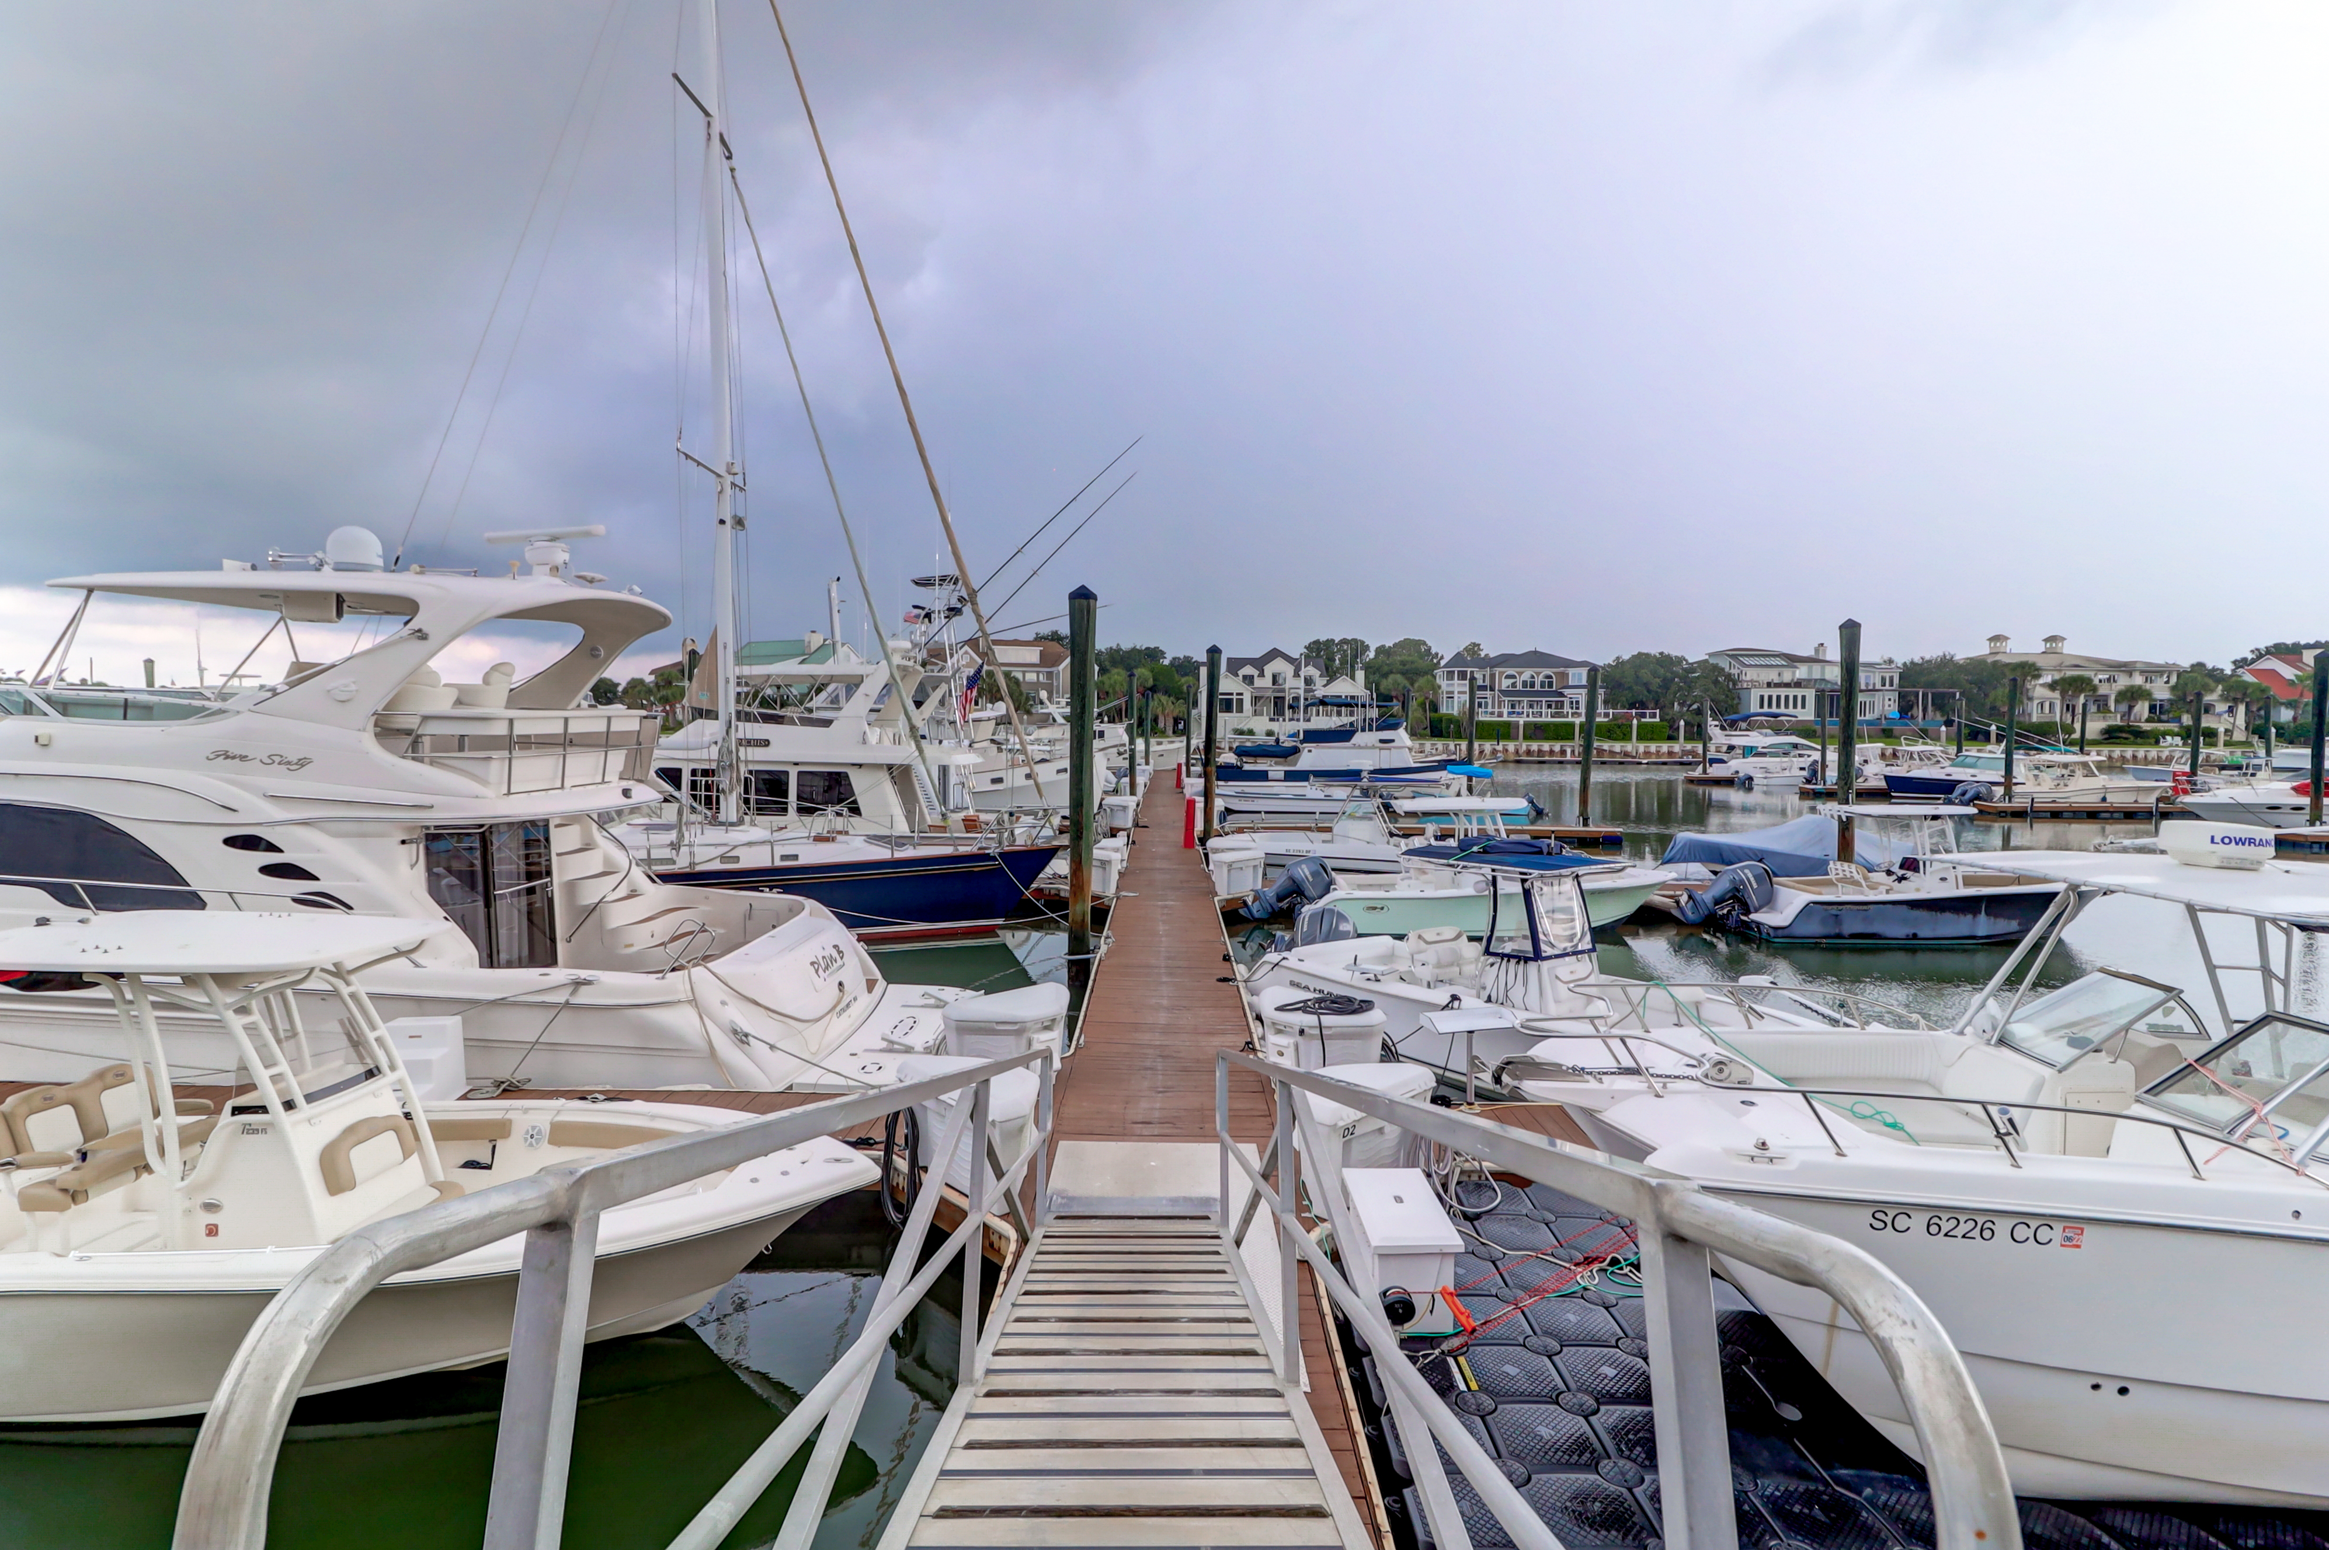
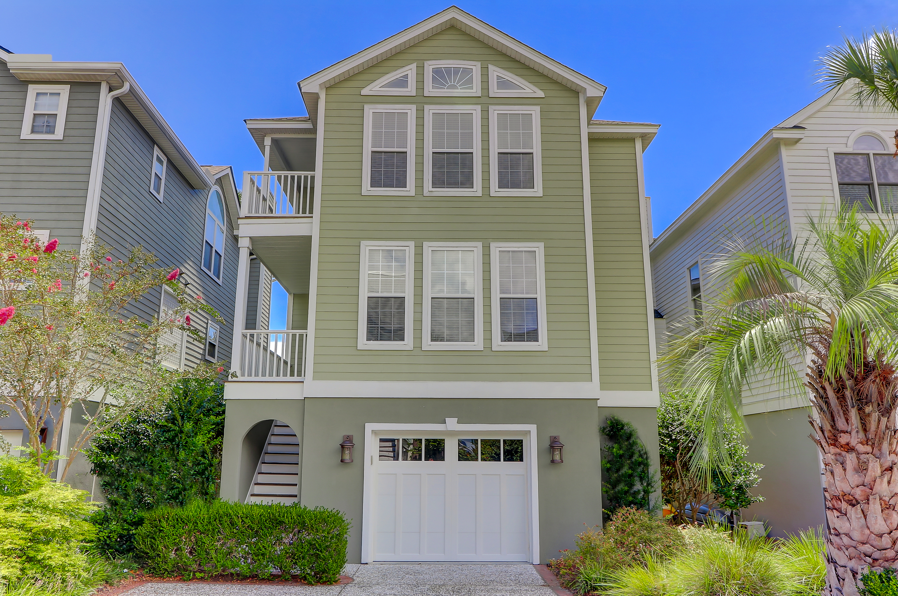



Financing Incentives

$3500 in Closing Cost Assistance with Use of Preferred Lender.

Turn Key

Fully Furnished
Amazing Decorator Details
Great Views
Great Rental History
Perfect Second Home
And . . .
30’ Boat Slip
Just across the street!

Stunning Custom Home
in Wild Dunes
Golf Course Views
4BR/4BA
Gorgeous Kitchen
2459 SF
30’ Deeded Boat Slip

53 Morgans Cove-Wild Dunes

$1.3M

Geri Lipps 843.810.8398
glipps@carolinaone.com

